|  |  |  |
| --- | --- | --- |
| Table 1: Descriptive Statistics for Economic Activity | | |
|  | n | % |
| Continue Schooling or not after September when individuals are 16 |  |  |
| Don't Continue Schooling | 5,860 | 69.67% |
| Continue Schooling | 2,551 | 30.33% |
| Educational Attainment O-levels |  |  |
| <5 O-Levels | 5,426 | 64.51% |
| >5 O-Levels | 2,985 | 35.49% |
| Sex of Respondent |  |  |
| Female | 4,215 | 50.11% |
| Male | 4,196 | 49.89% |
| Housing Tenure of Respondent when Child |  |  |
| Own Home | 4,045 | 48.09% |
| Don't Own Home | 4,366 | 51.91% |
| NS-SEC Social Class of Father when Respondent Child SOC2000 |  |  |
| Large Employers and higher managerial occupations | 261 | 3.10% |
| Higher professional occupations | 410 | 4.87% |
| Lower Managerial and professional occupations | 1,038 | 12.34% |
| Intermediate occupations | 805 | 9.57% |
| Small employers and own account workers | 1,024 | 12.17% |
| Lower supervisory and technical occupations | 1,372 | 16.31% |
| Semi-routine occupations | 1,485 | 17.66% |
| Routine occupations | 2,016 | 23.97% |
| RGSC Social Class of Father when Respondent Child SOC2000 |  |  |
| Professional | 362 | 4.30% |
| Managerial and Technical | 1,720 | 20.45% |
| Skilled non-manual | 905 | 10.76% |
| Skilled manual | 3,501 | 41.62% |
| Partly skilled | 1,205 | 14.33% |
| Unskilled | 718 | 8.54% |
| NS-SEC Social Class of Father when Respondent Child SOC90 |  |  |
| Large Employers and higher managerial occupations | 9 | 0.11% |
| Higher professional occupations | 346 | 4.11% |
| Lower Managerial and professional occupations | 689 | 8.19% |
| Intermediate occupations | 870 | 10.34% |
| Small employers and own account workers | 678 | 8.06% |
| Lower supervisory and technical occupations | 1,414 | 16.81% |
| Semi-routine occupations | 2,060 | 24.49% |
| Routine occupations | 2,345 | 27.88% |
| RGSC Social Class of Father when Respondent Child SOC90 |  |  |
| Professional | 304 | 3.61% |
| Managerial and Technical | 651 | 7.74% |
| Skilled non-manual | 1,129 | 13.42% |
| Skilled manual | 2,601 | 30.92% |
| Partly skilled | 2,940 | 34.95% |
| Unskilled | 786 | 9.34% |
|  |  |  |
|  | Mean | SD |
| CAMSIS Score of Father when Respondent Child SOC2000 | 44.57 | 13.63 |
| CAMSIS Score of Father when Respondent Child SOC90 | 42.04 | 12.84 |
|  |  |  |
| n |  | 8411 |
| Data Source: NCDS | | |

|  |  |  |  |
| --- | --- | --- | --- |
| Descriptive Statistics by Economic Activity | | | |
|  | Continue Schooling or not after September when individuals are 16 | | |
|  | Don't Continue Schooling | Continue Schooling | Total |
| N | 5860.00 (69.67%) | 2551.00 (30.33%) | 8411.00 (100.00%) |
| Educational Attainment O-levels |  |  |  |
| <5 O-Levels | 4991.00 (85.17%) | 435.00 (17.05%) | 5426.00 (64.51%) |
| >5 O-Levels | 869.00 (14.83%) | 2116.00 (82.95%) | 2985.00 (35.49%) |
| Sex of Respondent |  |  |  |
| Female | 2934.00 (50.07%) | 1281.00 (50.22%) | 4215.00 (50.11%) |
| Male | 2926.00 (49.93%) | 1270.00 (49.78%) | 4196.00 (49.89%) |
| Housing Tenure of Respondent when Child |  |  |  |
| Own Home | 2311.00 (39.44%) | 1734.00 (67.97%) | 4045.00 (48.09%) |
| Don't Own Home | 3549.00 (60.56%) | 817.00 (32.03%) | 4366.00 (51.91%) |
| NS-SEC Social Class of Father when Respondent Child SOC2000 |  |  |  |
| Large Employers and higher managerial occupations | 115.00 (1.96%) | 146.00 (5.72%) | 261.00 (3.10%) |
| Higher professional occupations | 119.00 (2.03%) | 291.00 (11.41%) | 410.00 (4.87%) |
| Lower Managerial and professional occupations | 494.00 (8.43%) | 544.00 (21.32%) | 1038.00 (12.34%) |
| Intermediate occupations | 451.00 (7.70%) | 354.00 (13.88%) | 805.00 (9.57%) |
| Small employers and own account workers | 755.00 (12.88%) | 269.00 (10.54%) | 1024.00 (12.17%) |
| Lower supervisory and technical occupations | 1018.00 (17.37%) | 354.00 (13.88%) | 1372.00 (16.31%) |
| Semi-routine occupations | 1180.00 (20.14%) | 305.00 (11.96%) | 1485.00 (17.66%) |
| Routine occupations | 1728.00 (29.49%) | 288.00 (11.29%) | 2016.00 (23.97%) |
| RGSC Social Class of Father when Respondent Child SOC2000 |  |  |  |
| Professional | 105.00 (1.79%) | 257.00 (10.07%) | 362.00 (4.30%) |
| Managerial and Technical | 884.00 (15.09%) | 836.00 (32.77%) | 1720.00 (20.45%) |
| Skilled non-manual | 527.00 (8.99%) | 378.00 (14.82%) | 905.00 (10.76%) |
| Skilled manual | 2742.00 (46.79%) | 759.00 (29.75%) | 3501.00 (41.62%) |
| Partly skilled | 979.00 (16.71%) | 226.00 (8.86%) | 1205.00 (14.33%) |
| Unskilled | 623.00 (10.63%) | 95.00 (3.72%) | 718.00 (8.54%) |
| NS-SEC Social Class of Father when Respondent Child SOC90 |  |  |  |
| Large Employers and higher managerial occupations | 4.00 (0.07%) | 5.00 (0.20%) | 9.00 (0.11%) |
| Higher professional occupations | 110.00 (1.88%) | 236.00 (9.25%) | 346.00 (4.11%) |
| Lower Managerial and professional occupations | 313.00 (5.34%) | 376.00 (14.74%) | 689.00 (8.19%) |
| Intermediate occupations | 442.00 (7.54%) | 428.00 (16.78%) | 870.00 (10.34%) |
| Small employers and own account workers | 492.00 (8.40%) | 186.00 (7.29%) | 678.00 (8.06%) |
| Lower supervisory and technical occupations | 1028.00 (17.54%) | 386.00 (15.13%) | 1414.00 (16.81%) |
| Semi-routine occupations | 1509.00 (25.75%) | 551.00 (21.60%) | 2060.00 (24.49%) |
| Routine occupations | 1962.00 (33.48%) | 383.00 (15.01%) | 2345.00 (27.88%) |
| RGSC Social Class of Father when Respondent Child SOC90 |  |  |  |
| Professional | 96.00 (1.64%) | 208.00 (8.15%) | 304.00 (3.61%) |
| Managerial and Technical | 270.00 (4.61%) | 381.00 (14.94%) | 651.00 (7.74%) |
| Skilled non-manual | 625.00 (10.67%) | 504.00 (19.76%) | 1129.00 (13.42%) |
| Skilled manual | 2082.00 (35.53%) | 519.00 (20.34%) | 2601.00 (30.92%) |
| Partly skilled | 2159.00 (36.84%) | 781.00 (30.62%) | 2940.00 (34.95%) |
| Unskilled | 628.00 (10.72%) | 158.00 (6.19%) | 786.00 (9.34%) |
| CAMSIS Score of Father when Respondent Child SOC2000 | 41.39 (11.79) | 51.88 (14.71) | 44.57 (13.63) |
| CAMSIS Score of Father when Respondent Child SOC90 | 39.56 (11.06) | 47.73 (14.71) | 42.04 (12.84) |

|  |  |  |  |  |  |  |  |  |  |
| --- | --- | --- | --- | --- | --- | --- | --- | --- | --- |
|  | NS-SEC Social Class of Father when Respondent Child SOC90 | | | | | | | | |
|  | Large Employers and higher managerial occupations | Higher professional occupations | Lower Managerial and professional occupations | Intermediate occupations | Small employers and own account workers | Lower supervisory and technical occupations | Semi-routine occupations | Routine occupations | Total |
| NS-SEC Social Class of Father when Respondent Child SOC2000 |  |  |  |  |  |  |  |  |  |
| Large Employers and higher managerial occupations | 9 (100.00%) | 18 (5.20%) | 19 (2.76%) | 87 (10.00%) | 0 (0.00%) | 7 (0.50%) | 121 (5.87%) | 0 (0.00%) | 261 (3.10%) |
| Higher professional occupations | 0 (0.00%) | 285 (82.37%) | 78 (11.32%) | 46 (5.29%) | 1 (0.15%) | 0 (0.00%) | 0 (0.00%) | 0 (0.00%) | 410 (4.87%) |
| Lower Managerial and professional occupations | 0 (0.00%) | 43 (12.43%) | 526 (76.34%) | 184 (21.15%) | 19 (2.80%) | 8 (0.57%) | 174 (8.45%) | 84 (3.58%) | 1038 (12.34%) |
| Intermediate occupations | 0 (0.00%) | 0 (0.00%) | 13 (1.89%) | 528 (60.69%) | 61 (9.00%) | 86 (6.08%) | 103 (5.00%) | 14 (0.60%) | 805 (9.57%) |
| Small employers and own account workers | 0 (0.00%) | 0 (0.00%) | 53 (7.69%) | 11 (1.26%) | 511 (75.37%) | 267 (18.88%) | 179 (8.69%) | 3 (0.13%) | 1024 (12.17%) |
| Lower supervisory and technical occupations | 0 (0.00%) | 0 (0.00%) | 0 (0.00%) | 14 (1.61%) | 29 (4.28%) | 984 (69.59%) | 141 (6.84%) | 204 (8.70%) | 1372 (16.31%) |
| Semi-routine occupations | 0 (0.00%) | 0 (0.00%) | 0 (0.00%) | 0 (0.00%) | 45 (6.64%) | 1 (0.07%) | 1252 (60.78%) | 187 (7.97%) | 1485 (17.66%) |
| Routine occupations | 0 (0.00%) | 0 (0.00%) | 0 (0.00%) | 0 (0.00%) | 12 (1.77%) | 61 (4.31%) | 90 (4.37%) | 1853 (79.02%) | 2016 (23.97%) |
| N | 9 (0.11%) | 346 (4.11%) | 689 (8.19%) | 870 (10.34%) | 678 (8.06%) | 1414 (16.81%) | 2060 (24.49%) | 2345 (27.88%) | 8411 (100.00%) |
| Data Source: NCDS [Sweeps 0-4] | | | | | | | | | |

|  |  |  |  |  |  |  |  |
| --- | --- | --- | --- | --- | --- | --- | --- |
|  | RGSC Social Class of Father when Respondent Child SOC90 | | | | | | |
|  | Professional | Managerial and Technical | Skilled non-manual | Skilled manual | Partly skilled | Unskilled | Total |
| RGSC Social Class of Father when Respondent Child SOC2000 |  |  |  |  |  |  |  |
| Professional | 268 (88.16%) | 73 (11.21%) | 20 (1.77%) | 0 (0.00%) | 1 (0.03%) | 0 (0.00%) | 362 (4.30%) |
| Managerial and Technical | 36 (11.84%) | 542 (83.26%) | 446 (39.50%) | 6 (0.23%) | 651 (22.14%) | 39 (4.96%) | 1720 (20.45%) |
| Skilled non-manual | 0 (0.00%) | 3 (0.46%) | 652 (57.75%) | 42 (1.61%) | 186 (6.33%) | 22 (2.80%) | 905 (10.76%) |
| Skilled manual | 0 (0.00%) | 32 (4.92%) | 10 (0.89%) | 2015 (77.47%) | 1349 (45.88%) | 95 (12.09%) | 3501 (41.62%) |
| Partly skilled | 0 (0.00%) | 1 (0.15%) | 1 (0.09%) | 191 (7.34%) | 753 (25.61%) | 259 (32.95%) | 1205 (14.33%) |
| Unskilled | 0 (0.00%) | 0 (0.00%) | 0 (0.00%) | 347 (13.34%) | 0 (0.00%) | 371 (47.20%) | 718 (8.54%) |
| N | 304 (3.61%) | 651 (7.74%) | 1129 (13.42%) | 2601 (30.92%) | 2940 (34.95%) | 786 (9.34%) | 8411 (100.00%) |
| Data Source: NCDS [Sweeps 0-4] | | | | | | | |

|  |  |
| --- | --- |
| CAMSIS2000 | |
| *Mean* | 44.57 |
| *Standard Deviation* | 13.63 |
| CAMSIS90 | |
| *Mean* | 42.04 |
| *Standard Deviation* | 12.84 |
| N | 8411 |
| Data Source NCDS [Sweeps 0-4] | |

|  |  |  |  |  |  |  |
| --- | --- | --- | --- | --- | --- | --- |
| Outcome Variable: Economic Activity | Deviance | $Δ$ Deviance (from Null) | $Δ$ d. f. (from Null) | McFadden’s Pseudo $R^{2}$ | AIC | BIC |
| Null Model | 10322.47 | - | - | - | 10324.47 | 10331.50 |
| Null Model + Educational Attainment | 6630.52 | 3,691.95 | 2 | 0.36 | 6634.52 | 6648.60 |
| Null Model + Sex | 10322.45 | 0.02 | 2 | 0.00 | 10326.45 | 10340.53 |
| Null Model + Tenure | 9734.07 | 588.40 | 2 | 0.06 | 9738.07 | 9752.15 |
| Null Model + NS-SEC (SOC 2000) | 9300.693 | 1,021.78 | 8 | 0.10 | 9316.69 | 9372.99 |

|  |  |  |  |  |  |  |
| --- | --- | --- | --- | --- | --- | --- |
| Outcome Variable: Economic Activity | Deviance | $Δ$ Deviance (from Previous) | $Δ$ d. f. (from Previous) | McFadden’s Pseudo $R^{2}$ | AIC | BIC |
| Null Model | 10322.47 | - | - | - | 10324.47 | 10331.50 |
| Null Model + Educational Attainment | 6630.52 | 3,691.95 | 2 | 0.36 | 6634.52 | 6648.60 |
| Null Model + Educational Attainment + Sex | 6628.73 | 1.793 | 2 | 0.36 | 6634.73 | 6655.84 |
| Null Model + Educational Attainment + Sex + Tenure | 6531.31 | 97.42 | 2 | 0.37 | 6539.31 | 6567.46 |
| Null Model + Educational Attainment + Sex + Tenure + NS-SEC (SOC 2000) | 6369.02 | 162.29 | 8 | 0.38 | 6391.02 | 6468.43 |

Apendix:

|  |  |  |  |  |  |  |
| --- | --- | --- | --- | --- | --- | --- |
| Outcome Variable: Economic Activity | Deviance | $Δ$ Deviance (from Null) | $Δ$ d. f. (from Null) | McFadden’s Pseudo $R^{2}$ | AIC | BIC |
| Null Model | 10322.47 | - | - | - | 10324.47 | 10331.50 |
| Null Model + Educational Attainment | 6630.52 | 3,691.95 | 2 | 0.36 | 6634.52 | 6648.60 |
| Null Model + Sex | 10322.45 | 0.02 | 2 | 0.00 | 10326.45 | 10340.53 |
| Null Model + Tenure | 9734.07 | 588.40 | 2 | 0.06 | 9738.07 | 9752.15 |
| Null Model + RGSC (SOC 2000) | 9434.16 | 888.31 | 6 | 0.09 | 9446.16 | 9488.38 |

|  |  |  |  |  |  |  |
| --- | --- | --- | --- | --- | --- | --- |
| Outcome Variable: Economic Activity | Deviance | $Δ$ Deviance (from Null) | $Δ$ d. f. (from Null) | McFadden’s Pseudo $R^{2}$ | AIC | BIC |
| Null Model | 10322.47 | - | - | - | 10324.47 | 10331.50 |
| Null Model + Educational Attainment | 6630.52 | 3,691.95 | 2 | 0.36 | 6634.52 | 6648.60 |
| Null Model + Sex | 10322.45 | 0.02 | 2 | 0.00 | 10326.45 | 10340.53 |
| Null Model + Tenure | 9734.07 | 588.40 | 2 | 0.06 | 9738.07 | 9752.15 |
| Null Model + CAMSIS (SOC 2000) | 9262.83 | 1,059.64 | 2 | 0.10 | 9266.83 | 9280.90 |

|  |  |  |  |  |  |  |
| --- | --- | --- | --- | --- | --- | --- |
| Outcome Variable: Economic Activity | Deviance | $Δ$ Deviance (from Previous) | $Δ$ d. f. (from Previous) | McFadden’s Pseudo $R^{2}$ | AIC | BIC |
| Null Model | 10322.47 | - | - | - | 10324.47 | 10331.50 |
| Null Model + Educational Attainment | 6630.52 | 3,691.95 | 2 | 0.36 | 6634.52 | 6648.60 |
| Null Model + Educational Attainment + Sex | 6628.73 | 1.793 | 2 | 0.36 | 6634.73 | 6655.84 |
| Null Model + Educational Attainment + Sex + Tenure | 6531.31 | 97.42 | 2 | 0.37 | 6539.31 | 6567.46 |
| Null Model + Educational Attainment + Sex + Tenure + RGSC (SOC 2000) | 6410.37 | 120.94 | 6 | 0.38 | 6428.37 | 6491.71 |

|  |  |  |  |  |  |  |
| --- | --- | --- | --- | --- | --- | --- |
| Outcome Variable: Economic Activity | Deviance | $Δ$ Deviance (from Previous) | $Δ$ d. f. (from Previous) | McFadden’s Pseudo $R^{2}$ | AIC | BIC |
| Null Model | 10322.47 | - | - | - | 10324.47 | 10331.50 |
| Null Model + Educational Attainment | 6630.52 | 3,691.95 | 2 | 0.36 | 6634.52 | 6648.60 |
| Null Model + Educational Attainment + Sex | 6628.73 | 1.793 | 2 | 0.36 | 6634.73 | 6655.84 |
| Null Model + Educational Attainment + Sex + Tenure | 6531.31 | 97.42 | 2 | 0.37 | 6539.31 | 6567.46 |
| Null Model + Educational Attainment + Sex + Tenure + CAMSIS (SOC 2000) | 6380.51 | 150.80 | 2 | 0.38 | 6390.51 | 6425.69 |

|  |  |  |  |  |  |  |  |  |
| --- | --- | --- | --- | --- | --- | --- | --- | --- |
|  | NS-SEC | | | Average Marginal Effects | | Quasi-variance | | |
| Economic Activity: ‘Don’t Continue Schooling’ Reference Category | **Coef.** | **S.E.** | **Sig.** | $Δ$**Prob.** | **S.E.** | **S.E.** | **LB** | **UB** |
| Continue Schooling |  |  |  |  |  |  |  |  |
| Educational Attainment |  |  |  |  |  |  |  |  |
| *Less than five O’levels* | Ref. | (.) |  | (.) | (.) | (.) | (.) | (.) |
| *Five or More O’levels* | 3.07 | (0.07) | *** | 0.56 | (0.01) | (.) | (.) | (.) |
| Sex |  |  |  |  |  |  |  |  |
| *Female* | Ref. | (.) |  | (.) | (.) | (.) | (.) | (.) |
| *Male* | 0.06 | (0.06) |  | 0.01 | (0.01) | (.) | (.) | (.) |
| Housing Tenure |  |  |  |  |  |  |  |  |
| *Own Home* | Ref. | (.) |  | (.) | (.) | (.) | (.) | (.) |
| *Do not Own Home* | -0.40 | (0.07) | *** | -0.05 | (0.01) | (.) | (.) | (.) |
| NS-SEC (SOC 2000) |  |  |  |  |  |  |  |  |
| *1.1* | 0.00 | (0.18) |  | 0.00 | (0.02) | 0.16 | -0.36 | 0.36 |
| *1.2* | 0.57 | (0.16) | *** | 0.08 | (0.02) | 0.14 | 0.26 | 0.88 |
| *2* | Ref. | (.) |  | (.) | (.) | 0.08 | -0.18 | 0.18 |
| *3* | -0.19 | (0.12) |  | -0.02 | (0.02) | 0.09 | -0.40 | 0.02 |
| *4* | -0.69 | (0.12) | *** | -0.09 | (0.02) | 0.090 | -0.89 | -0.49 |
| *5* | -0.64 | (0.11) | *** | -0.08 | (0.01) | 0.08 | -0.81 | -0.46 |
| *6* | -0.62 | (0.12) | *** | -0.08 | (0.02) | 0.08 | -0.80 | -0.44 |
| *7* | -1.01 | (0.11) | *** | -0.13 | (0.01) | 0.08 | -1.18 | -0.83 |
| Intercept | -1.68 | (0.10) | *** | (.) | (.) | (.) | (.) | (.) |
| Number of observations | 8411 | | | | | | | |
| McFadden’s $R^{2}$ | 0.38 | | | | | | | |
| McFadden’s Adjusted Pseudo $R^{2}$ | 0.38 | | | | | | | |
| Cox-Snell Pseudo $R^{2}$ | 0.38 | | | | | | | |
| Nagelkerke Pseudo $R^{2}$ | 0.53 | | | | | | | |
| Tjur’s $R^{2}$ | 0.45 | | | | | | | |
| AIC | 6391.02 | | | | | | | |
| BIC | 6468.43 | | | | | | | |
| *** p<.001, ** p<.01, * p<.05 Data Source: NCDS [Sweeps 0-4]  Note: Complete Records Analysis | | | | | | | | |

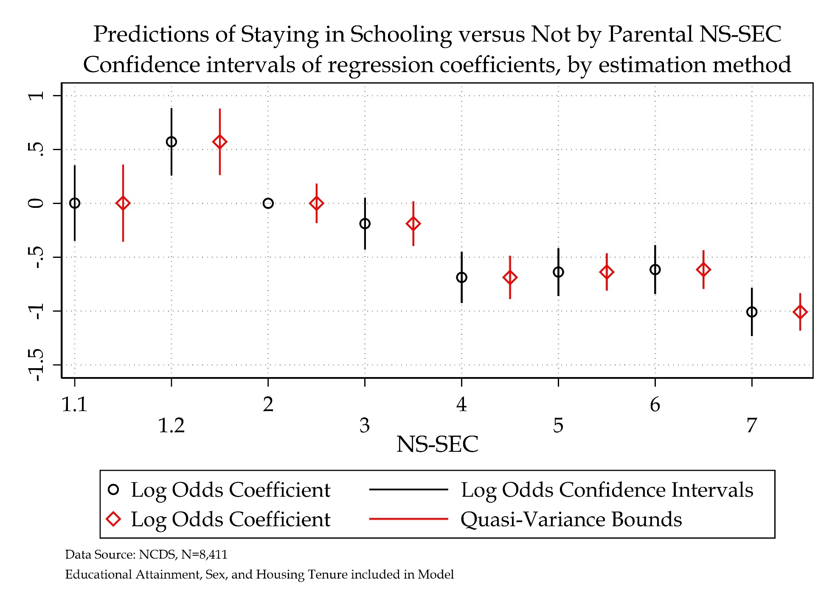

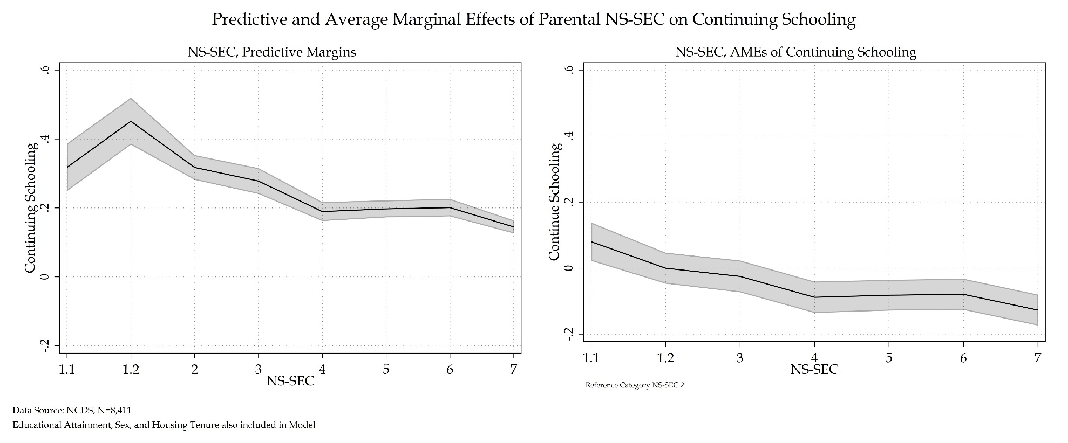

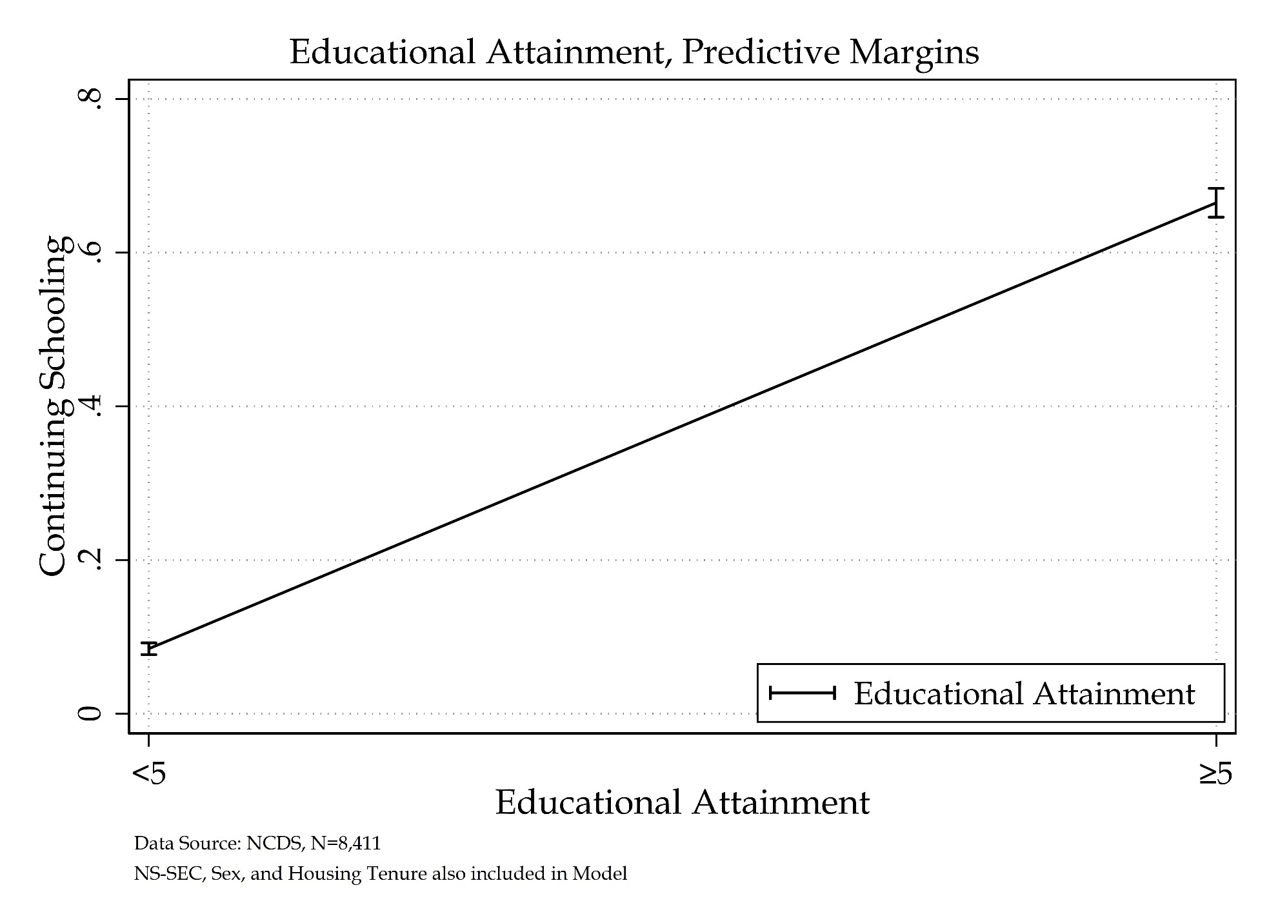

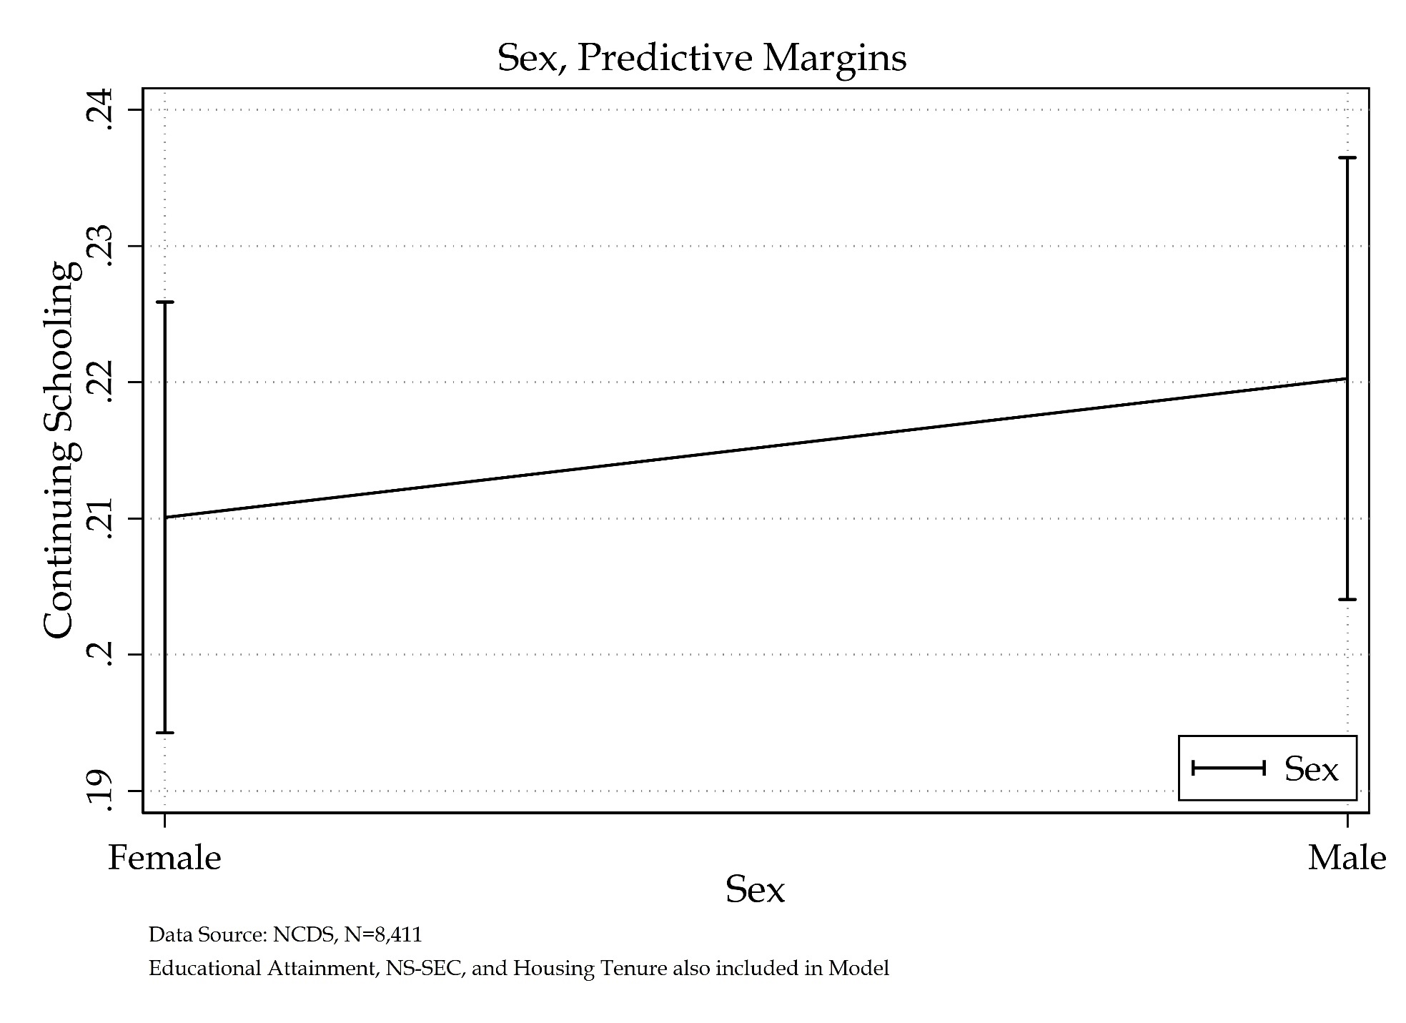

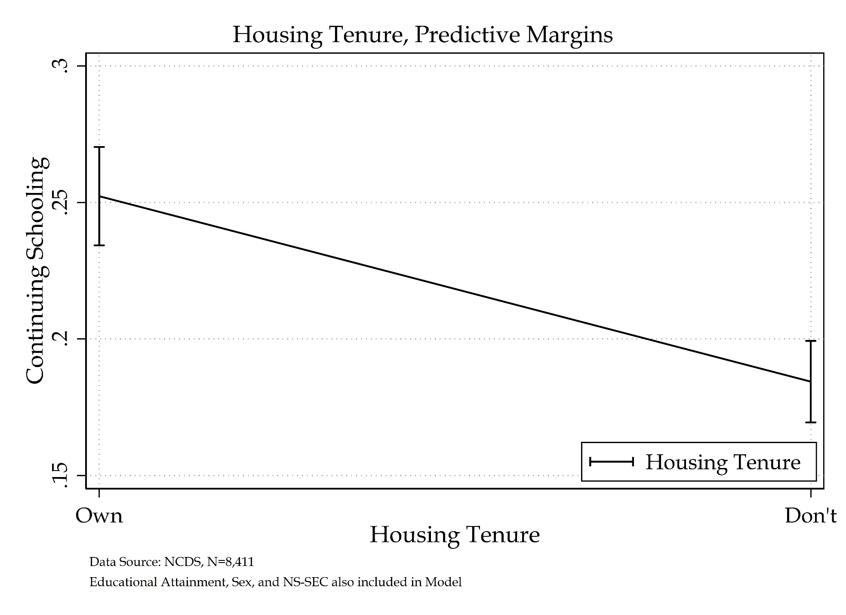

|  |  |  |  |  |  |  |  |  |  |  |  |  |  |  |  |  |  |  |  |  |  |
| --- | --- | --- | --- | --- | --- | --- | --- | --- | --- | --- | --- | --- | --- | --- | --- | --- | --- | --- | --- | --- | --- |
|  | NS-SEC | | | Average Marginal Effects | | Quasi-variance | | | RGSC | | | Average Marginal Effects | | Quasi-variance | | | CAMSIS | | | Average Marginal Effects | |
| Economic Activity: ‘Don’t Continue Schooling’ Reference Category | **Coef.** | **S.E.** | **Sig.** | **Prob.** | **S.E.** | **S.E.** | **LB** | **UB** | **Coef.** | **S.E.** | **Sig.** | **Prob.** | **S.E.** | **S.E.** | **LB** | **UB** | **Coef.** | **S.E.** | **Sig.** | $Δ$**Prob.** | **S.E.** |
| Continue Schooling |  |  |  |  |  |  |  |  |  |  |  |  |  |  |  |  |  |  |  |  |  |
| Educational Attainment |  |  |  |  |  |  |  |  |  |  |  |  |  |  |  |  |  |  |  |  |  |
| *Less than five O’levels* | Ref. | (.) |  | (.) | (.) | (.) | (.) | (.) | (.) | (.) |  | (.) | (.) | (.) | (.) | (.) | (.) | (.) |  | (.) | (.) |
| *Five or More O’levels* | 3.07 | (0.07) | *** | 0.56 | (0.01) | (.) | (.) | (.) | 3.09 | (0.07) | *** | 0.56 | (0.02) | (.) | (.) | (.) | 3.06 | (0.07) | *** | 0.56 | (0.01) |
| Sex |  |  |  |  |  |  |  |  |  |  |  |  |  |  |  |  |  |  |  |  |  |
| *Female* | Ref. | (.) |  | (.) | (.) | (.) | (.) | (.) | (.) | (.) |  | (.) | (.) | (.) | (.) | (.) | (.) | (.) |  | (.) | (.) |
| *Male* | 0.06 | (0.06) |  | 0.01 | (0.01) | (.) | (.) | (.) | 0.06 | (0.06) |  | -0.01 | (0.01) | (.) | (.) | (.) | 0.05 | (0.06) |  | 0.01 | (0.01) |
| Housing Tenure |  |  |  |  |  |  |  |  |  |  |  |  |  |  |  |  |  |  |  |  |  |
| *Own Home* | Ref. | (.) |  | (.) | (.) | (.) | (.) | (.) | (.) | (.) |  | (.) | (.) | (.) | (.) | (.) | (.) | (.) |  | (.) | (.) |
| *Do not Own Home* | -0.40 | (0.07) | *** | -0.05 | (0.01) | (.) | (.) | (.) | -0.43 | (0.07) | *** | -0.05 | (0.01) | (.) | (.) | (.) | -0.38 | (0.07) | *** | -0.04 | (0.01) |
| NS-SEC (SOC 2000) |  |  |  |  |  |  |  |  |  |  |  |  |  |  |  |  |  |  |  |  |  |
| *1.1* | 0.00 | (0.18) |  | 0.00 | (0.02) | 0.16 | -0.36 | 0.36 |  |  |  |  |  |  |  |  |  |  |  |  |  |
| *1.2* | 0.57 | (0.16) | *** | 0.08 | (0.02) | 0.14 | 0.26 | 0.88 |  |  |  |  |  |  |  |  |  |  |  |  |  |
| *2* | Ref. | (.) |  | (.) | (.) | 0.08 | -0.18 | 0.18 |  |  |  |  |  |  |  |  |  |  |  |  |  |
| *3* | -0.19 | (0.12) |  | -0.02 | (0.02) | 0.09 | -0.40 | 0.02 |  |  |  |  |  |  |  |  |  |  |  |  |  |
| *4* | -0.69 | (0.12) | *** | -0.09 | (0.02) | 0.090 | -0.89 | -0.49 |  |  |  |  |  |  |  |  |  |  |  |  |  |
| *5* | -0.64 | (0.11) | *** | -0.08 | (0.01) | 0.08 | -0.81 | -0.46 |  |  |  |  |  |  |  |  |  |  |  |  |  |
| *6* | -0.62 | (0.12) | *** | -0.08 | (0.02) | 0.08 | -0.80 | -0.44 |  |  |  |  |  |  |  |  |  |  |  |  |  |
| *7* | -1.01 | (0.11) | *** | -0.13 | (0.01) | 0.08 | -1.18 | -0.83 |  |  |  |  |  |  |  |  |  |  |  |  |  |
| RGSC (SOC 2000) |  |  |  |  |  |  |  |  |  |  |  |  |  |  |  |  |  |  |  |  |  |
| *1* |  |  |  |  |  |  |  |  | 0.67 | (0.16) | *** | 0.09 | (0.02) | 0.15 | 0.33 | 1.01 |  |  |  |  |  |
| *2* |  |  |  |  |  |  |  |  | Ref. | (.) |  | (.) | (.) | 0.07 | -0.15 | 0.15 |  |  |  |  |  |
| *3NM* |  |  |  |  |  |  |  |  | -0.05 | (0.11) |  | -0.01 | (0.01) | 0.09 | -0.25 | 0.16 |  |  |  |  |  |
| *3M* |  |  |  |  |  |  |  |  | -0.57 | (0.08) | *** | -0.07 | (0.01) | 0.05 | -0.69 | -0.45 |  |  |  |  |  |
| *4* |  |  |  |  |  |  |  |  | -0.62 | (0.11) | *** | -0.08 | (0.01) | 0.09 | -0.83 | -0.41 |  |  |  |  |  |
| *5* |  |  |  |  |  |  |  |  | -0.82 | (0.15) |  | -0.10 | (0.02) | 0.13 | -1.13 | -0.51 |  |  |  |  |  |
| CAMSIS (SOC 2000) |  |  |  |  |  |  |  |  |  |  |  |  |  |  |  |  | 0.03 | (0.00) | *** | 0.00 | (0.00) |
| Intercept | -1.68 | (0.10) | *** |  |  |  |  |  | -1.82 | (0.09) | *** |  |  |  |  |  | -3.56 | (0.14) | *** |  |  |
| Number of observations | 8411 | | | | | | | | 8411 | | | | | | | | 8411 | | | | |
| McFadden’s $R^{2}$ | 0.38 | | | | | | | | 0.38 | | | | | | | | 0.38 | | | | |
| McFadden’s Adjusted Pseudo $R^{2}$ | 0.38 | | | | | | | | 0.38 | | | | | | | | 0.38 | | | | |
| Cox-Snell Pseudo $R^{2}$ | 0.38 | | | | | | | | 0.37 | | | | | | | | 0.37 | | | | |
| Nagelkerke Pseudo $R^{2}$ | 0.53 | | | | | | | | 0.53 | | | | | | | | 0.53 | | | | |
| Tjur’s $R^{2}$ | 0.45 | | | | | | | | 0.45 | | | | | | | | 0.45 | | | | |
| AIC | 6391.02 | | | | | | | | 6428.37 | | | | | | | | 6390.51 | | | | |
| BIC | 6468.43 | | | | | | | | 6491.71 | | | | | | | | 6425.69 | | | | |
| *** p<.001, ** p<.01, * p<.05 Data Source: NCDS [Sweeps 0-4]  Note: Sensitivity Analysis of Social Stratification Measures | | | | | | | | | | | | | | | | | | | | | |

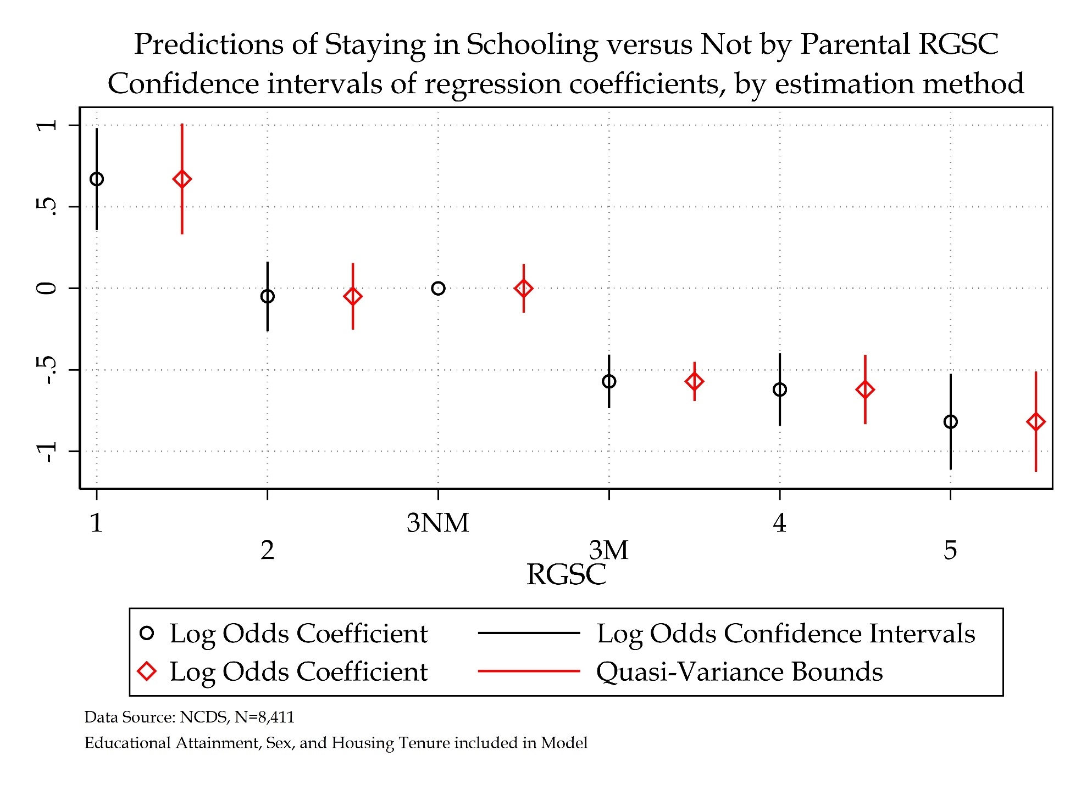

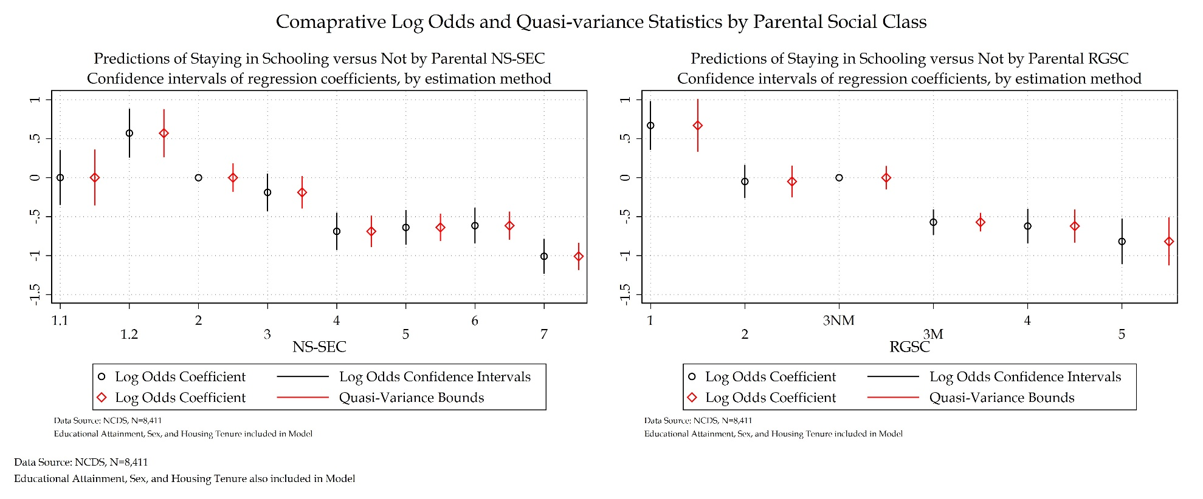

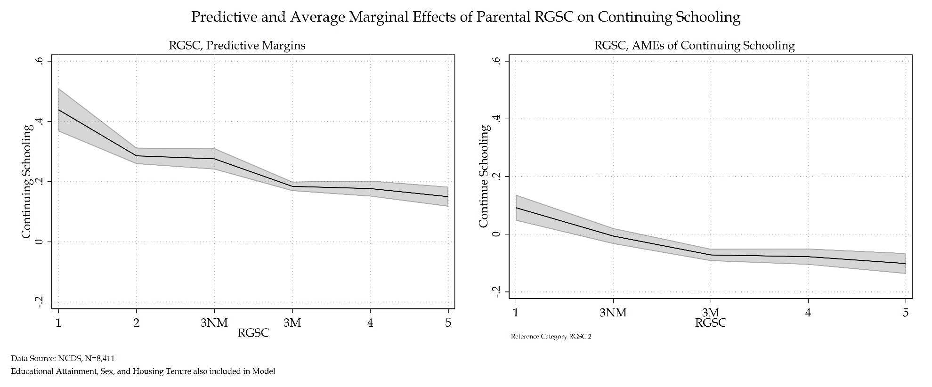

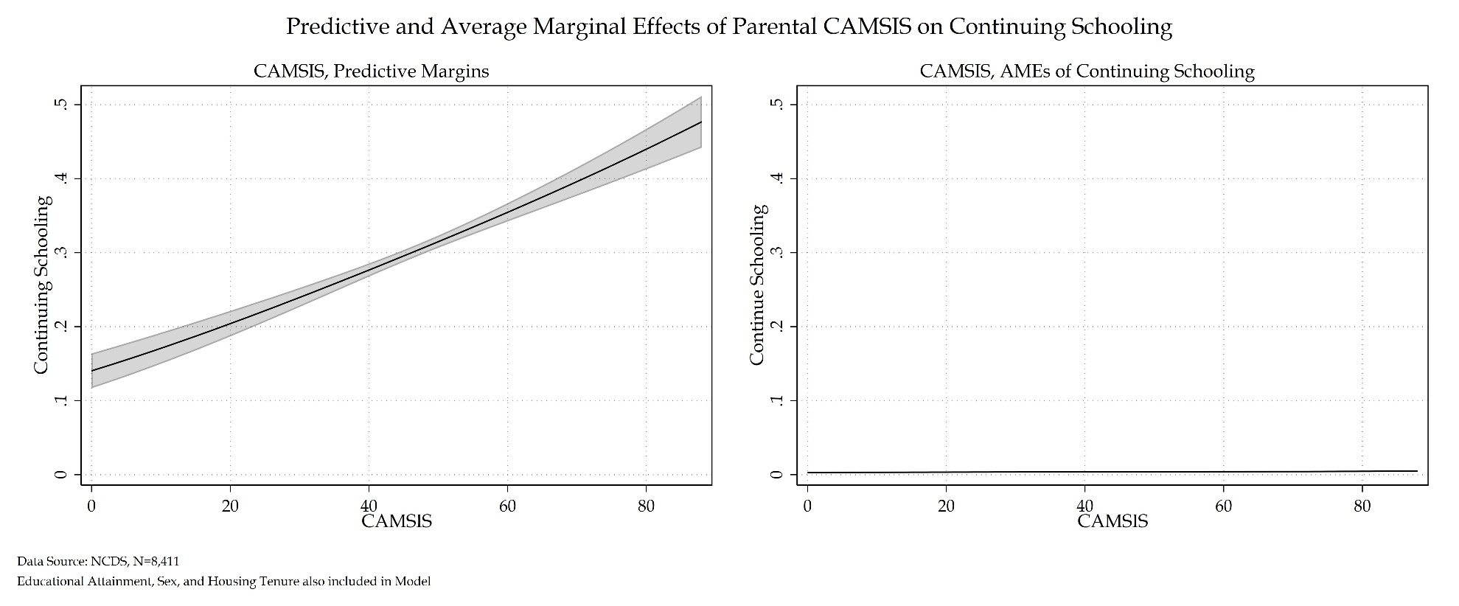

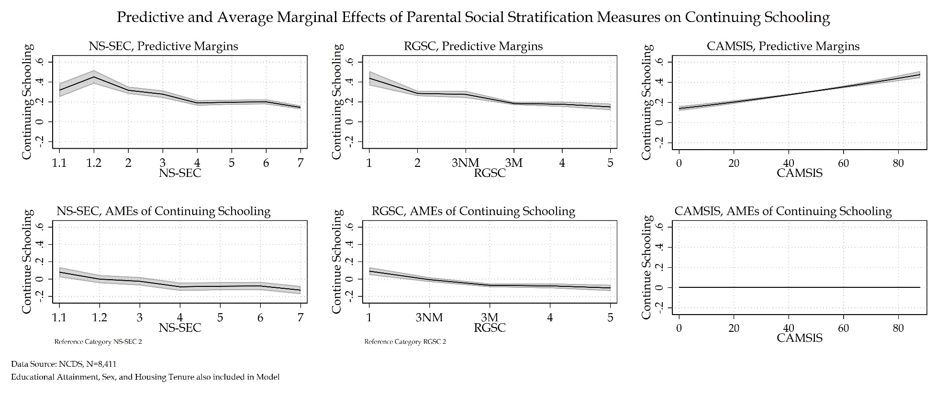

|  |  |  |  |  |  |  |
| --- | --- | --- | --- | --- | --- | --- |
| Outcome Variable: Economic Activity | Deviance | $Δ$ Deviance (from Null) | $Δ$ d. f. (from Null) | McFadden’s Pseudo $R^{2}$ | AIC | BIC |
| Null Model | 10322.47 | - | - | - | 10324.47 | 10331.50 |
| Null Model + Educational Attainment | 6630.52 | 3,691.95 | 2 | 0.36 | 6634.52 | 6648.60 |
| Null Model + Sex | 10322.45 | 0.02 | 2 | 0.00 | 10326.45 | 10340.53 |
| Null Model + Tenure | 9734.07 | 588.40 | 2 | 0.06 | 9738.07 | 9752.15 |
| Null Model + NS-SEC (SOC 90) | 9596.03 | 726.44 | 8 | 0.07 | 9600.03 | 9614.11 |

|  |  |  |  |  |  |  |
| --- | --- | --- | --- | --- | --- | --- |
| Outcome Variable: Economic Activity | Deviance | $Δ$ Deviance (from Previous) | $Δ$ d. f. (from Previous) | McFadden’s Pseudo $R^{2}$ | AIC | BIC |
| Null Model | 10322.47 | - | - | - | 10324.47 | 10331.50 |
| Null Model + Educational Attainment | 6630.52 | 3,691.95 | 2 | 0.36 | 6634.52 | 6648.60 |
| Null Model + Educational Attainment + Sex | 6628.73 | 1.793 | 2 | 0.36 | 6634.73 | 6655.84 |
| Null Model + Educational Attainment + Sex + Tenure | 6531.31 | 97.42 | 2 | 0.37 | 6539.31 | 6567.46 |
| Null Model + Educational Attainment + Sex + Tenure + NS-SEC (SOC 90) | 6426.61 | 104.7 | 8 | 0.38 | 6448.61 | 6526.02 |

|  |  |  |  |  |  |  |  |  |  |  |  |  |  |  |  |  |
| --- | --- | --- | --- | --- | --- | --- | --- | --- | --- | --- | --- | --- | --- | --- | --- | --- |
|  | NS-SEC (SOC200) | | | Average Marginal Effects | | Quasi-variance | | | NS-SEC (SOC 90) | | | Average Marginal Effects | | Quasi-variance | | |
| Economic Activity: ‘Don’t Continue Schooling’ Reference Category | Coef. | S.E. | Sig. | Prob. | S.E. | S.E. | LB | UB | Coef. | S.E. | Sig. | $Δ$ Prob. | S.E. | S.E. | LB | UB |
| Continue Schooling |  |  |  |  |  |  |  |  |  |  |  |  |  |  |  |  |
| Educational Attainment |  |  |  |  |  |  |  |  |  |  |  |  |  |  |  |  |
| Less than five O’levels | Ref. | (.) |  | (.) | (.) | (.) | (.) | (.) | (.) | (.) |  | (.) | (.) | (.) | (.) | (.) |
| Five or More O’levels | 3.07 | (0.07) | *** | 0.56 | (0.01) | (.) | (.) | (.) | 3.10 | (0.07) | *** | 0.57 | (0.02) | (.) | (.) | (.) |
| Sex |  |  |  |  |  |  |  |  |  |  |  |  |  |  |  |  |
| Female | Ref. | (.) |  | (.) | (.) | (.) | (.) | (.) | (.) | (.) |  | (.) | (.) | (.) | (.) | (.) |
| Male | 0.06 | (0.06) |  | 0.01 | (0.01) | (.) | (.) | (.) | 0.06 | (0.06) |  | 0.01 | (0.01) | (.) | (.) | (.) |
| Housing Tenure |  |  |  |  |  |  |  |  |  |  |  |  |  |  |  |  |
| Own Home | Ref. | (.) |  | (.) | (.) | (.) | (.) | (.) | (.) | (.) |  | (.) | (.) | (.) | (.) | (.) |
| Do not Own Home | -0.40 | (0.07) | *** | -0.05 | (0.01) | (.) | (.) | (.) | -0.46 | (0.07) | *** | -0.06 | (0.01) | (.) | (.) | (.) |
| NS-SEC |  |  |  |  |  |  |  |  |  |  |  |  |  |  |  |  |
| 1.1 | 0.00 | (0.18) |  | 0.00 | (0.02) | 0.16 | -0.36 | 0.36 | -0.03 | (0.84) |  | -0.00 | (0.11) | 0.83 | -1.89 | 1.82 |
| 1.2 | 0.57 | (0.16) | *** | 0.08 | (0.02) | 0.14 | 0.26 | 0.88 | 0.43 | (0.18) | * | 0.06 | (0.02) | 0.1478 | 0.10 | 0.76 |
| 2 | Ref. | (.) |  | (.) | (.) | 0.08 | -0.18 | 0.18 | (.) | (.) |  | (.) | (.) | 0.11 | -0.23 | 0.23 |
| 3 | -0.19 | (0.12) |  | -0.02 | (0.02) | 0.09 | -0.40 | 0.02 | -0.14 | (0.13) |  | -0.02 | (0.02) | 0.09 | -0.34 | 0.06 |
| 4 | -0.69 | (0.12) | *** | -0.09 | (0.02) | 0.090 | -0.89 | -0.49 | -0.57 | (0.15) | *** | -0.07 | (0.02) | 0.11 | -0.82 | -0.33 |
| 5 | -0.64 | (0.11) | *** | -0.08 | (0.01) | 0.08 | -0.81 | -0.46 | -0.60 | (0.13) | *** | -0.08 | (0.02) | 0.08 | -0.77 | -0.43 |
| 6 | -0.62 | (0.12) | *** | -0.08 | (0.02) | 0.08 | -0.80 | -0.44 | -0.48 | (0.12) | *** | -0.06 | (0.02) | 0.06 | -0.62 | -0.34 |
| 7 | -1.01 | (0.11) | *** | -0.13 | (0.01) | 0.08 | -1.18 | -0.83 | -0.87 | (0.12) | *** | -0.11 | (0.02) | 0.07 | -1.03 | -0.71 |
| Intercept | -1.68 | (0.10) | *** |  |  |  |  |  | -1.68 | (0.12) | *** |  |  |  |  |  |
| Number of observations | 8411 | | | | | | | | 8411 | | | | | | | |
| McFadden’s $R^{2}$ | 0.38 | | | | | | | | 0.38 | | | | | | | |
| McFadden’s Adjusted Pseudo $R^{2}$ | 0.38 | | | | | | | | 0.38 | | | | | | | |
| Cox-Snell Pseudo $R^{2}$ | 0.38 | | | | | | | | 0.37 | | | | | | | |
| Nagelkerke Pseudo $R^{2}$ | 0.53 | | | | | | | | 0.52 | | | | | | | |
| Tjur’s $R^{2}$ | 0.45 | | | | | | | | 0.45 | | | | | | | |
| AIC | 6391.02 | | | | | | | | 6448.61 | | | | | | | |
| BIC | 6468.43 | | | | | | | | 6526.02 | | | | | | | |
| *** p<.001, ** p<.01, * p<.05 Data Source: NCDS [Sweeps 0-4]  Note: Sensitivity Analysis of Social Stratification Measures | | | | | | | | | | | | | | | | |

Appendix:

|  |  |  |  |  |  |  |
| --- | --- | --- | --- | --- | --- | --- |
| Outcome Variable: Economic Activity | Deviance | $Δ$ Deviance (from Null) | $Δ$ d. f. (from Null) | McFadden’s Pseudo $R^{2}$ | AIC | BIC |
| Null Model | 10322.47 | - | - | - | 10324.47 | 10331.50 |
| Null Model + Educational Attainment | 6630.52 | 3,691.95 | 2 | 0.36 | 6634.52 | 6648.60 |
| Null Model + Sex | 10322.45 | 0.02 | 2 | 0.00 | 10326.45 | 10340.53 |
| Null Model + Tenure | 9734.07 | 588.40 | 2 | 0.06 | 9738.07 | 9752.15 |
| Null Model + RGSC (SOC 90) | 9607.20 | 715.27 | 6 | 0.07 | 9619.20 | 9661.42 |

|  |  |  |  |  |  |  |
| --- | --- | --- | --- | --- | --- | --- |
| Outcome Variable: Economic Activity | Deviance | $Δ$ Deviance (from Previous) | $Δ$ d. f. (from Previous) | McFadden’s Pseudo $R^{2}$ | AIC | BIC |
| Null Model | 10322.47 | - | - | - | 10324.47 | 10331.50 |
| Null Model + Educational Attainment | 6630.52 | 3,691.95 | 2 | 0.36 | 6634.52 | 6648.60 |
| Null Model + Educational Attainment + Sex | 6628.73 | 1.793 | 2 | 0.36 | 6634.73 | 6655.84 |
| Null Model + Educational Attainment + Sex + Tenure | 6531.31 | 97.42 | 2 | 0.37 | 6539.31 | 6567.46 |
| Null Model + Educational Attainment + Sex + Tenure + RGSC (SOC 90) | 6437.65 | 93.66 | 6 | 0.38 | 6455.65 | 6518.98 |

|  |  |  |  |  |  |  |
| --- | --- | --- | --- | --- | --- | --- |
| Outcome Variable: Economic Activity | Deviance | $Δ$ Deviance (from Null) | $Δ$ d. f. (from Null) | McFadden’s Pseudo $R^{2}$ | AIC | BIC |
| Null Model | 10322.47 | - | - | - | 10324.47 | 10331.50 |
| Null Model + Educational Attainment | 6630.52 | 3,691.95 | 2 | 0.36 | 6634.52 | 6648.60 |
| Null Model + Sex | 10322.45 | 0.02 | 2 | 0.00 | 10326.45 | 10340.53 |
| Null Model + Tenure | 9734.07 | 588.40 | 2 | 0.06 | 9738.07 | 9752.15 |
| Null Model + CAMSIS (SOC 90) | 9614.39 | 708.08 | 2 | 0.07 | 9618.39 | 9632.47 |

|  |  |  |  |  |  |  |
| --- | --- | --- | --- | --- | --- | --- |
| Outcome Variable: Economic Activity | Deviance | $Δ$ Deviance (from Previous) | $Δ$ d. f. (from Previous) | McFadden’s Pseudo $R^{2}$ | AIC | BIC |
| Null Model | 10322.47 | - | - | - | 10324.47 | 10331.50 |
| Null Model + Educational Attainment | 6630.52 | 3,691.95 | 2 | 0.36 | 6634.52 | 6648.60 |
| Null Model + Educational Attainment + Sex | 6628.73 | 1.793 | 2 | 0.36 | 6634.73 | 6655.84 |
| Null Model + Educational Attainment + Sex + Tenure | 6531.31 | 97.42 | 2 | 0.37 | 6539.31 | 6567.46 |
| Null Model + Educational Attainment + Sex + Tenure + CAMSIS (SOC 90) | 6426.61 | 104.7 | 8 | 0.38 | 6448.61 | 6526.02 |

|  |  |  |  |  |  |  |  |  |  |  |  |  |  |  |  |  |
| --- | --- | --- | --- | --- | --- | --- | --- | --- | --- | --- | --- | --- | --- | --- | --- | --- |
|  | RGSC (SOC 2000) | | | Average Marginal Effects | | Quasi-variance | | | RGSC (SOC 90) | | | Average Marginal Effects | | Quasi-variance | | |
| Economic Activity: ‘Don’t Continue Schooling’ Reference Category | **Coef.** | **S.E.** | **Sig.** | **Prob.** | **S.E.** | **S.E.** | **LB** | **UB** | **Coef.** | **S.E.** | **Sig.** | $Δ$**Prob.** | **S.E.** | **S.E.** | **LB** | **UB** |
| Continue Schooling |  |  |  |  |  |  |  |  |  |  |  |  |  |  |  |  |
| Educational Attainment |  |  |  |  |  |  |  |  |  |  |  |  |  |  |  |  |
| *Less than five O’levels* | Ref. | (.) |  | (.) | (.) | (.) | (.) | (.) | (.) | (.) |  | (.) | (.) | (.) | (.) | (.) |
| *Five or More O’levels* | 3.09 | (0.07) | *** | 0.56 | (0.02) | (.) | (.) | (.) | 3.11 | (0.07) | *** | 0.58 | (0.01) | (.) | (.) | (.) |
| Sex |  |  |  |  |  |  |  |  |  |  |  |  |  |  |  |  |
| *Female* | Ref. | (.) |  | (.) | (.) | (.) | (.) | (.) | (.) | (.) |  | (.) | (.) | (.) | (.) | (.) |
| *Male* | 0.06 | (0.06) |  | -0.01 | (0.01) | (.) | (.) | (.) | 0.06 | (0.06) |  | 0.01 | (0.01) | (.) | (.) | (.) |
| Housing Tenure |  |  |  |  |  |  |  |  |  |  |  |  |  |  |  |  |
| *Own Home* | Ref. | (.) |  | (.) | (.) | (.) | (.) | (.) | (.) | (.) |  | (.) | (.) | (.) | (.) | (.) |
| *Do not Own Home* | -0.43 | (0.07) | *** | -0.05 | (0.01) | (.) | (.) | (.) | -0.50 | (0.07) | *** | -0.06 | (0.01) | (.) | (.) | (.) |
| RGSC (SOC 2000) |  |  |  |  |  |  |  |  |  |  |  |  |  |  |  |  |
| *1* | 0.67 | (0.16) | *** | 0.09 | (0.02) | 0.15 | 0.33 | 1.01 | 0.34 | (0.19) |  | 0.05 | (0.03) | 0.16 | -0.03 | 0.70 |
| *2* | Ref. | (.) |  | (.) | (.) | 0.07 | -0.15 | 0.15 | Ref. | (.) |  | (.) | (.) | 0.11 | -0.24 | 0.24 |
| *3NM* | -0.05 | (0.11) |  | -0.01 | (0.01) | 0.09 | -0.25 | 0.16 | -0.39 | (0.13) | ** | -0.05 | (0.02) | 0.08 | -0.58 | -0.21 |
| *3M* | -0.57 | (0.08) | *** | -0.07 | (0.01) | 0.05 | -0.69 | -0.45 | -0.85 | (0.12) | *** | -0.11 | (0.02) | 0.06 | -1.00 | -0.71 |
| *4* | -0.62 | (0.11) | *** | -0.08 | (0.01) | 0.09 | -0.83 | -0.41 | -0.69 | (0.12) | *** | -0.09 | (0.02) | 0.05 | -0.82 | -0.57 |
| *5* | -0.82 | (0.15) |  | -0.10 | (0.02) | 0.13 | -1.13 | -0.51 | -0.72 | (0.16) | *** | -0.09 | (0.02) | 0.11 | -0.98 | -0.46 |
| Intercept | -1.82 | (0.09) | *** |  |  |  |  |  | -1.68 | (0.10) | *** |  |  |  |  |  |
| Number of observations | 8411 | | | | | | | | 8411 | | | | | | | |
| McFadden’s $R^{2}$ | 0.38 | | | | | | | | 0.38 | | | | | | | |
| McFadden’s Adjusted Pseudo $R^{2}$ | 0.38 | | | | | | | | 0.37 | | | | | | | |
| Cox-Snell Pseudo $R^{2}$ | 0.37 | | | | | | | | 0.37 | | | | | | | |
| Nagelkerke Pseudo $R^{2}$ | 0.53 | | | | | | | | 0.52 | | | | | | | |
| Tjur’s $R^{2}$ | 0.45 | | | | | | | | 0.45 | | | | | | | |
| AIC | 6428.37 | | | | | | | | 6391.02 | | | | | | | |
| BIC | 6491.71 | | | | | | | | 6468.43 | | | | | | | |
| *** p<.001, ** p<.01, * p<.05 Data Source: NCDS [Sweeps 0-4]  Note: Sensitivity Analysis of Social Stratification Measures | | | | | | | | | | | | | | | | |

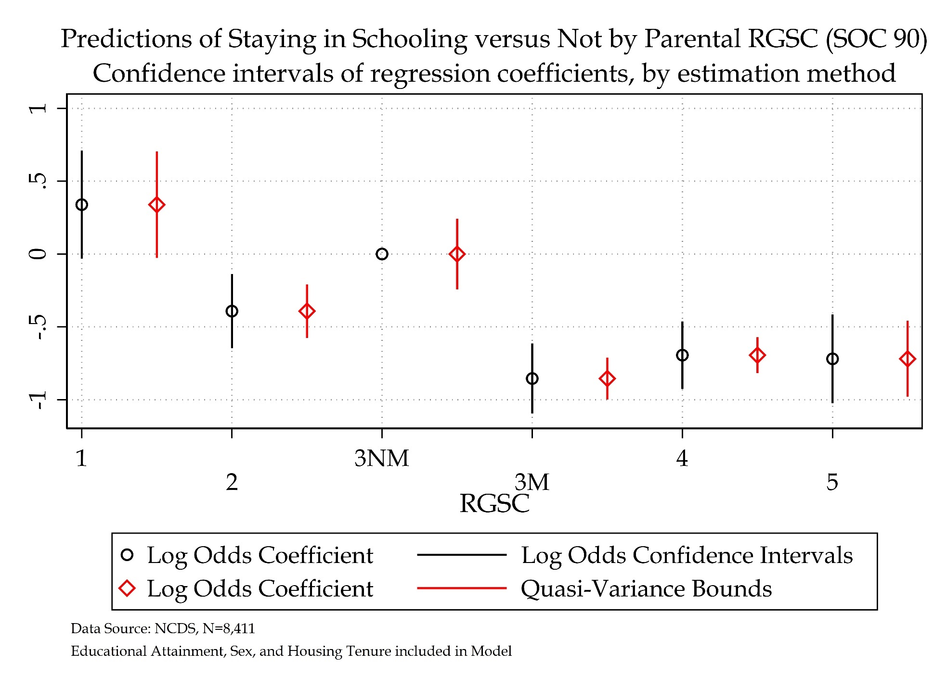

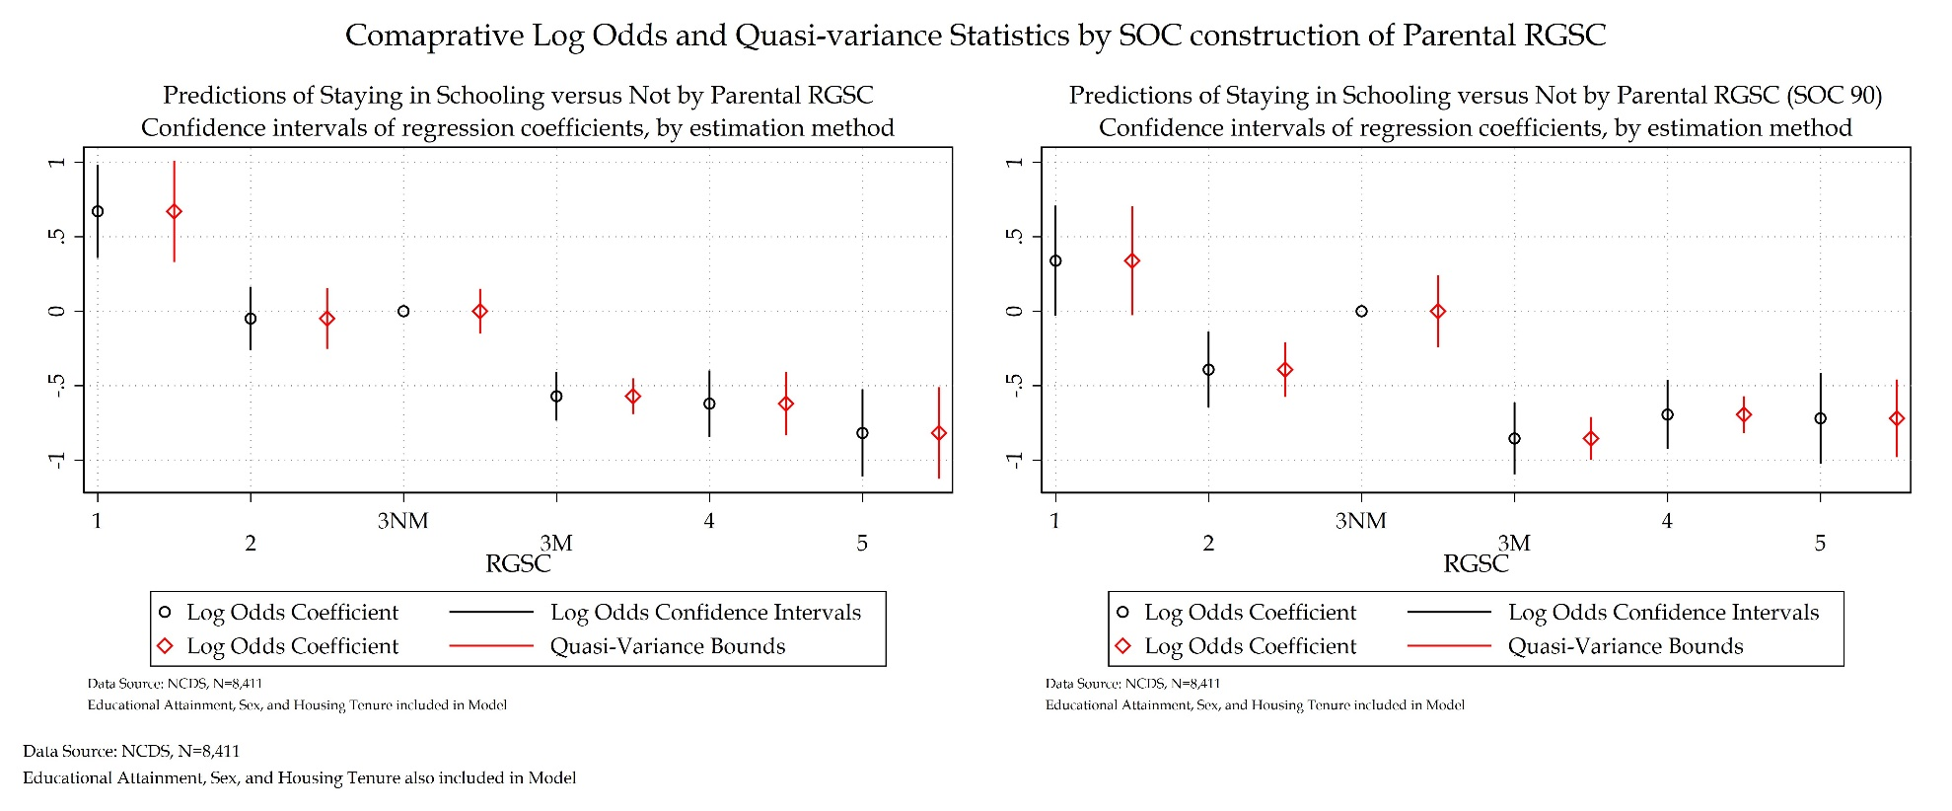

|  |  |  |  |  |  |  |  |  |  |  |
| --- | --- | --- | --- | --- | --- | --- | --- | --- | --- | --- |
|  | CAMSIS (SOC 2000) | | | Average Marginal Effects | | CAMSIS (SOC 90) | | | Average Marginal Effects | |
| Economic Activity: ‘Don’t Continue Schooling’ Reference Category | **Coef.** | **S.E.** | **Sig.** | **Prob.** | **S.E.** | **Coef.** | **S.E.** | **Sig.** | $Δ$**Prob.** | **S.E.** |
| Continue Schooling |  |  |  |  |  |  |  |  |  |  |
| Educational Attainment |  |  |  |  |  |  |  |  |  |  |
| *Less than five O’levels* | Ref. | (.) |  | (.) | (.) | (.) | (.) |  | (.) | (.) |
| *Five or More O’levels* | 3.06 | (0.07) | *** | 0.56 | (0.01) | 3.11 | (0.07) | *** | 0.57 | (0.01) |
| Sex |  |  |  |  |  |  |  |  |  |  |
| *Female* | Ref. | (.) |  | (.) | (.) | (.) | (.) |  | (.) | (.) |
| *Male* | 0.05 | (0.06) |  | 0.01 | (0.01) | 0.06 | (0.06) |  | 0.01 | (0.01) |
| Housing Tenure |  |  |  |  |  |  |  |  |  |  |
| *Own Home* | Ref. | (.) |  | (.) | (.) | (.) | (.) |  | (.) | (.) |
| *Do not Own Home* | -0.38 | (0.07) | *** | -0.04 | (0.01) | -0.48 | (0.07) | *** | -0.06 | (0.01) |
| CAMSIS (SOC 2000) | 0.03 | (0.00) | *** | 0.00 | (0.00) | 0.02 | (0.00) | *** | 0.00 | (0.00) |
| Intercept | -3.56 | (0.14) | *** |  |  |  |  |  |  |  |
| Number of observations | 8411 | | | | | 8411 | | | | |
| McFadden’s $R^{2}$ | 0.38 | | | | | 0.38 | | | | |
| McFadden’s Adjusted Pseudo $R^{2}$ | 0.38 | | | | | 0.37 | | | | |
| Cox-Snell Pseudo $R^{2}$ | 0.37 | | | | | 0.37 | | | | |
| Nagelkerke Pseudo $R^{2}$ | 0.53 | | | | | 0.52 | | | | |
| Tjur’s $R^{2}$ | 0.45 | | | | | 0.45 | | | | |
| AIC | 6390.51 | | | | | 6450.80 | | | | |
| BIC | 6425.69 | | | | | 6485.99 | | | | |
| *** p<.001, ** p<.01, * p<.05 Data Source: NCDS [Sweeps 0-4]  Note: Sensitivity Analysis of Social Stratification Measures | | | | | | | | | | |

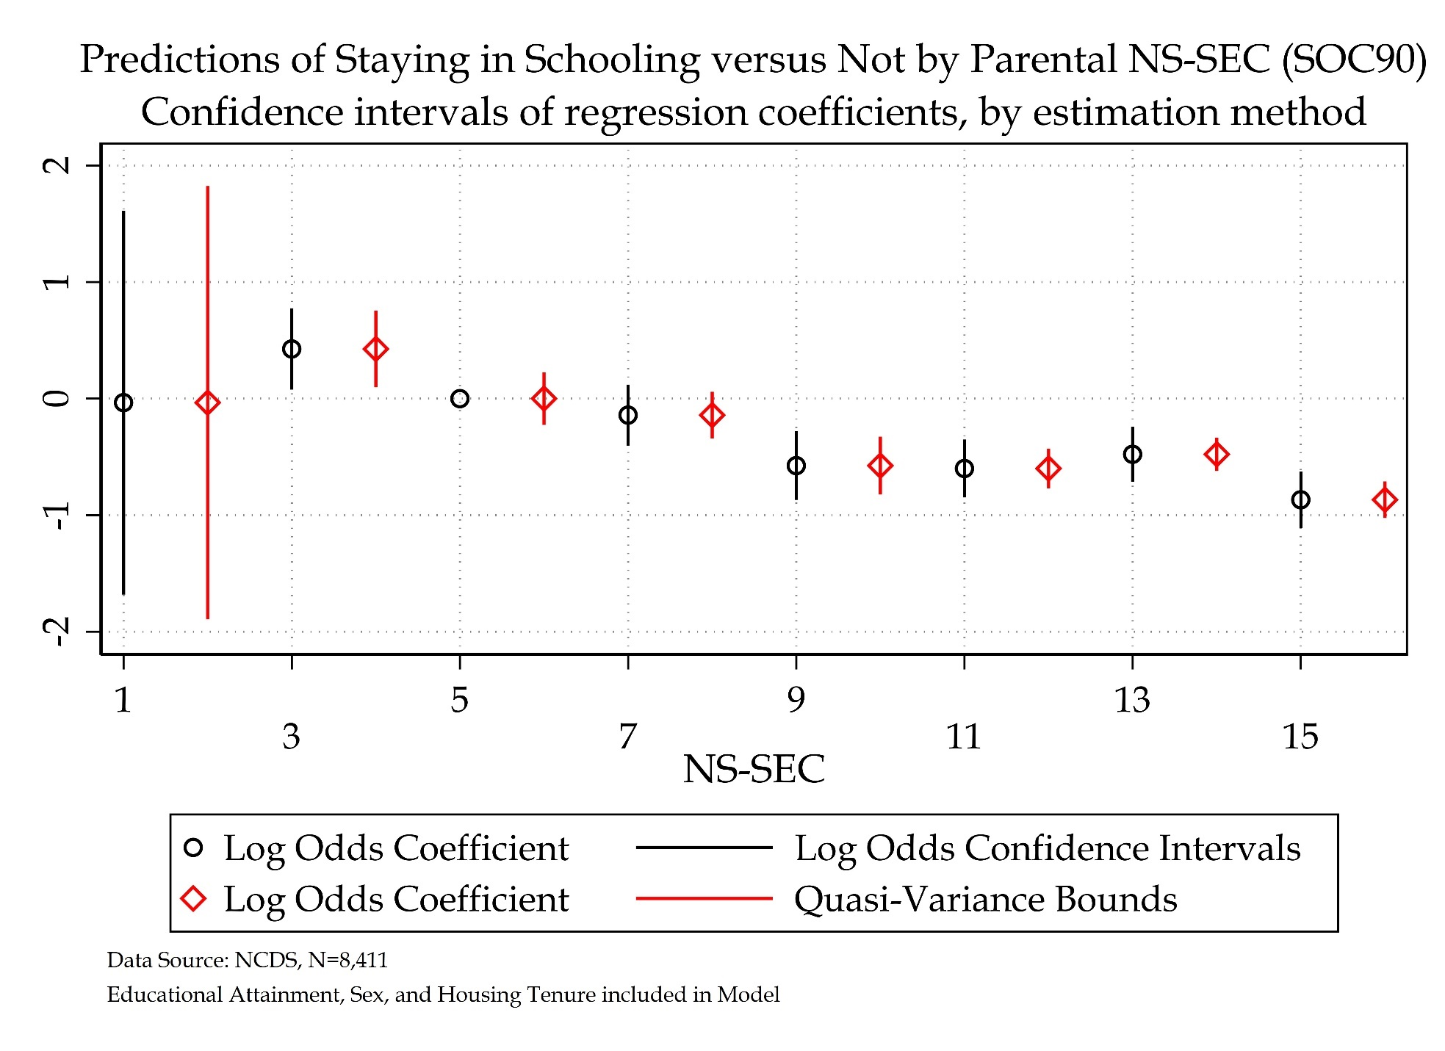

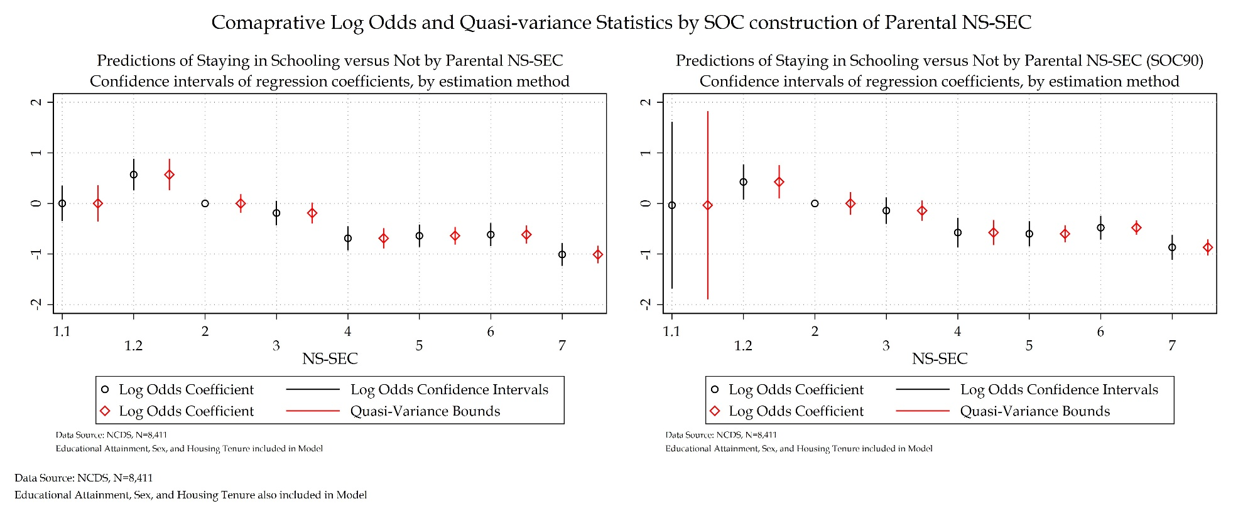

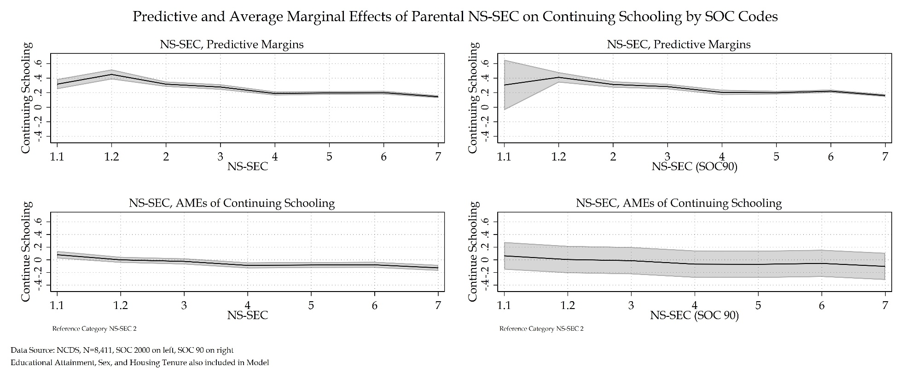

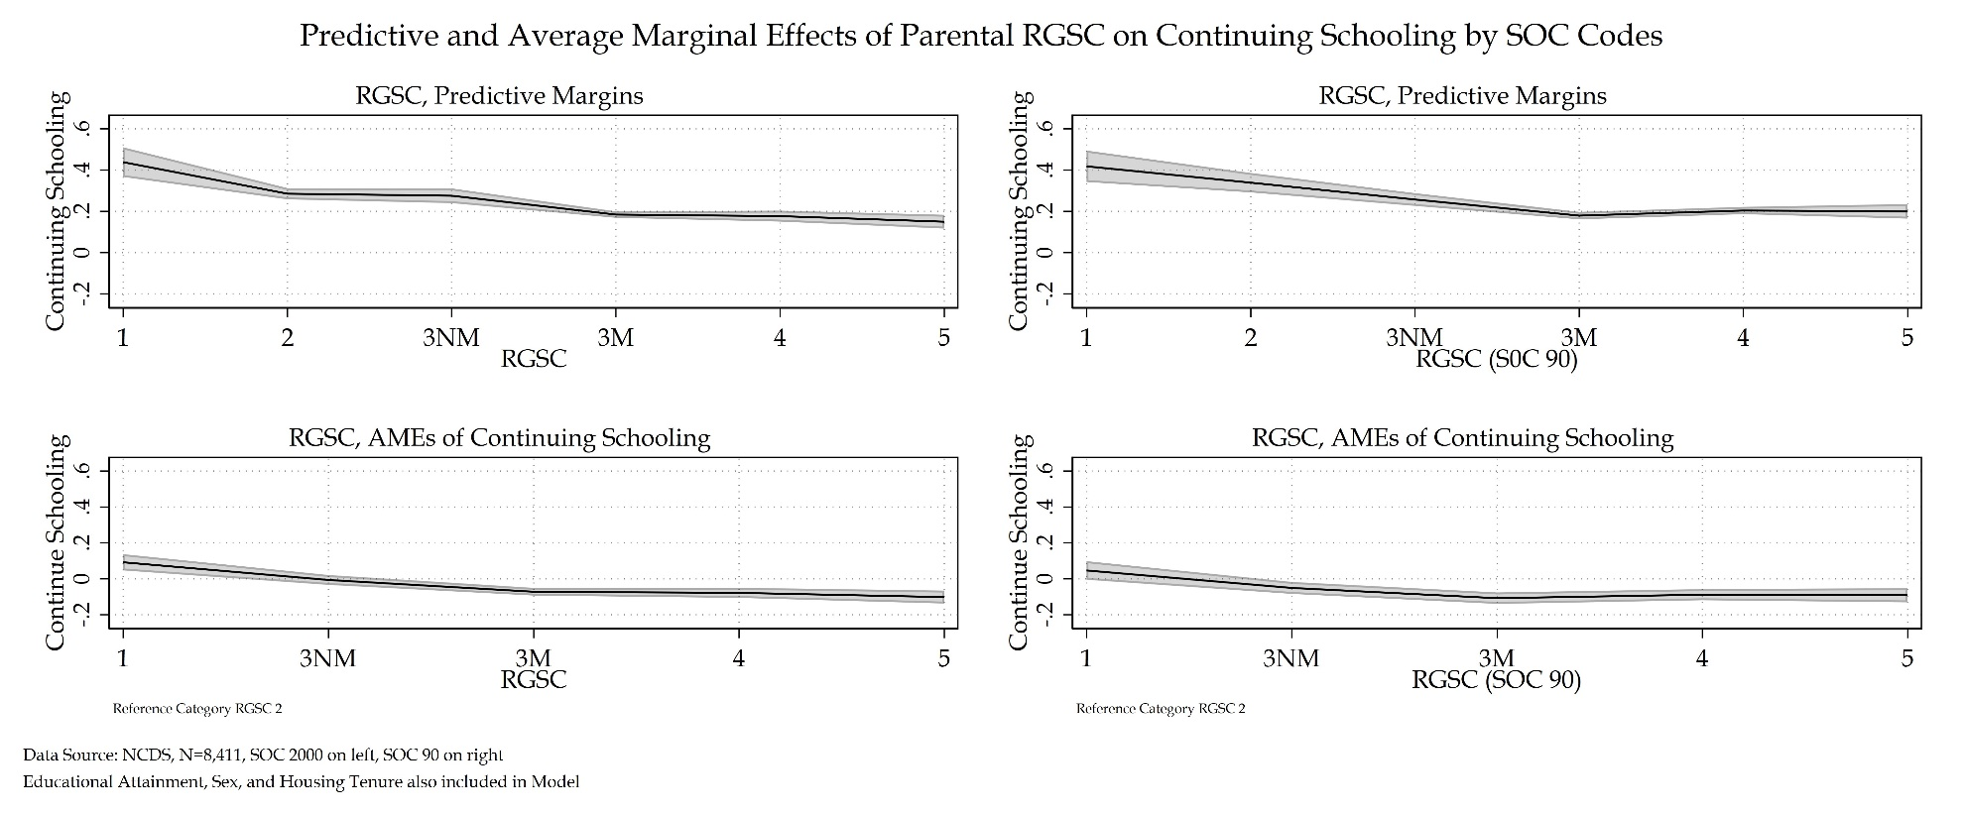

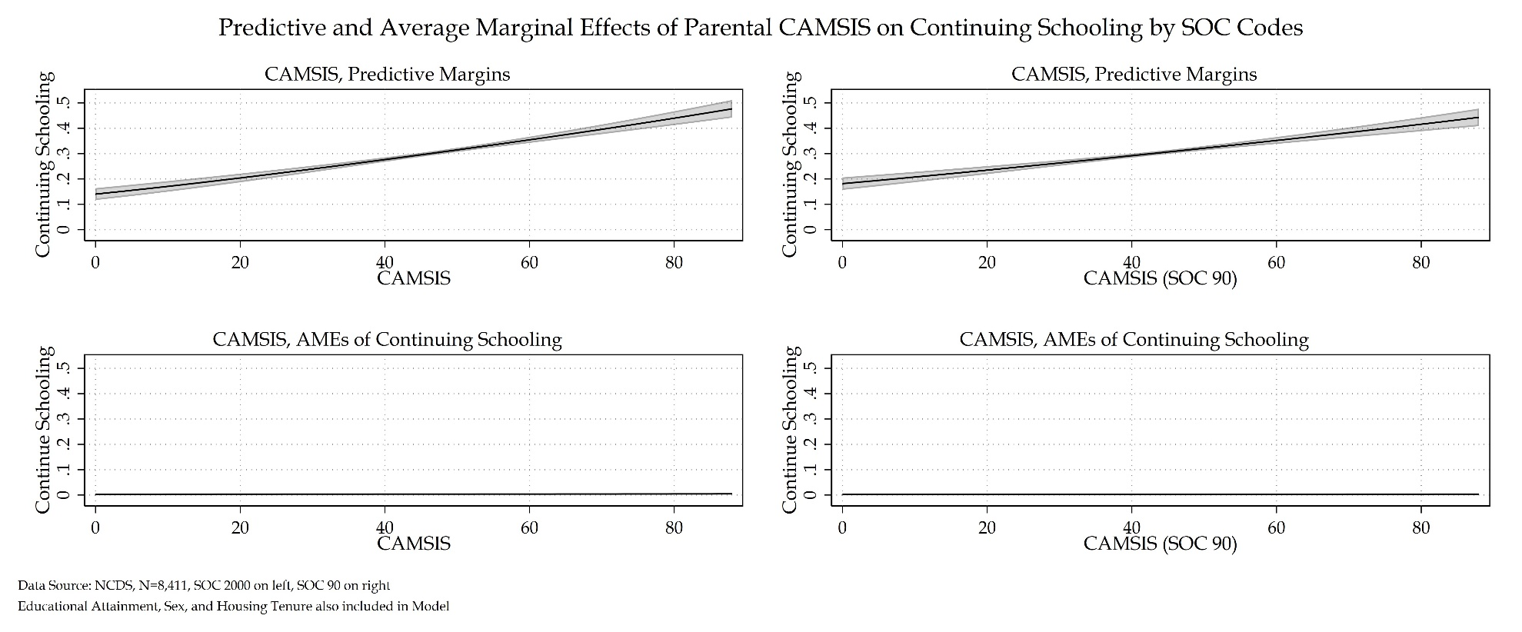

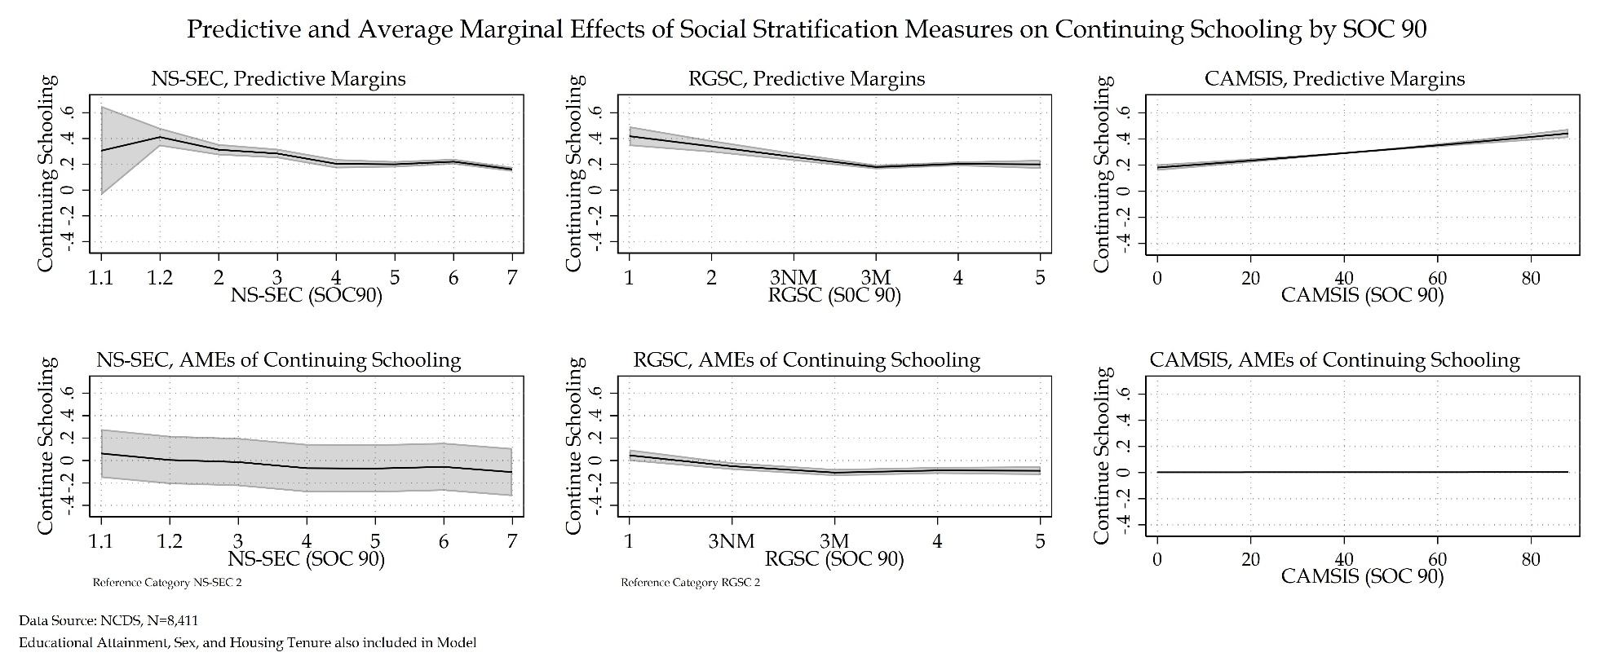

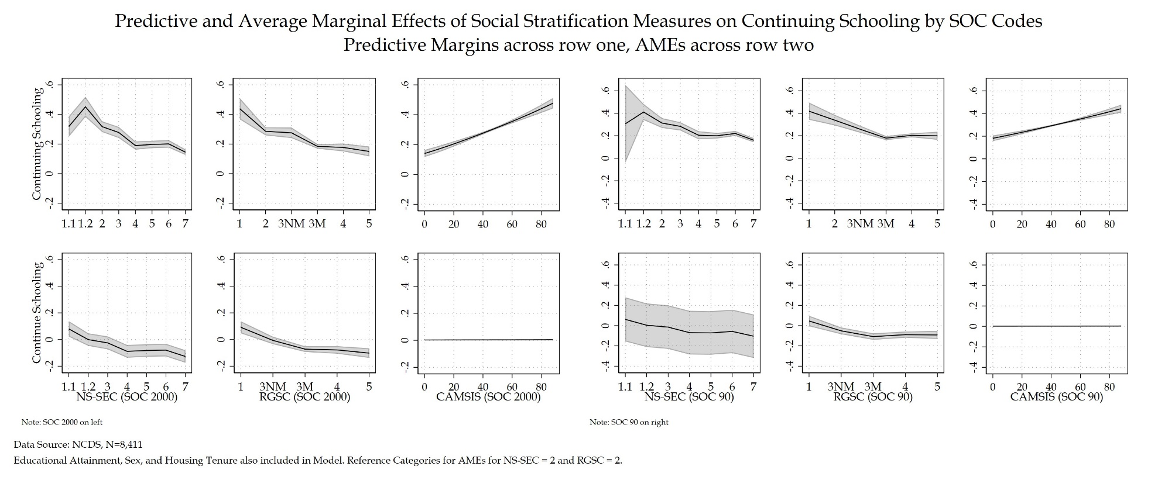

|  |  |  |  |  |  |  |  |  |  |  |
| --- | --- | --- | --- | --- | --- | --- | --- | --- | --- | --- |
|  | NS-SEC (SOC200) CRA | | | Average Marginal Effects | | NS-SEC (SOC 2000) MI | | | Average Marginal Effects | |
| Economic Activity: ‘Don’t Continue Schooling’ Reference Category | Coef. | S.E. | Sig. | Prob. | S.E. | Coef. | S.E. | Sig. | $Δ$ Prob. | S.E. |
| Continue Schooling |  |  |  |  |  |  |  |  |  |  |
| Educational Attainment |  |  |  |  |  |  |  |  |  |  |
| Less than five O’levels | Ref. | (.) |  | (.) | (.) | (.) | (.) |  | (.) | (.) |
| Five or More O’levels | 3.07 | (0.07) | *** | 0.56 | (0.01) | 3.04 | (0.05) | *** | 0.56 | (0.01) |
| Sex |  |  |  |  |  |  |  |  |  |  |
| Female | Ref. | (.) |  | (.) | (.) | (.) | (.) |  | (.) | (.) |
| Male | 0.06 | (0.06) |  | 0.01 | (0.01) | 0.10 | (0.05) |  | 0.01 | (0.01) |
| Housing Tenure |  |  |  |  |  |  |  |  |  |  |
| Own Home | Ref. | (.) |  | (.) | (.) | (.) | (.) |  | (.) | (.) |
| Do not Own Home | -0.40 | (0.07) | *** | -0.05 | (0.01) | -0.39 | (0.06) | *** | -0.05 | (0.01) |
| NS-SEC |  |  |  |  |  |  |  |  |  |  |
| 1.1 | 0.00 | (0.18) |  | 0.00 | (0.02) | 0.05 | (0.17) |  | 0.01 | (0.02) |
| 1.2 | 0.57 | (0.16) | *** | 0.08 | (0.02) | 0.58 | (0.15) | *** | 0.08 | (0.02) |
| 2 | Ref. | (.) |  | (.) | (.) | (.) | (.) |  | (.) | (.) |
| 3 | -0.19 | (0.12) |  | -0.02 | (0.02) | -0.17 | (0.12) |  | -0.02 | (0.02) |
| 4 | -0.69 | (0.12) | *** | -0.09 | (0.02) | -0.67 | (0.12) | *** | -0.09 | (0.02) |
| 5 | -0.64 | (0.11) | *** | -0.08 | (0.01) | -0.62 | (0.11) | *** | -0.08 | (0.01) |
| 6 | -0.62 | (0.12) | *** | -0.08 | (0.02) | -0.63 | (0.12) | *** | -0.08 | (0.02) |
| 7 | -1.01 | (0.11) | *** | -0.13 | (0.01) | -1.05 | (0.11) | *** | -0.13 | (0.01) |
| Intercept | -1.68 | (0.10) | *** |  |  | -1.64 | (0.09) | *** |  |  |
| Number of observations | 8411 | | | | | 12536 | | | | |
| Average RVI |  | | | | | 0.29 | | | | |
| Largest FMI |  | | | | | 0.39 | | | | |
| *** p<.001, ** p<.01, * p<.05 Data Source: NCDS [Sweeps 0-4]  Note: Sensitivity Analysis of Social Stratification Measures | | | | | | | | | | |

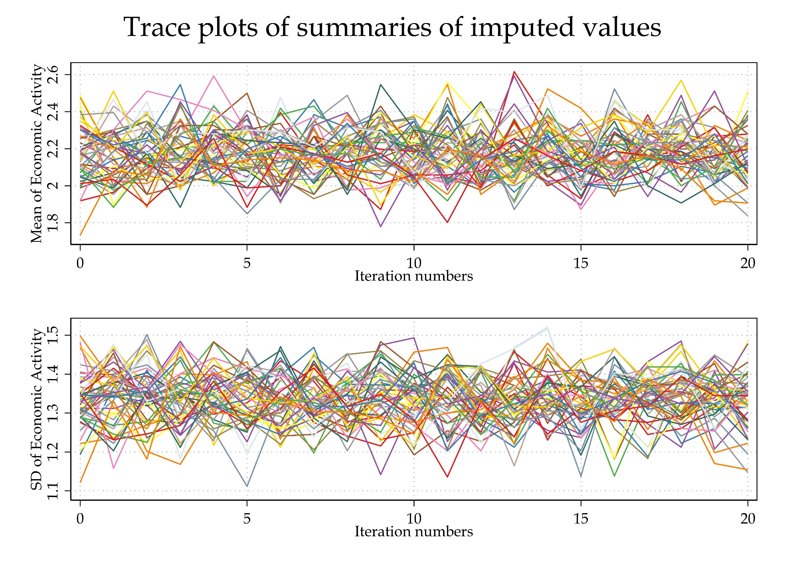

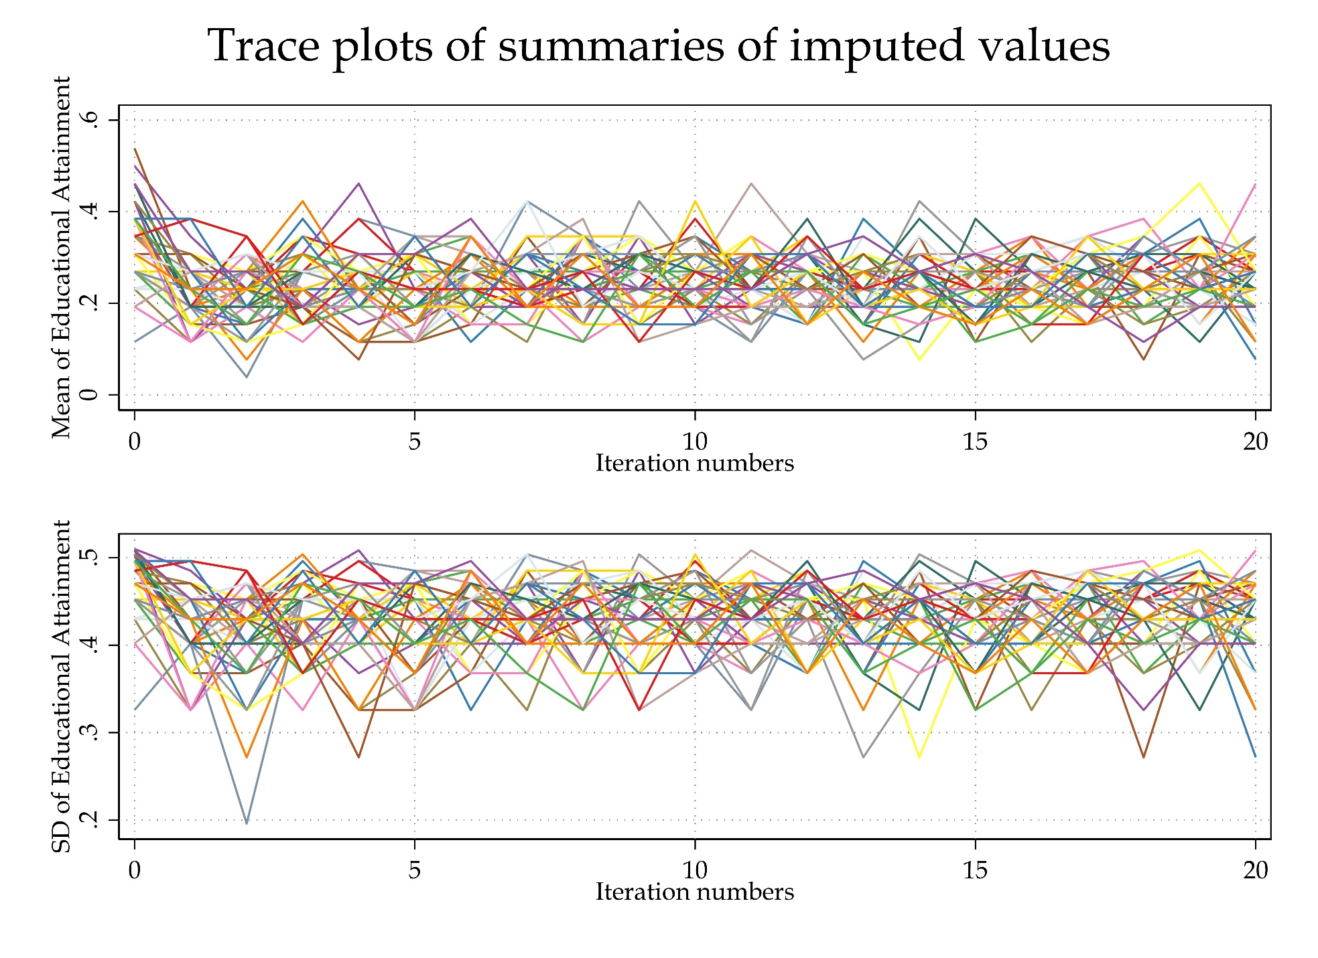

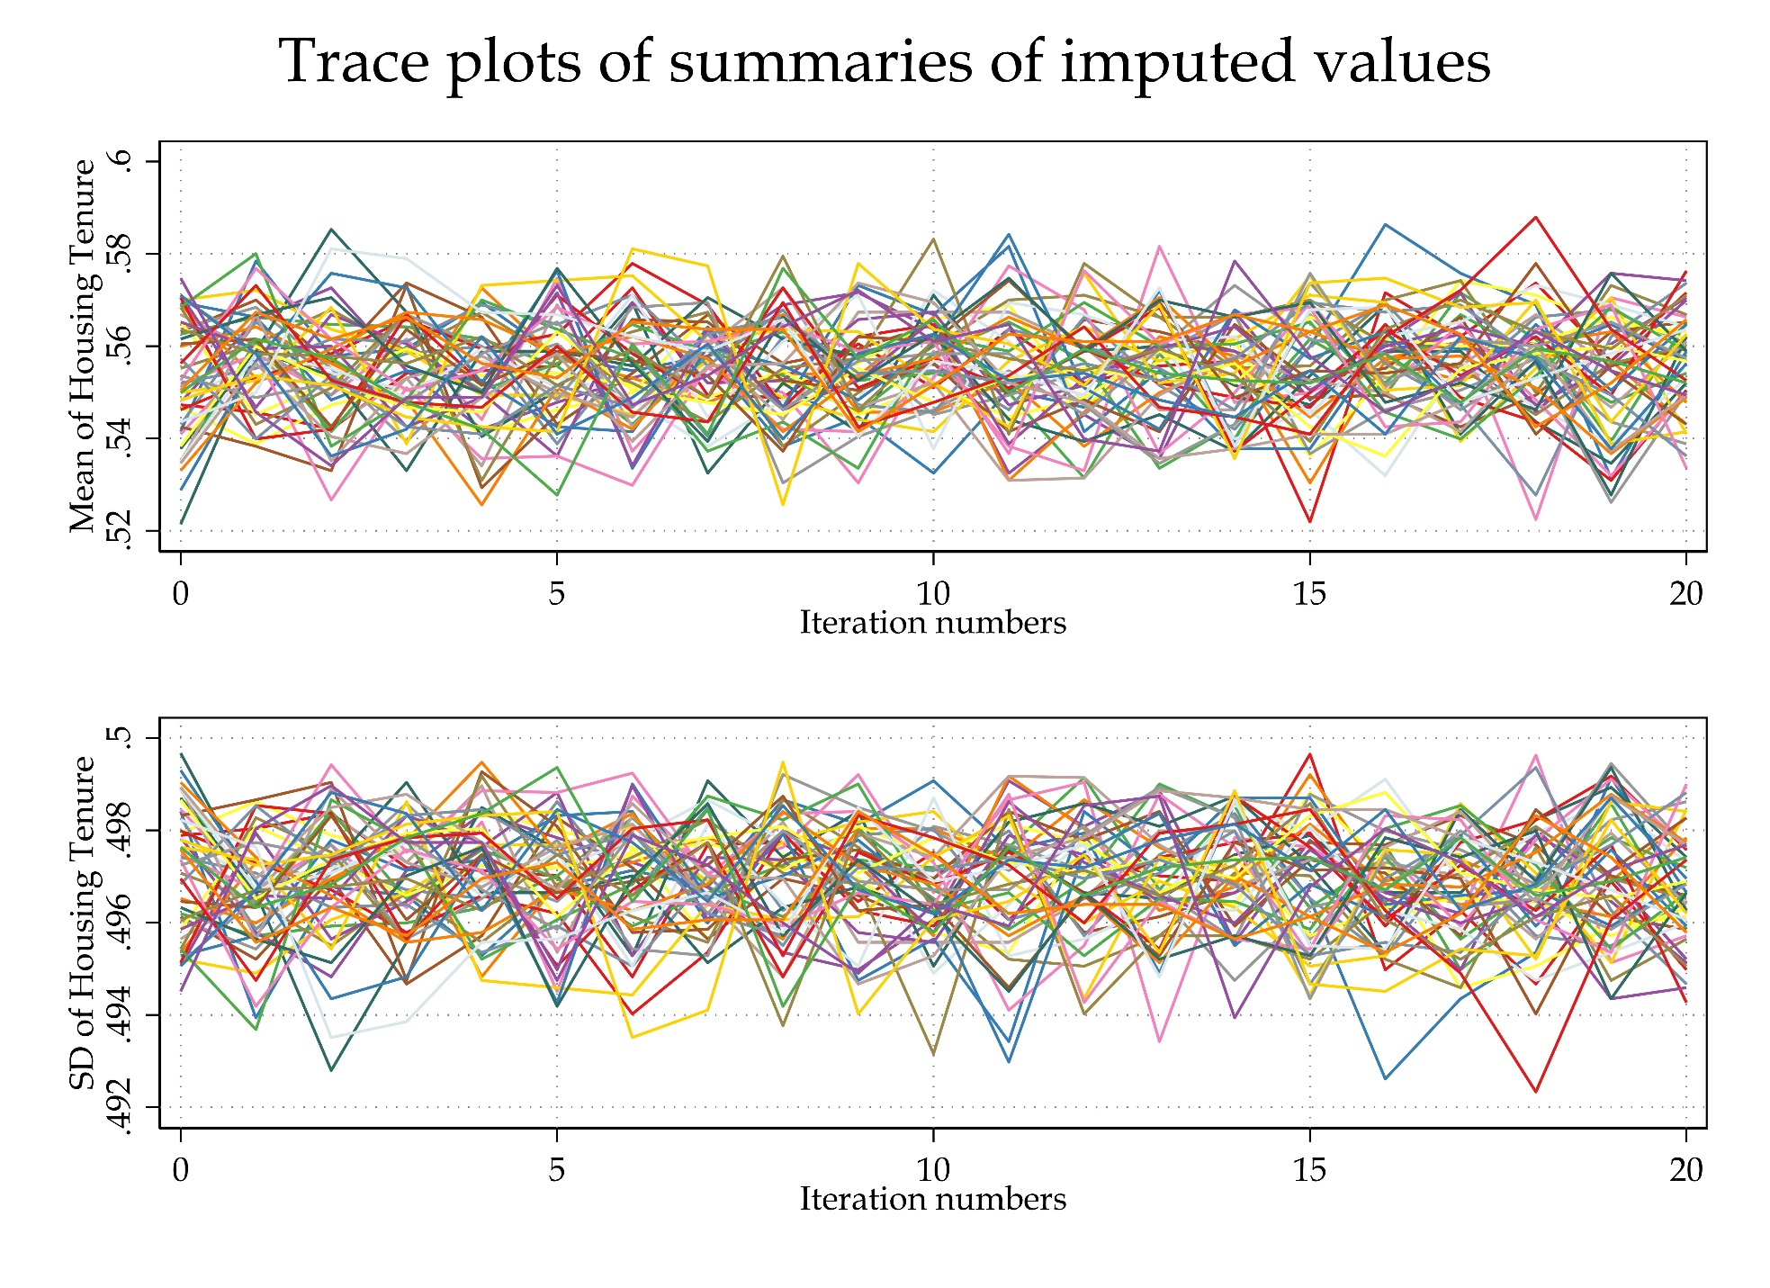

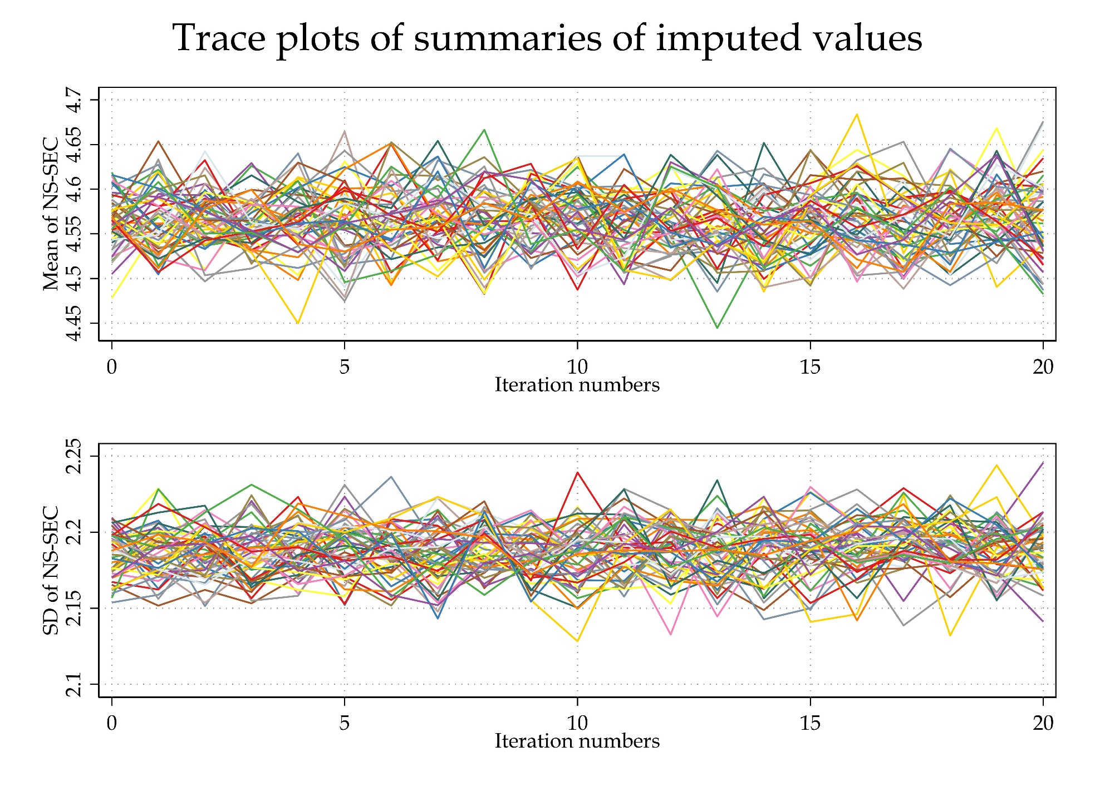

BCS SECTION:

|  |  |  |
| --- | --- | --- |
| Table 1: Descriptive Statistics for Economic Activity | | |
|  | n | % |
| econbin |  |  |
| Not Continuing Schooling | 260 | 35.96% |
| Continuing Schooling | 463 | 64.04% |
| Educational Attainment O'levels |  |  |
| Less than Five O'Levels | 414 | 57.26% |
| Five or More O'Levels | 309 | 42.74% |
| Sex of Respondent |  |  |
| Female | 417 | 57.68% |
| Male | 306 | 42.32% |
| Housing Tenure of Respondent when a Child |  |  |
| Own Home | 571 | 78.98% |
| Don't Own Home | 152 | 21.02% |
| Semi-Dominant NS-SEC Social Class of Parents when Respondent was 10 SOC2000 |  |  |
| Large Employers and higher managerial occupations | 42 | 5.81% |
| Higher professional occupations | 55 | 7.61% |
| Lower Managerial and professional occupations | 142 | 19.64% |
| Intermediate occupations | 82 | 11.34% |
| Small employers and own account workers | 72 | 9.96% |
| Lower supervisory and technical occupations | 125 | 17.29% |
| Semi-routine occupations | 89 | 12.31% |
| Routine occupations | 116 | 16.04% |
| Semi-Dominant NS-SEC Social Class of Parents when Respondent was 10 SOC90 |  |  |
| Large Employers and higher managerial occupations | 41 | 5.67% |
| Higher professional occupations | 61 | 8.44% |
| Lower Managerial and professional occupations | 142 | 19.64% |
| Intermediate occupations | 85 | 11.76% |
| Small employers and own account workers | 73 | 10.10% |
| Lower supervisory and technical occupations | 127 | 17.57% |
| Semi-routine occupations | 90 | 12.45% |
| Routine occupations | 104 | 14.38% |
| Semi-Dominant RGSC Social Class of Parents when Respondent was 10 SOC2000 |  |  |
| Professional | 40 | 5.53% |
| Managerial and Technical | 219 | 30.29% |
| Skilled non-manual | 89 | 12.31% |
| Skilled manual | 249 | 34.44% |
| Partly skilled | 94 | 13.00% |
| Unskilled | 32 | 4.43% |
| Semi-Dominant RGSC Social Class of Parents when Respondent was 10 SOC90 |  |  |
| Professional | 53 | 7.33% |
| Managerial and Technical | 192 | 26.56% |
| Skilled non-manual | 117 | 16.18% |
| Skilled manual | 234 | 32.37% |
| Partly skilled | 104 | 14.38% |
| Unskilled | 23 | 3.18% |
|  |  |  |
|  | Mean | SD |
| Semi-Dominant CAMSIS Respondent was 10 SOC2000 | 49.71 | 13.82 |
| Semi-Dominant CAMSIS Respondent was 10 SOC90 | 50.13 | 14.53 |
|  |  |  |
| n |  | 723 |
| Data Source: BCS [Sweeps 0-4] | | |

|  |  |  |  |
| --- | --- | --- | --- |
| Descriptive Statistics by Economic Activity | | | |
|  | econbin | | |
|  | Not Continuing Schooling | Continuing Schooling | Total |
| N | 260.00 (35.96%) | 463.00 (64.04%) | 723.00 (100.00%) |
| Educational Attainment O'levels |  |  |  |
| Less than Five O'Levels | 213.00 (81.92%) | 201.00 (43.41%) | 414.00 (57.26%) |
| Five or More O'Levels | 47.00 (18.08%) | 262.00 (56.59%) | 309.00 (42.74%) |
| Sex of Respondent |  |  |  |
| Female | 142.00 (54.62%) | 275.00 (59.40%) | 417.00 (57.68%) |
| Male | 118.00 (45.38%) | 188.00 (40.60%) | 306.00 (42.32%) |
| Housing Tenure of Respondent when a Child |  |  |  |
| Own Home | 185.00 (71.15%) | 386.00 (83.37%) | 571.00 (78.98%) |
| Don't Own Home | 75.00 (28.85%) | 77.00 (16.63%) | 152.00 (21.02%) |
| Semi-Dominant NS-SEC Social Class of Parents when Respondent was 10 SOC2000 |  |  |  |
| Large Employers and higher managerial occupations | 7.00 (2.69%) | 35.00 (7.56%) | 42.00 (5.81%) |
| Higher professional occupations | 9.00 (3.46%) | 46.00 (9.94%) | 55.00 (7.61%) |
| Lower Managerial and professional occupations | 35.00 (13.46%) | 107.00 (23.11%) | 142.00 (19.64%) |
| Intermediate occupations | 22.00 (8.46%) | 60.00 (12.96%) | 82.00 (11.34%) |
| Small employers and own account workers | 34.00 (13.08%) | 38.00 (8.21%) | 72.00 (9.96%) |
| Lower supervisory and technical occupations | 56.00 (21.54%) | 69.00 (14.90%) | 125.00 (17.29%) |
| Semi-routine occupations | 42.00 (16.15%) | 47.00 (10.15%) | 89.00 (12.31%) |
| Routine occupations | 55.00 (21.15%) | 61.00 (13.17%) | 116.00 (16.04%) |
| Semi-Dominant NS-SEC Social Class of Parents when Respondent was 10 SOC90 |  |  |  |
| Large Employers and higher managerial occupations | 5.00 (1.92%) | 36.00 (7.78%) | 41.00 (5.67%) |
| Higher professional occupations | 15.00 (5.77%) | 46.00 (9.94%) | 61.00 (8.44%) |
| Lower Managerial and professional occupations | 33.00 (12.69%) | 109.00 (23.54%) | 142.00 (19.64%) |
| Intermediate occupations | 22.00 (8.46%) | 63.00 (13.61%) | 85.00 (11.76%) |
| Small employers and own account workers | 36.00 (13.85%) | 37.00 (7.99%) | 73.00 (10.10%) |
| Lower supervisory and technical occupations | 58.00 (22.31%) | 69.00 (14.90%) | 127.00 (17.57%) |
| Semi-routine occupations | 44.00 (16.92%) | 46.00 (9.94%) | 90.00 (12.45%) |
| Routine occupations | 47.00 (18.08%) | 57.00 (12.31%) | 104.00 (14.38%) |
| Semi-Dominant RGSC Social Class of Parents when Respondent was 10 SOC2000 |  |  |  |
| Professional | 8.00 (3.08%) | 32.00 (6.91%) | 40.00 (5.53%) |
| Managerial and Technical | 52.00 (20.00%) | 167.00 (36.07%) | 219.00 (30.29%) |
| Skilled non-manual | 26.00 (10.00%) | 63.00 (13.61%) | 89.00 (12.31%) |
| Skilled manual | 114.00 (43.85%) | 135.00 (29.16%) | 249.00 (34.44%) |
| Partly skilled | 45.00 (17.31%) | 49.00 (10.58%) | 94.00 (13.00%) |
| Unskilled | 15.00 (5.77%) | 17.00 (3.67%) | 32.00 (4.43%) |
| Semi-Dominant RGSC Social Class of Parents when Respondent was 10 SOC90 |  |  |  |
| Professional | 11.00 (4.23%) | 42.00 (9.07%) | 53.00 (7.33%) |
| Managerial and Technical | 50.00 (19.23%) | 142.00 (30.67%) | 192.00 (26.56%) |
| Skilled non-manual | 32.00 (12.31%) | 85.00 (18.36%) | 117.00 (16.18%) |
| Skilled manual | 99.00 (38.08%) | 135.00 (29.16%) | 234.00 (32.37%) |
| Partly skilled | 56.00 (21.54%) | 48.00 (10.37%) | 104.00 (14.38%) |
| Unskilled | 12.00 (4.62%) | 11.00 (2.38%) | 23.00 (3.18%) |
| Semi-Dominant CAMSIS Respondent was 10 SOC2000 | 45.28 (12.02) | 52.19 (14.15) | 49.71 (13.82) |
| Semi-Dominant CAMSIS Respondent was 10 SOC90 | 45.69 (12.67) | 52.62 (14.91) | 50.13 (14.53) |

|  |  |  |  |  |  |  |  |  |  |
| --- | --- | --- | --- | --- | --- | --- | --- | --- | --- |
| Descriptive Statistics comparing NS-SEC by SOC2000 and SOC90 codes | | | | | | | | | |
|  | Semi-Dominant NS-SEC Social Class of Parents when Respondent was 10 SOC90 | | | | | | | | |
|  | Large Employers and higher managerial occupations | Higher professional occupations | Lower Managerial and professional occupations | Intermediate occupations | Small employers and own account workers | Lower supervisory and technical occupations | Semi-routine occupations | Routine occupations | Total |
| N | 41.00 (5.67%) | 61.00 (8.44%) | 142.00 (19.64%) | 85.00 (11.76%) | 73.00 (10.10%) | 127.00 (17.57%) | 90.00 (12.45%) | 104.00 (14.38%) | 723.00 (100.00%) |
| Semi-Dominant NS-SEC Social Class of Parents when Respondent was 10 SOC2000 |  |  |  |  |  |  |  |  |  |
| Large Employers and higher managerial occupations | 37.00 (90.24%) | 0.00 (0.00%) | 0.00 (0.00%) | 3.00 (3.53%) | 2.00 (2.74%) | 0.00 (0.00%) | 0.00 (0.00%) | 0.00 (0.00%) | 42.00 (5.81%) |
| Higher professional occupations | 1.00 (2.44%) | 48.00 (78.69%) | 5.00 (3.52%) | 1.00 (1.18%) | 0.00 (0.00%) | 0.00 (0.00%) | 0.00 (0.00%) | 0.00 (0.00%) | 55.00 (7.61%) |
| Lower Managerial and professional occupations | 3.00 (7.32%) | 13.00 (21.31%) | 117.00 (82.39%) | 3.00 (3.53%) | 4.00 (5.48%) | 1.00 (0.79%) | 0.00 (0.00%) | 1.00 (0.96%) | 142.00 (19.64%) |
| Intermediate occupations | 0.00 (0.00%) | 0.00 (0.00%) | 3.00 (2.11%) | 73.00 (85.88%) | 0.00 (0.00%) | 2.00 (1.57%) | 2.00 (2.22%) | 2.00 (1.92%) | 82.00 (11.34%) |
| Small employers and own account workers | 0.00 (0.00%) | 0.00 (0.00%) | 11.00 (7.75%) | 1.00 (1.18%) | 60.00 (82.19%) | 0.00 (0.00%) | 0.00 (0.00%) | 0.00 (0.00%) | 72.00 (9.96%) |
| Lower supervisory and technical occupations | 0.00 (0.00%) | 0.00 (0.00%) | 0.00 (0.00%) | 0.00 (0.00%) | 1.00 (1.37%) | 118.00 (92.91%) | 2.00 (2.22%) | 4.00 (3.85%) | 125.00 (17.29%) |
| Semi-routine occupations | 0.00 (0.00%) | 0.00 (0.00%) | 5.00 (3.52%) | 4.00 (4.71%) | 0.00 (0.00%) | 0.00 (0.00%) | 79.00 (87.78%) | 1.00 (0.96%) | 89.00 (12.31%) |
| Routine occupations | 0.00 (0.00%) | 0.00 (0.00%) | 1.00 (0.70%) | 0.00 (0.00%) | 6.00 (8.22%) | 6.00 (4.72%) | 7.00 (7.78%) | 96.00 (92.31%) | 116.00 (16.04%) |

|  |  |  |  |  |  |  |  |
| --- | --- | --- | --- | --- | --- | --- | --- |
| Descriptive Statistics comparing RGSC by SOC2000 and SOC90 codes | | | | | | | |
|  | Semi-Dominant RGSC Social Class of Parents when Respondent was 10 SOC90 | | | | | | |
|  | Professional | Managerial and Technical | Skilled non-manual | Skilled manual | Partly skilled | Unskilled | Total |
| N | 53.00 (7.33%) | 192.00 (26.56%) | 117.00 (16.18%) | 234.00 (32.37%) | 104.00 (14.38%) | 23.00 (3.18%) | 723.00 (100.00%) |
| Semi-Dominant RGSC Social Class of Parents when Respondent was 10 SOC2000 |  |  |  |  |  |  |  |
| Professional | 39.00 (73.58%) | 1.00 (0.52%) | 0.00 (0.00%) | 0.00 (0.00%) | 0.00 (0.00%) | 0.00 (0.00%) | 40.00 (5.53%) |
| Managerial and Technical | 13.00 (24.53%) | 171.00 (89.06%) | 28.00 (23.93%) | 2.00 (0.85%) | 5.00 (4.81%) | 0.00 (0.00%) | 219.00 (30.29%) |
| Skilled non-manual | 0.00 (0.00%) | 8.00 (4.17%) | 79.00 (67.52%) | 1.00 (0.43%) | 1.00 (0.96%) | 0.00 (0.00%) | 89.00 (12.31%) |
| Skilled manual | 0.00 (0.00%) | 9.00 (4.69%) | 1.00 (0.85%) | 221.00 (94.44%) | 18.00 (17.31%) | 0.00 (0.00%) | 249.00 (34.44%) |
| Partly skilled | 1.00 (1.89%) | 3.00 (1.56%) | 4.00 (3.42%) | 8.00 (3.42%) | 75.00 (72.12%) | 3.00 (13.04%) | 94.00 (13.00%) |
| Unskilled | 0.00 (0.00%) | 0.00 (0.00%) | 5.00 (4.27%) | 2.00 (0.85%) | 5.00 (4.81%) | 20.00 (86.96%) | 32.00 (4.43%) |

|  |  |
| --- | --- |
| CAMSIS2000 | |
| *Mean* | 49.71 |
| *Standard Deviation* | 13.82 |
| CAMSIS90 | |
| *Mean* | 50.13 |
| *Standard Deviation* | 14.53 |
| N | 723 |
| Data Source BCS | |

|  |  |  |  |  |  |  |
| --- | --- | --- | --- | --- | --- | --- |
| Outcome Variable: Economic Activity | Deviance | $Δ$ Deviance (from Null) | $Δ$ d. f. (from Null) | McFadden’s Pseudo $R^{2}$ | AIC | BIC |
| Null Model | 944.52 | - | - | - | 946.52 | 951.10 |
| Null Model + Educational Attainment | 837.06 | 107.46 | 2 | 0.11 | 841.06 | 850.22 |
| Null Model + Sex | 942.97 | 1.55 | 2 | 0.00 | 946.97 | 956.13 |
| Null Model + Tenure | 929.97 | 14.55 | 2 | 0.02 | 933.97 | 943.14 |
| Null Model + NS-SEC (SOC 2000) | 895.96 | 48.56 | 8 | 0.05 | 911.96 | 948.63 |

|  |  |  |  |  |  |  |
| --- | --- | --- | --- | --- | --- | --- |
| Outcome Variable: Economic Activity | Deviance | $Δ$ Deviance (from Previous) | $Δ$ d. f. (from Previous) | McFadden’s Pseudo $R^{2}$ | AIC | BIC |
| Null Model | 944.52 | - | - | - | 946.52 | 951.10 |
| Null Model + Educational Attainment | 837.06 | 107.46 | 2 | 0.11 | 841.06 | 850.22 |
| Null Model + Educational Attainment + Sex | 833.38 | 3.68 | 2 | 0.12 | 839.38 | 853.13 |
| Null Model + Educational Attainment + Sex + Tenure | 828.50 | 4.88 | 2 | 0.12 | 836.50 | 854.83 |
| Null Model + Educational Attainment + Sex + Tenure + NS-SEC (SOC 2000) | 803.55 | 24.95 | 8 | 0.15 | 825.55 | 875.97 |

|  |  |  |  |  |  |  |
| --- | --- | --- | --- | --- | --- | --- |
| Outcome Variable: Economic Activity | Deviance | $Δ$ Deviance (from Null) | $Δ$ d. f. (from Null) | McFadden’s Pseudo $R^{2}$ | AIC | BIC |
| Null Model | 944.52 | - | - | - | 946.52 | 951.10 |
| Null Model + Educational Attainment | 837.06 | 107.46 | 2 | 0.11 | 841.06 | 850.22 |
| Null Model + Sex | 942.97 | 1.55 | 2 | 0.00 | 946.97 | 956.13 |
| Null Model + Tenure | 929.97 | 14.55 | 2 | 0.02 | 933.97 | 943.14 |
| Null Model + RGSC (SOC 2000) | 905.42 | 39.10 | 6 | 0.04 | 917.42 | 944.92 |

|  |  |  |  |  |  |  |
| --- | --- | --- | --- | --- | --- | --- |
| Outcome Variable: Economic Activity | Deviance | $Δ$ Deviance (from Previous) | $Δ$ d. f. (from Previous) | McFadden’s Pseudo $R^{2}$ | AIC | BIC |
| Null Model | 944.52 | - | - | - | 946.52 | 951.10 |
| Null Model + Educational Attainment | 837.06 | 107.46 | 2 | 0.11 | 841.06 | 850.22 |
| Null Model + Educational Attainment + Sex | 833.38 | 3.68 | 2 | 0.12 | 839.38 | 853.13 |
| Null Model + Educational Attainment + Sex + Tenure | 828.50 | 4.88 | 2 | 0.12 | 836.50 | 854.83 |
| Null Model + Educational Attainment + Sex + Tenure + RGSC (SOC 2000) | 809.37 | 19.13 | 6 | 0.15 | 827.37 | 868.62 |

|  |  |  |  |  |  |  |
| --- | --- | --- | --- | --- | --- | --- |
| Outcome Variable: Economic Activity | Deviance | $Δ$ Deviance (from Null) | $Δ$ d. f. (from Null) | McFadden’s Pseudo $R^{2}$ | AIC | BIC |
| Null Model | 944.52 | - | - | - | 946.52 | 951.10 |
| Null Model + Educational Attainment | 837.06 | 107.46 | 2 | 0.11 | 841.06 | 850.22 |
| Null Model + Sex | 942.97 | 1.55 | 2 | 0.00 | 946.97 | 956.13 |
| Null Model + Tenure | 929.97 | 14.55 | 2 | 0.02 | 933.97 | 943.14 |
| Null Model + CAMSIS (SOC 2000) | 901.14 | 43.38 | 2 | 0.05 | 905.14 | 914.31 |

|  |  |  |  |  |  |  |
| --- | --- | --- | --- | --- | --- | --- |
| Outcome Variable: Economic Activity | Deviance | $Δ$ Deviance (from Previous) | $Δ$ d. f. (from Previous) | McFadden’s Pseudo $R^{2}$ | AIC | BIC |
| Null Model | 944.52 | - | - | - | 946.52 | 951.10 |
| Null Model + Educational Attainment | 837.06 | 107.46 | 2 | 0.11 | 841.06 | 850.22 |
| Null Model + Educational Attainment + Sex | 833.38 | 3.68 | 2 | 0.12 | 839.38 | 853.13 |
| Null Model + Educational Attainment + Sex + Tenure | 828.50 | 4.88 | 2 | 0.12 | 836.50 | 854.83 |
| Null Model + Educational Attainment + Sex + Tenure + CAMSIS (SOC 2000) | 813.03 | 15.47 | 2 | 0.14 | 823.03 | 845.95 |

|  |  |  |  |  |  |  |  |  |
| --- | --- | --- | --- | --- | --- | --- | --- | --- |
|  | NS-SEC | | | Average Marginal Effects | | Quasi-variance | | |
| Economic Activity: ‘Don’t Continue Schooling’ Reference Category | **Coef.** | **S.E.** | **Sig.** | $Δ$**Prob.** | **S.E.** | **S.E.** | **LB** | **UB** |
| Continue Schooling |  |  |  |  |  |  |  |  |
| Educational Attainment |  |  |  |  |  |  |  |  |
| *Less than five O’levels* | Ref. | (.) |  | (.) | (.) | (.) | (.) | (.) |
| *Five or More O’levels* | 1.67 | (0.19) | *** | 0.33 | (0.03) | (.) | (.) | (.) |
| Sex |  |  |  |  |  |  |  |  |
| *Female* | Ref. | (.) |  | (.) | (.) | (.) | (.) | (.) |
| *Male* | -0.35 | (0.17) | * | -0.07 | (0.03) | (.) | (.) | (.) |
| Housing Tenure |  |  |  |  |  |  |  |  |
| *Own Home* | Ref. | (.) |  | (.) | (.) | (.) | (.) | (.) |
| *Do not Own Home* | -0.30 | (0.21) |  | -0.06 | (0.04) | (.) | (.) | (.) |
| NS-SEC (SOC 2000) |  |  |  |  |  |  |  |  |
| *1.1* | 0.60 | (0.48) |  | 0.10 | (0.07) | 0.44 | -0.37 | 1.57 |
| *1.2* | 0.46 | (0.43) |  | 0.08 | (0.07) | 0.38 | -0.39 | 1.31 |
| *2* | Ref. | (.) |  | (.) | (.) | 0.21 | -0.47 | 0.47 |
| *3* | -0.03 | (0.34) |  | -0.01 | (0.06) | 0.27 | -0.63 | 0.56 |
| *4* | -0.79 | (0.33) | * | -0.16 | (0.07) | 0.25 | -1.36 | -0.22 |
| *5* | -0.82 | (0.29) | ** | -0.16 | (0.06) | 0.20 | -1.26 | -0.38 |
| *6* | -0.56 | (0.31) |  | -0.11 | (0.06) | 0.23 | -1.07 | -0.04 |
| *7* | -0.55 | (0.29) |  | -0.11 | (0.06) | 0.20 | -1.00 | -0.10 |
| Intercept | 0.55 | (0.23) | * | (.) | (.) | (.) | (.) | (.) |
| Number of observations | 723 | | | | | | | |
| McFadden’s $R^{2}$ | 0.15 | | | | | | | |
| McFadden’s Adjusted Pseudo $R^{2}$ | 0.12 | | | | | | | |
| Cox-Snell Pseudo $R^{2}$ | 0.18 | | | | | | | |
| Nagelkerke Pseudo $R^{2}$ | 0.24 | | | | | | | |
| Tjur’s $R^{2}$ | 0.18 | | | | | | | |
| AIC | 825.55 | | | | | | | |
| BIC | 875.97 | | | | | | | |
| *** p<.001, ** p<.01, * p<.05 Data Source: BCS  Note: Complete Records Analysis | | | | | | | | |

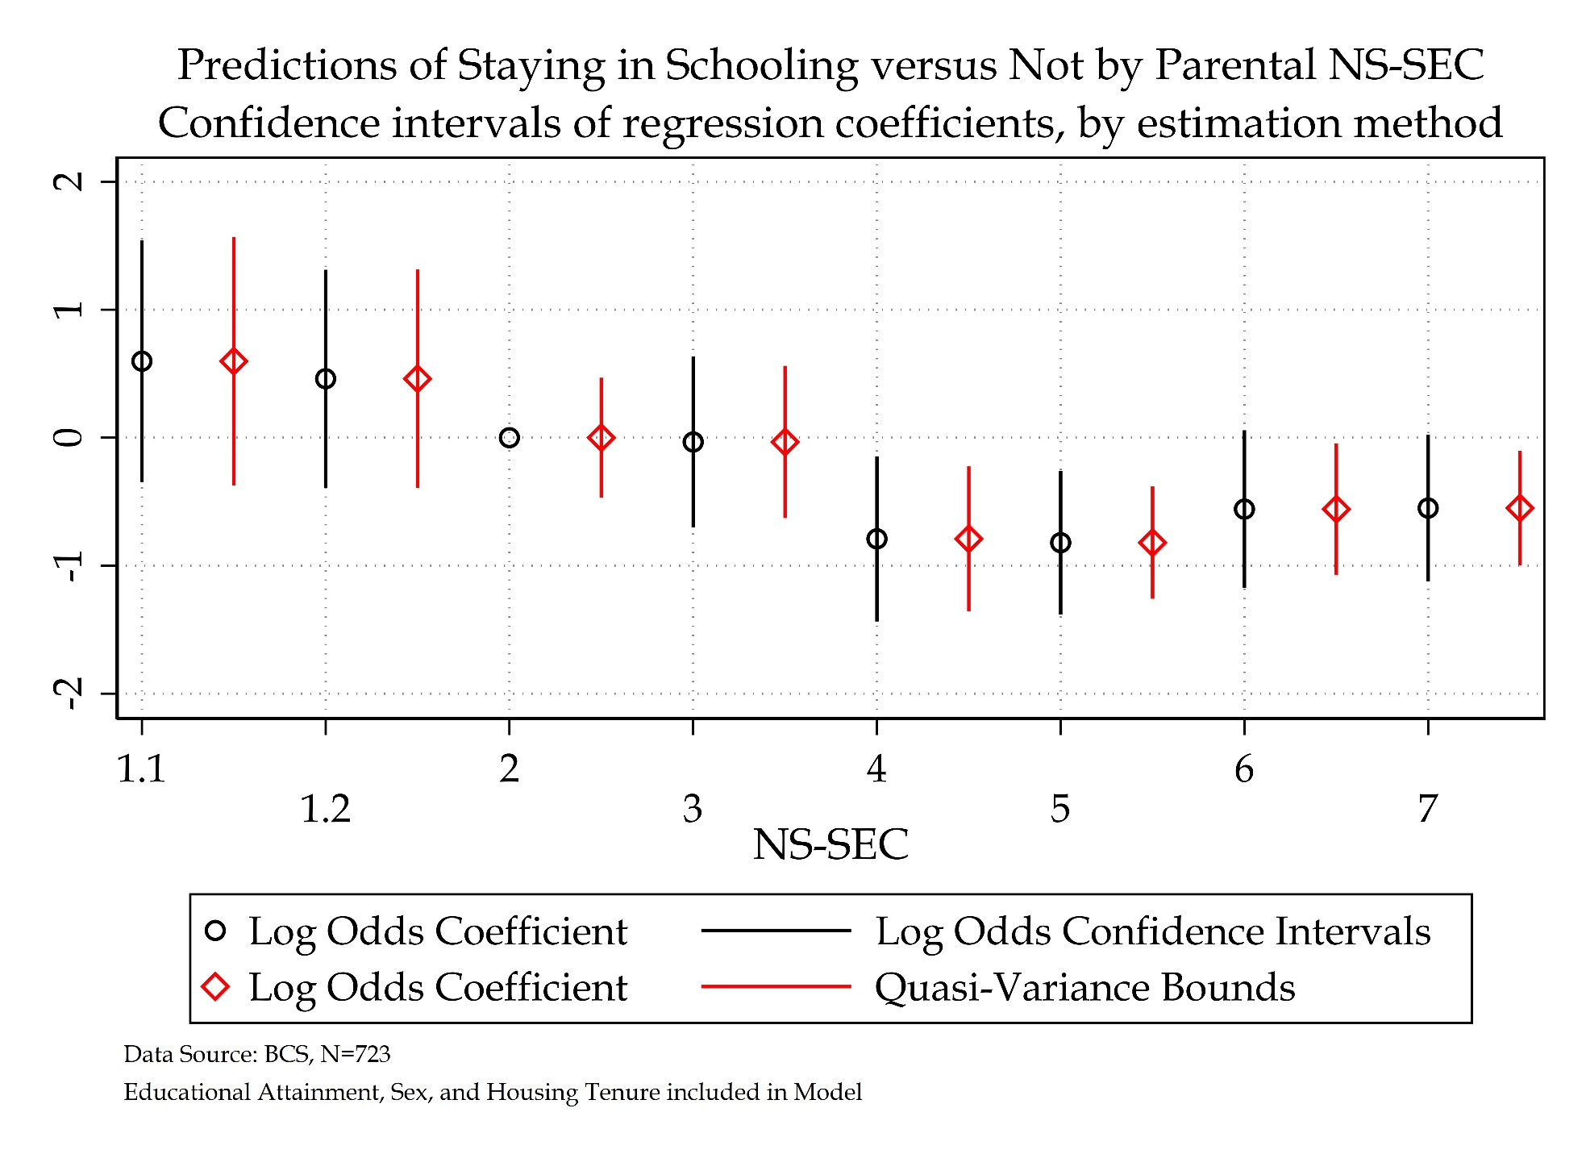

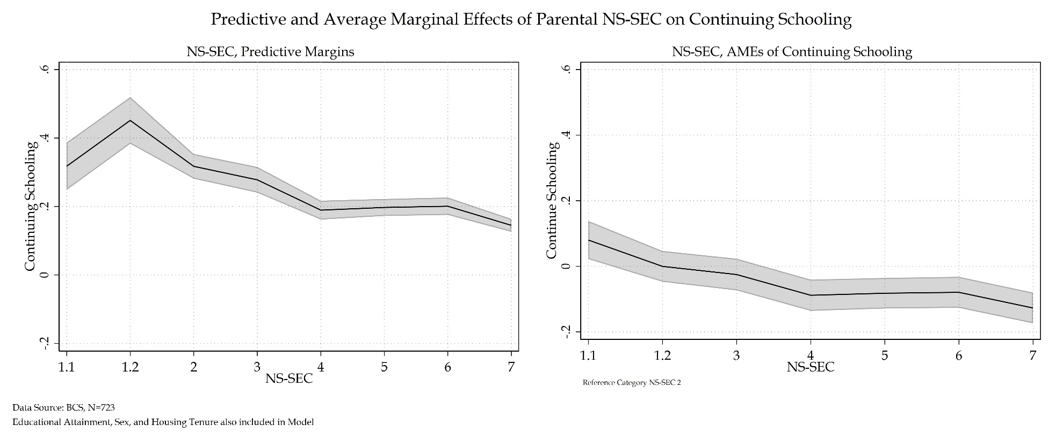

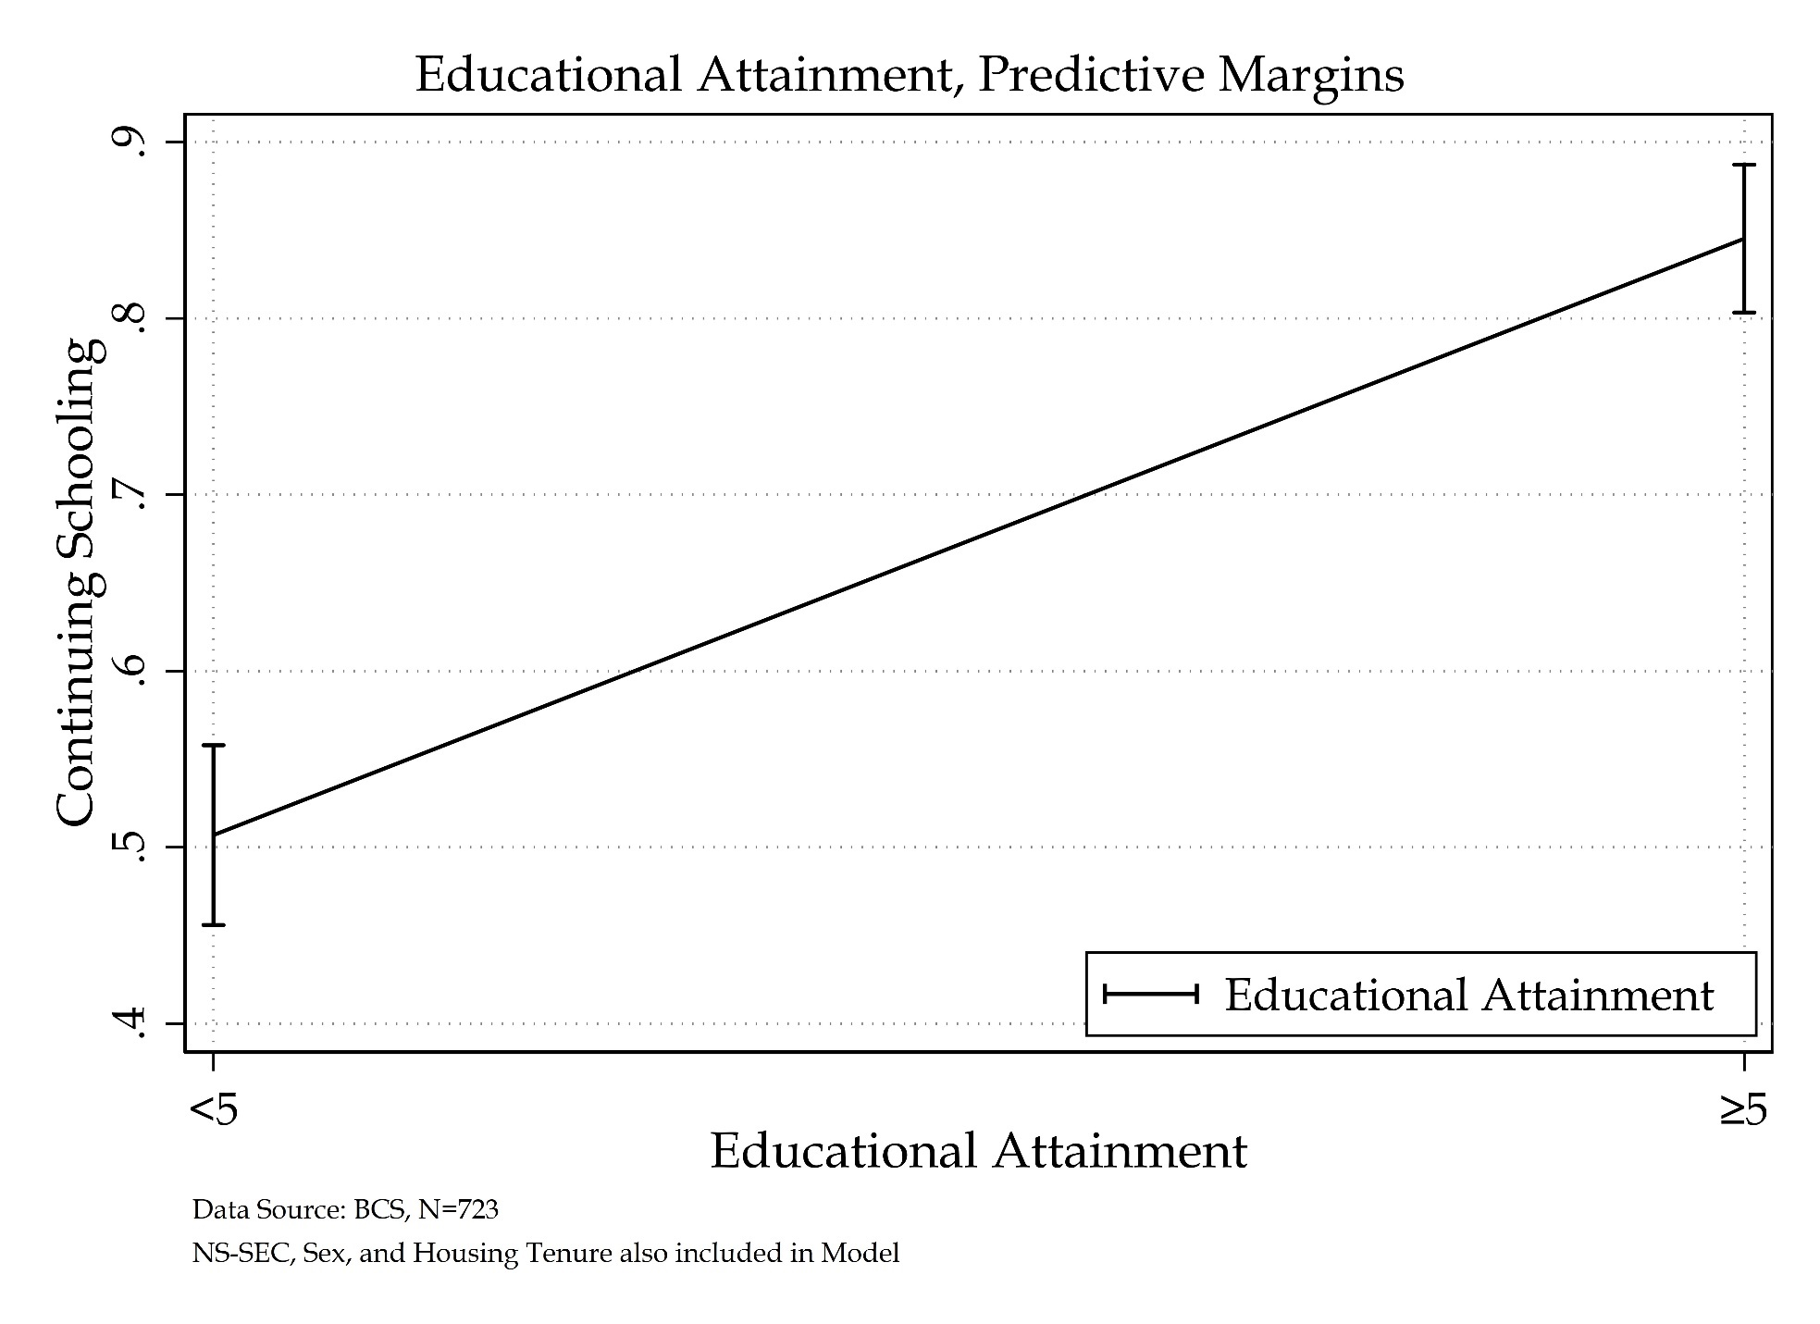

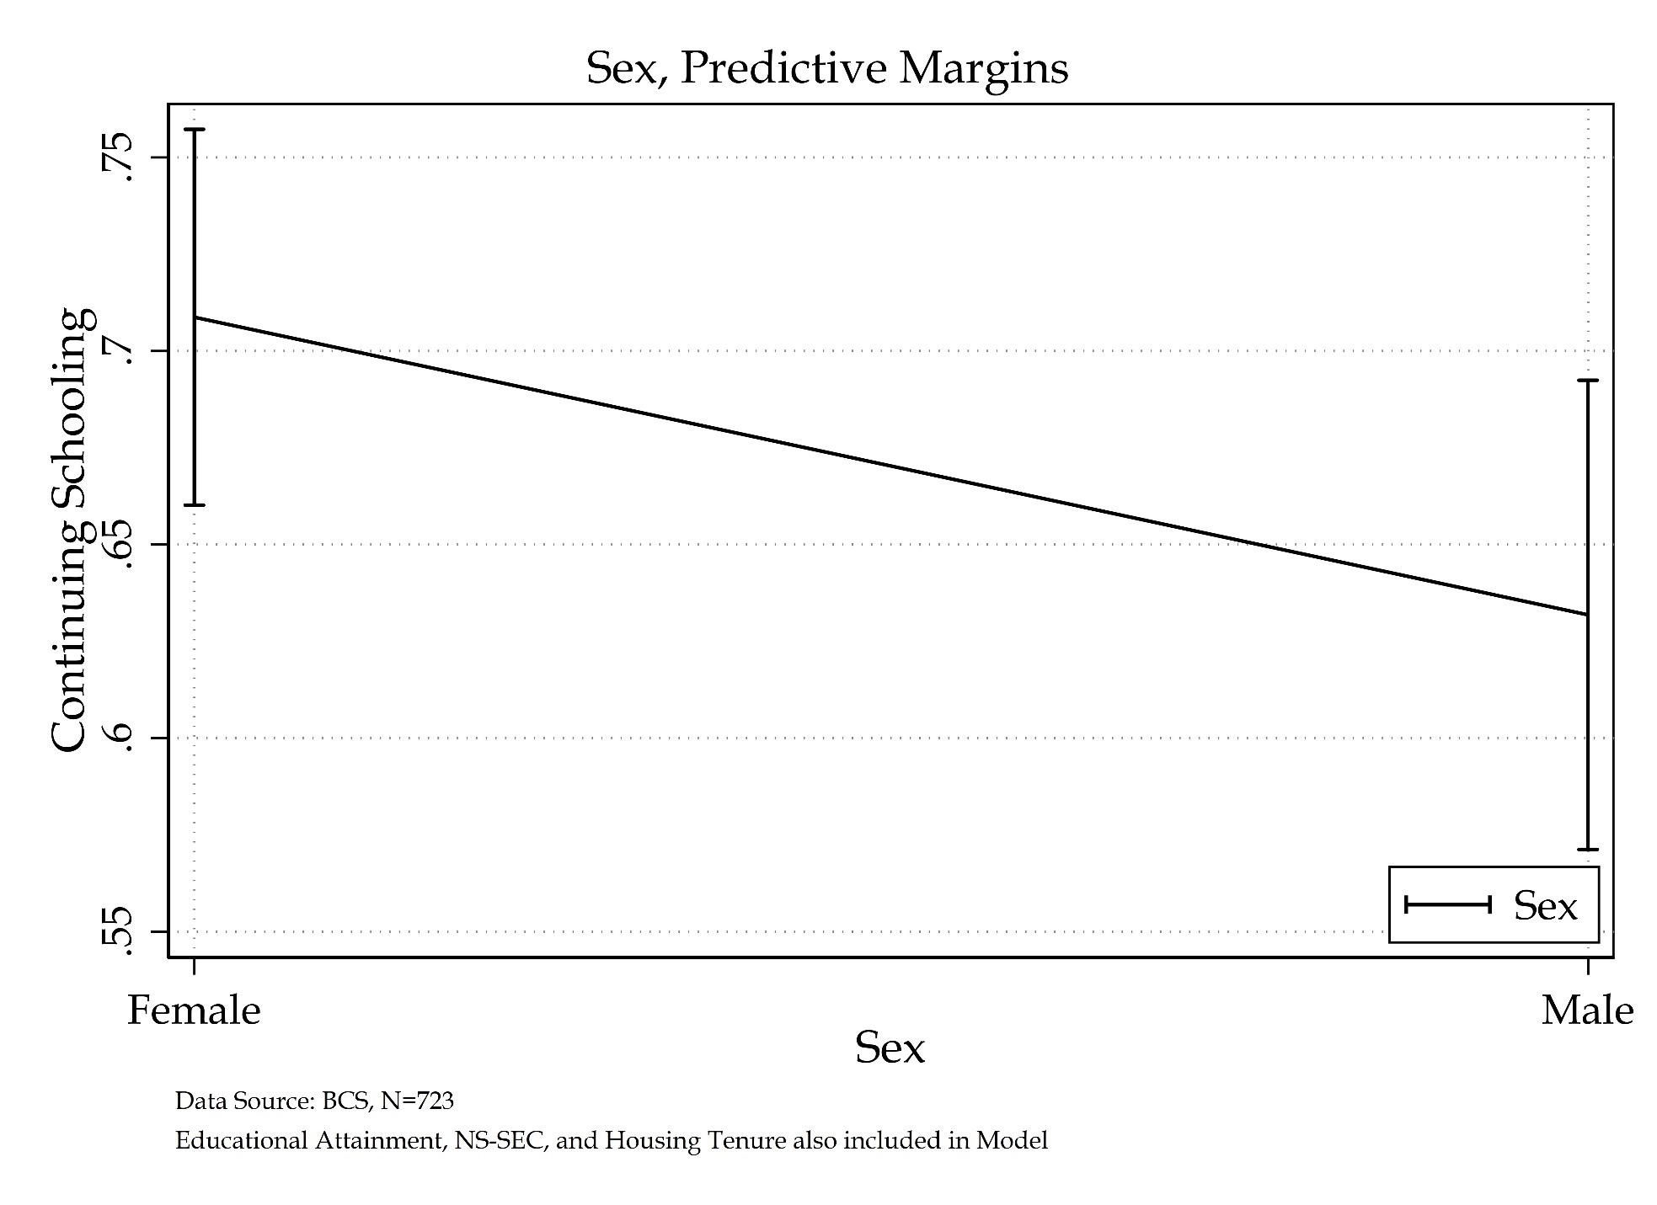

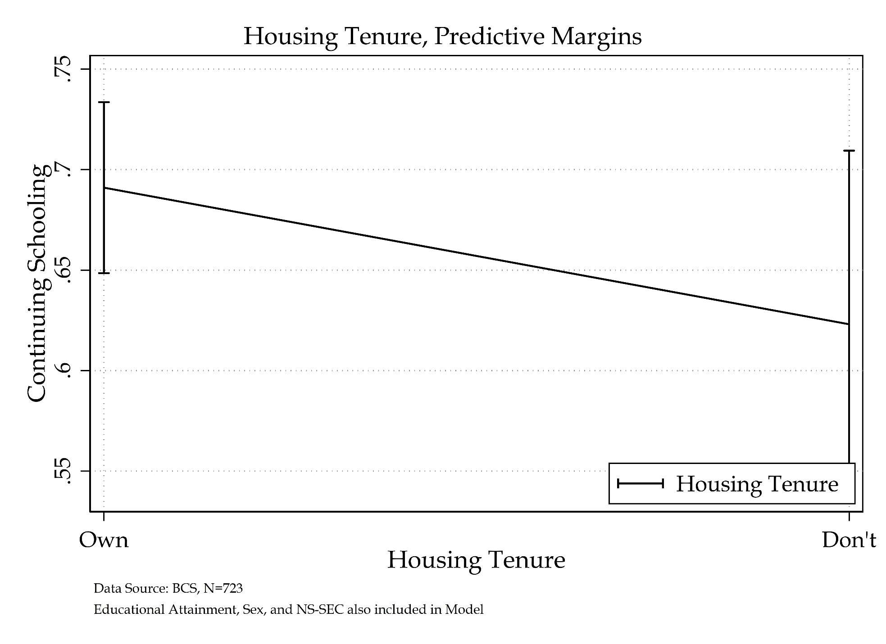

|  |  |  |  |  |  |  |  |  |  |  |  |  |  |  |  |  |  |  |  |  |  |
| --- | --- | --- | --- | --- | --- | --- | --- | --- | --- | --- | --- | --- | --- | --- | --- | --- | --- | --- | --- | --- | --- |
|  | NS-SEC | | | Average Marginal Effects | | Quasi-variance | | | RGSC | | | Average Marginal Effects | | Quasi-variance | | | CAMSIS | | | Average Marginal Effects | |
| Economic Activity: ‘Don’t Continue Schooling’ Reference Category | **Coef.** | **S.E.** | **Sig.** | **Prob.** | **S.E.** | **S.E.** | **LB** | **UB** | **Coef.** | **S.E.** | **Sig.** | **Prob.** | **S.E.** | **S.E.** | **LB** | **UB** | **Coef.** | **S.E.** | **Sig.** | $Δ$**Prob.** | **S.E.** |
| Continue Schooling |  |  |  |  |  |  |  |  |  |  |  |  |  |  |  |  |  |  |  |  |  |
| Educational Attainment |  |  |  |  |  |  |  |  |  |  |  |  |  |  |  |  |  |  |  |  |  |
| *Less than five O’levels* | Ref. | (.) |  | (.) | (.) | (.) | (.) | (.) | (.) | (.) |  | (.) | (.) | (.) | (.) | (.) | (.) | (.) |  | (.) | (.) |
| *Five or More O’levels* | 1.67 | (0.19) | *** | 0.33 | (0.03) | (.) | (.) | (.) | 1.67 | (0.19) | *** | 0.33 | (0.03) | (.) | (.) | (.) | 1.67 | (0.19) | *** | 0.32 | (0.03) |
| Sex |  |  |  |  |  |  |  |  |  |  |  |  |  |  |  |  |  |  |  |  |  |
| *Female* | Ref. | (.) |  | (.) | (.) | (.) | (.) | (.) | (.) | (.) |  | (.) | (.) | (.) | (.) | (.) | (.) | (.) |  | (.) | (.) |
| *Male* | -0.35 | (0.17) | * | -0.07 | (0.03) | (.) | (.) | (.) | -0.33 | (0.17) |  | -0.06 | (0.03) | (.) | (.) | (.) | -0.33 | (0.17) |  | -0.06 | (0.03) |
| Housing Tenure |  |  |  |  |  |  |  |  |  |  |  |  |  |  |  |  |  |  |  |  |  |
| *Own Home* | Ref. | (.) |  | (.) | (.) | (.) | (.) | (.) | (.) | (.) |  | (.) | (.) | (.) | (.) | (.) | (.) | (.) |  | (.) | (.) |
| *Do not Own Home* | -0.30 | (0.21) |  | -0.06 | (0.04) | (.) | (.) | (.) | -0.33 | (0.21) |  | -0.06 | (0.04) | (.) | (.) | (.) | -0.30 | (0.21) |  | -0.06 | (0.04) |
| NS-SEC (SOC 2000) |  |  |  |  |  |  |  |  |  |  |  |  |  |  |  |  |  |  |  |  |  |
| *1.1* | 0.60 | (0.48) |  | 0.10 | (0.07) | 0.44 | -0.37 | 1.57 |  |  |  |  |  |  |  |  |  |  |  |  |  |
| *1.2* | 0.46 | (0.43) |  | 0.08 | (0.07) | 0.38 | -0.39 | 1.31 |  |  |  |  |  |  |  |  |  |  |  |  |  |
| *2* | Ref. | (.) |  | (.) | (.) | 0.21 | -0.47 | 0.47 |  |  |  |  |  |  |  |  |  |  |  |  |  |
| *3* | -0.03 | (0.34) |  | -0.01 | (0.06) | 0.27 | -0.63 | 0.56 |  |  |  |  |  |  |  |  |  |  |  |  |  |
| *4* | -0.79 | (0.33) | * | -0.16 | (0.07) | 0.25 | -1.36 | -0.22 |  |  |  |  |  |  |  |  |  |  |  |  |  |
| *5* | -0.82 | (0.29) | ** | -0.16 | (0.06) | 0.20 | -1.26 | -0.38 |  |  |  |  |  |  |  |  |  |  |  |  |  |
| *6* | -0.56 | (0.31) |  | -0.11 | (0.06) | 0.23 | -1.07 | -0.04 |  |  |  |  |  |  |  |  |  |  |  |  |  |
| *7* | -0.55 | (0.29) |  | -0.11 | (0.06) | 0.20 | -1.00 | -0.10 |  |  |  |  |  |  |  |  |  |  |  |  |  |
| RGSC (SOC 2000) |  |  |  |  |  |  |  |  |  |  |  |  |  |  |  |  |  |  |  |  |  |
| *1* |  |  |  |  |  |  |  |  | 0.13 | (0.45) |  | 0.02 | (0.08) | 0.15 | 0.33 | 1.01 |  |  |  |  |  |
| *2* |  |  |  |  |  |  |  |  | Ref. | (.) |  | (.) | (.) | 0.07 | -0.15 | 0.15 |  |  |  |  |  |
| *3NM* |  |  |  |  |  |  |  |  | -0.12 | (0.30) |  | -0.02 | (0.06) | 0.09 | -0.25 | 0.16 |  |  |  |  |  |
| *3M* |  |  |  |  |  |  |  |  | -0.80 | (0.22) | *** | -0.16 | (0.04) | 0.05 | -0.69 | -0.45 |  |  |  |  |  |
| *4* |  |  |  |  |  |  |  |  | -0.73 | (0.28) | ** | -0.14 | (0.06) | 0.09 | -0.83 | -0.41 |  |  |  |  |  |
| *5* |  |  |  |  |  |  |  |  | -0.64 | (0.42) |  | -0.12 | (0.08) | 0.13 | -1.13 | -0.51 |  |  |  |  |  |
| CAMSIS (SOC 2000) |  |  |  |  |  |  |  |  |  |  |  |  |  |  |  |  | 0.03 | (0.01) | *** | 0.00 | (0.00) |
| Intercept | 0.55 | (0.23) | * |  |  |  |  |  | 0.64 | (0.20) | ** |  |  |  |  |  | -1.06 | (0.35) | ** |  |  |
| Number of observations | 723 | | | | | | | | 723 | | | | | | | | 723 | | | | |
| McFadden’s $R^{2}$ | 0.15 | | | | | | | | 0.14 | | | | | | | | 0.14 | | | | |
| McFadden’s Adjusted Pseudo $R^{2}$ | 0.12 | | | | | | | | 0.12 | | | | | | | | 0.12 | | | | |
| Cox-Snell Pseudo $R^{2}$ | 0.18 | | | | | | | | 0.17 | | | | | | | | 0.17 | | | | |
| Nagelkerke Pseudo $R^{2}$ | 0.24 | | | | | | | | 0.23 | | | | | | | | 0.23 | | | | |
| Tjur’s $R^{2}$ | 0.18 | | | | | | | | 0.18 | | | | | | | | 0.17 | | | | |
| AIC | 825.55 | | | | | | | | 827.37 | | | | | | | | 823.03 | | | | |
| BIC | 875.97 | | | | | | | | 868.62 | | | | | | | | 845.94 | | | | |
| *** p<.001, ** p<.01, * p<.05 Data Source: NCDS [Sweeps 0-4]  Note: Sensitivity Analysis of Social Stratification Measures | | | | | | | | | | | | | | | | | | | | | |

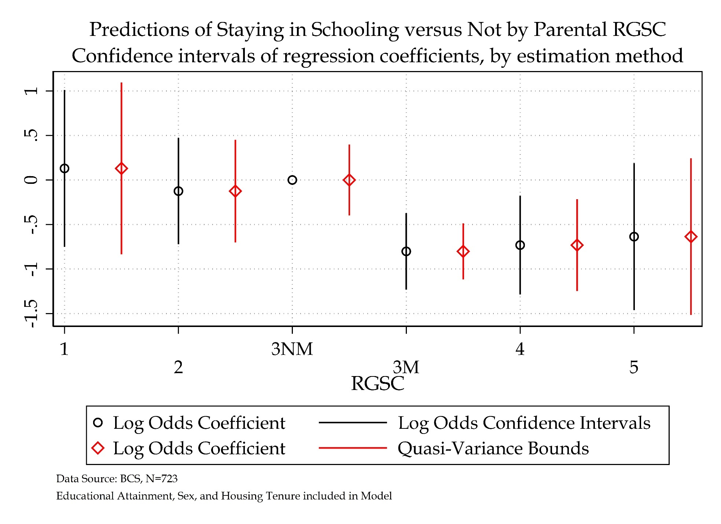

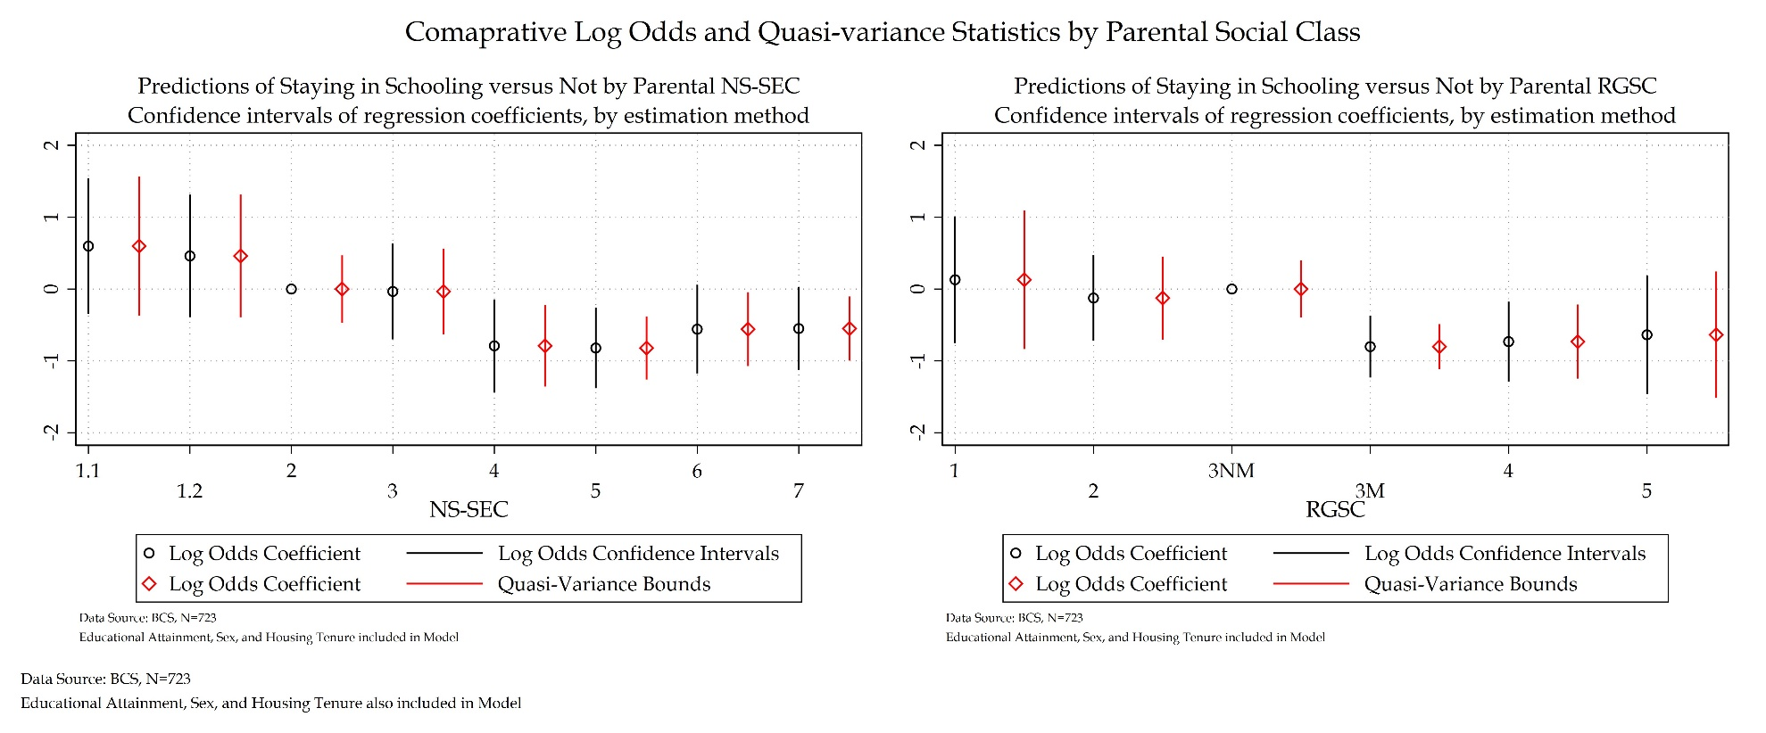

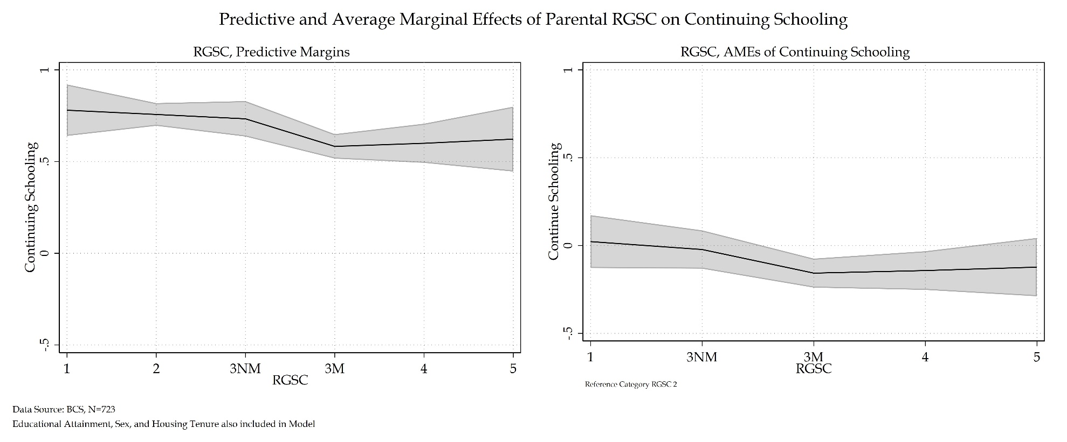

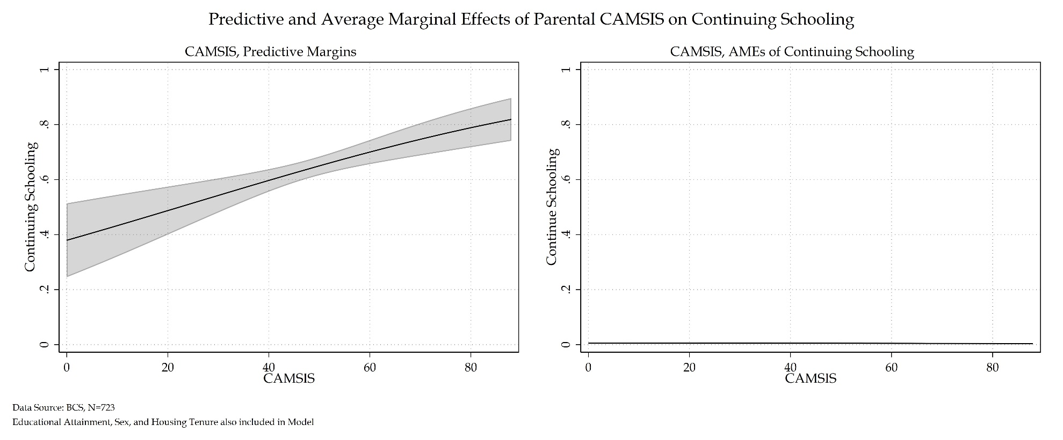

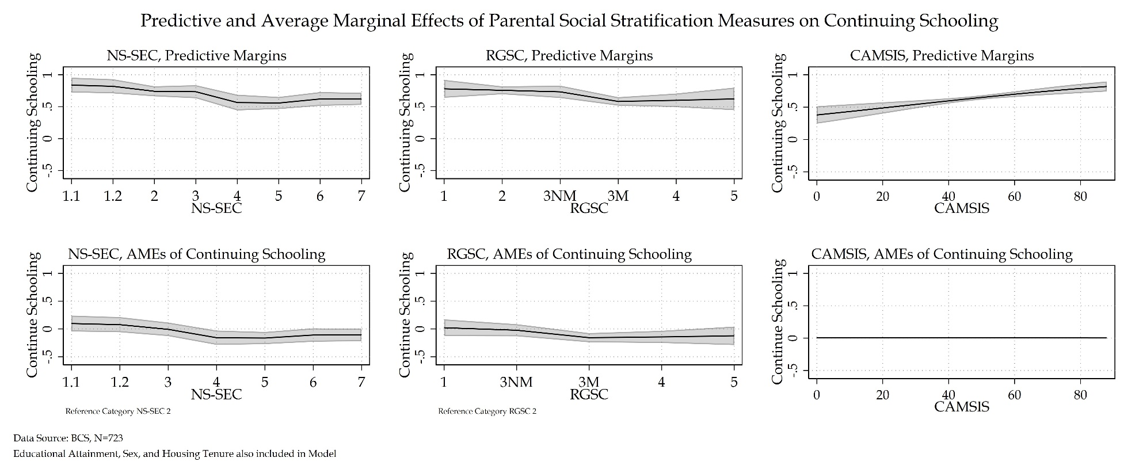

|  |  |  |  |  |  |  |
| --- | --- | --- | --- | --- | --- | --- |
| Outcome Variable: Economic Activity | Deviance | $Δ$ Deviance (from Null) | $Δ$ d. f. (from Null) | McFadden’s Pseudo $R^{2}$ | AIC | BIC |
| Null Model | 944.52 | - | - | - | 946.52 | 951.10 |
| Null Model + Educational Attainment | 837.06 | 107.46 | 2 | 0.11 | 841.06 | 850.22 |
| Null Model + Sex | 942.97 | 1.55 | 2 | 0.00 | 946.97 | 956.13 |
| Null Model + Tenure | 929.97 | 14.55 | 2 | 0.02 | 933.97 | 943.14 |
| Null Model + NS-SEC (SOC 90) | 893.86 | 50.66 | 8 | 0.05 | 909.86 | 946.53 |

|  |  |  |  |  |  |  |
| --- | --- | --- | --- | --- | --- | --- |
| Outcome Variable: Economic Activity | Deviance | $Δ$ Deviance (from Previous) | $Δ$ d. f. (from Previous) | McFadden’s Pseudo $R^{2}$ | AIC | BIC |
| Null Model | 944.52 | - | - | - | 946.52 | 951.10 |
| Null Model + Educational Attainment | 837.06 | 107.46 | 2 | 0.11 | 841.06 | 850.22 |
| Null Model + Educational Attainment + Sex | 833.38 | 3.68 | 2 | 0.12 | 839.38 | 853.13 |
| Null Model + Educational Attainment + Sex + Tenure | 828.50 | 4.88 | 2 | 0.12 | 836.50 | 854.83 |
| Null Model + Educational Attainment + Sex + Tenure + NS-SEC (SOC 90) | 801.34 | 27.16 | 8 | 0.15 | 823.34 | 873.76 |

|  |  |  |  |  |  |  |
| --- | --- | --- | --- | --- | --- | --- |
| Outcome Variable: Economic Activity | Deviance | $Δ$ Deviance (from Null) | $Δ$ d. f. (from Null) | McFadden’s Pseudo $R^{2}$ | AIC | BIC |
| Null Model | 944.52 | - | - | - | 946.52 | 951.10 |
| Null Model + Educational Attainment | 837.06 | 107.46 | 2 | 0.11 | 841.06 | 850.22 |
| Null Model + Sex | 942.97 | 1.55 | 2 | 0.00 | 946.97 | 956.13 |
| Null Model + Tenure | 929.97 | 14.55 | 2 | 0.02 | 933.97 | 943.14 |
| Null Model + RGSC (SOC 90) | 905.88 | 38.64 | 6 | 0.04 | 917.88 | 945.38 |

|  |  |  |  |  |  |  |
| --- | --- | --- | --- | --- | --- | --- |
| Outcome Variable: Economic Activity | Deviance | $Δ$ Deviance (from Previous) | $Δ$ d. f. (from Previous) | McFadden’s Pseudo $R^{2}$ | AIC | BIC |
| Null Model | 944.52 | - | - | - | 946.52 | 951.10 |
| Null Model + Educational Attainment | 837.06 | 107.46 | 2 | 0.11 | 841.06 | 850.22 |
| Null Model + Educational Attainment + Sex | 833.38 | 3.68 | 2 | 0.12 | 839.38 | 853.13 |
| Null Model + Educational Attainment + Sex + Tenure | 828.50 | 4.88 | 2 | 0.12 | 836.50 | 854.83 |
| Null Model + Educational Attainment + Sex + Tenure + RGSC (SOC 90) | 810.88 | 17.62 | 6 | 0.14 | 828.88 | 870.13 |

|  |  |  |  |  |  |  |
| --- | --- | --- | --- | --- | --- | --- |
| Outcome Variable: Economic Activity | Deviance | $Δ$ Deviance (from Null) | $Δ$ d. f. (from Null) | McFadden’s Pseudo $R^{2}$ | AIC | BIC |
| Null Model | 944.52 | - | - | - | 946.52 | 951.10 |
| Null Model + Educational Attainment | 837.06 | 107.46 | 2 | 0.11 | 841.06 | 850.22 |
| Null Model + Sex | 942.97 | 1.55 | 2 | 0.00 | 946.97 | 956.13 |
| Null Model + Tenure | 929.97 | 14.55 | 2 | 0.02 | 933.97 | 943.14 |
| Null Model + CAMSIS (SOC 90) | 905.23 | 24.74 | 2 | 0.04 | 909.23 | 918.39 |

|  |  |  |  |  |  |  |
| --- | --- | --- | --- | --- | --- | --- |
| Outcome Variable: Economic Activity | Deviance | $Δ$ Deviance (from Previous) | $Δ$ d. f. (from Previous) | McFadden’s Pseudo $R^{2}$ | AIC | BIC |
| Null Model | 944.52 | - | - | - | 946.52 | 951.10 |
| Null Model + Educational Attainment | 837.06 | 107.46 | 2 | 0.11 | 841.06 | 850.22 |
| Null Model + Educational Attainment + Sex | 833.38 | 3.68 | 2 | 0.12 | 839.38 | 853.13 |
| Null Model + Educational Attainment + Sex + Tenure | 828.50 | 4.88 | 2 | 0.12 | 836.50 | 854.83 |
| Null Model + Educational Attainment + Sex + Tenure + CAMSIS (SOC 90) | 813.98 | 14.52 | 2 | 0.14 | 823.98 | 846.90 |

|  |  |  |  |  |  |  |  |  |  |  |  |  |  |  |  |  |
| --- | --- | --- | --- | --- | --- | --- | --- | --- | --- | --- | --- | --- | --- | --- | --- | --- |
|  | NS-SEC (SOC200) | | | Average Marginal Effects | | Quasi-variance | | | NS-SEC (SOC 90) | | | Average Marginal Effects | | Quasi-variance | | |
| Economic Activity: ‘Don’t Continue Schooling’ Reference Category | Coef. | S.E. | Sig. | Prob. | S.E. | S.E. | LB | UB | Coef. | S.E. | Sig. | Prob. | S.E. | S.E. | LB | UB |
| Continue Schooling |  |  |  |  |  |  |  |  |  |  |  |  |  |  |  |  |
| Educational Attainment |  |  |  |  |  |  |  |  |  |  |  |  |  |  |  |  |
| Less than five O’levels | Ref. | (.) |  | (.) | (.) | (.) | (.) | (.) | (.) | (.) |  | (.) | (.) | (.) | (.) | (.) |
| Five or More O’levels | 1.67 | (0.19) | *** | 0.33 | (0.03) | (.) | (.) | (.) | 1.68 | (0.20) | *** | 0.33 | (0.03) | (.) | (.) | (.) |
| Sex |  |  |  |  |  |  |  |  |  |  |  |  |  |  |  |  |
| Female | Ref. | (.) |  | (.) | (.) | (.) | (.) | (.) | (.) | (.) |  | (.) | (.) | (.) | (.) | (.) |
| Male | -0.35 | (0.17) | * | -0.07 | (0.03) | (.) | (.) | (.) | -0.34 | (0.17) |  | -0.06 | (0.03) | (.) | (.) | (.) |
| Housing Tenure |  |  |  |  |  |  |  |  |  |  |  |  |  |  |  |  |
| Own Home | Ref. | (.) |  | (.) | (.) | (.) | (.) | (.) | (.) | (.) |  | (.) | (.) | (.) | (.) | (.) |
| Do not Own Home | -0.30 | (0.21) |  | -0.06 | (0.04) | (.) | (.) | (.) | -0.30 | (0.21) |  | -0.06 | (0.04) | (.) | (.) | (.) |
| NS-SEC |  |  |  |  |  |  |  |  |  |  |  |  |  |  |  |  |
| 1.1 | 0.60 | (0.48) |  | 0.10 | (0.07) | 0.44 | -0.37 | 1.57 | 0.78 | (0.54) |  | 0.12 | (0.07) | 0.50 | -0.33 | 1.89 |
| 1.2 | 0.46 | (0.43) |  | 0.08 | (0.07) | 0.38 | -0.39 | 1.31 | -0.27 | (0.38) |  | -0.05 | (0.07) | 0.32 | -0.98 | 0.44 |
| 2 | Ref. | (.) |  | (.) | (.) | 0.21 | -0.47 | 0.47 | (.) | (.) |  | (.) | (.) | 0.21 | -0.48 | 0.48 |
| 3 | -0.03 | (0.34) |  | -0.01 | (0.06) | 0.27 | -0.63 | 0.56 | -0.16 | (0.34) |  | -0.03 | (0.06) | 0.27 | -0.76 | 0.43 |
| 4 | -0.79 | (0.33) | * | -0.16 | (0.07) | 0.25 | -1.36 | -0.22 | -0.95 | (0.33) | ** | -0.19 | (0.06) | 0.25 | -1.51 | -0.39 |
| 5 | -0.82 | (0.29) | ** | -0.16 | (0.06) | 0.20 | -1.26 | -0.38 | -1.00 | (0.29) | *** | -0.20 | (0.05) | 0.20 | -1.44 | -0.56 |
| 6 | -0.56 | (0.31) |  | -0.11 | (0.06) | 0.23 | -1.07 | -0.04 | -0.73 | (0.31) | * | -0.14 | (0.06) | 0.23 | -1.24 | -0.23 |
| 7 | -0.55 | (0.29) |  | -0.11 | (0.06) | 0.20 | -1.00 | -0.10 | -0.61 | (0.30) | * | -0.12 | (0.06) | 0.21 | -1.08 | -0.14 |
| Intercept | 0.55 | (0.23) | * | (.) | (.) | (.) | (.) | (.) | 0.68 | (0.23) | ** | (.) | (.) | (.) | (.) | (.) |
| Number of observations | 723 | | | | | | | | 723 | | | | | | | |
| McFadden’s $R^{2}$ | 0.15 | | | | | | | | 0.15 | | | | | | | |
| McFadden’s Adjusted Pseudo $R^{2}$ | 0.12 | | | | | | | | 0.12 | | | | | | | |
| Cox-Snell Pseudo $R^{2}$ | 0.18 | | | | | | | | 0.18 | | | | | | | |
| Nagelkerke Pseudo $R^{2}$ | 0.24 | | | | | | | | 0.25 | | | | | | | |
| Tjur’s $R^{2}$ | 0.18 | | | | | | | | 0.19 | | | | | | | |
| AIC | 825.55 | | | | | | | | 823.34 | | | | | | | |
| BIC | 875.97 | | | | | | | | 873.76 | | | | | | | |
| *** p<.001, ** p<.01, * p<.05 Data Source: BCS  Note: Sensitivity Analysis of Social Stratification Measures | | | | | | | | | | | | | | | | |

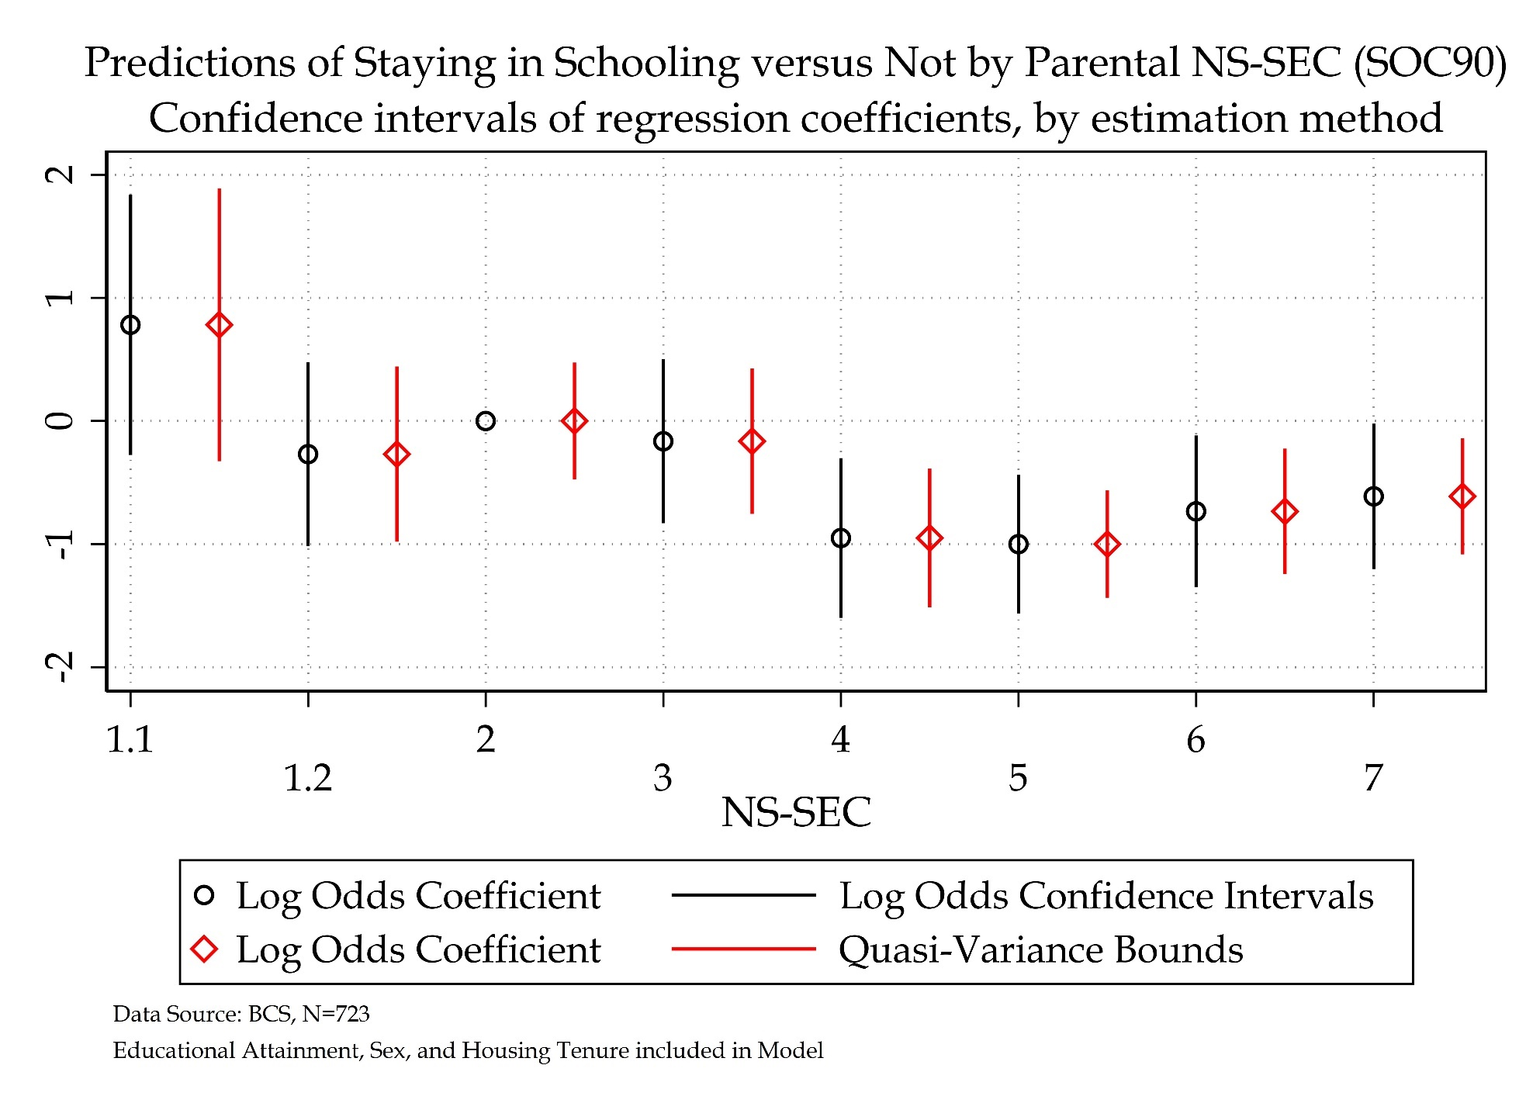

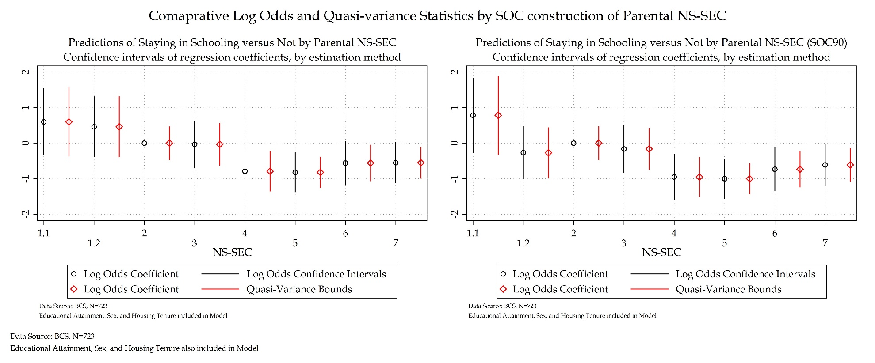

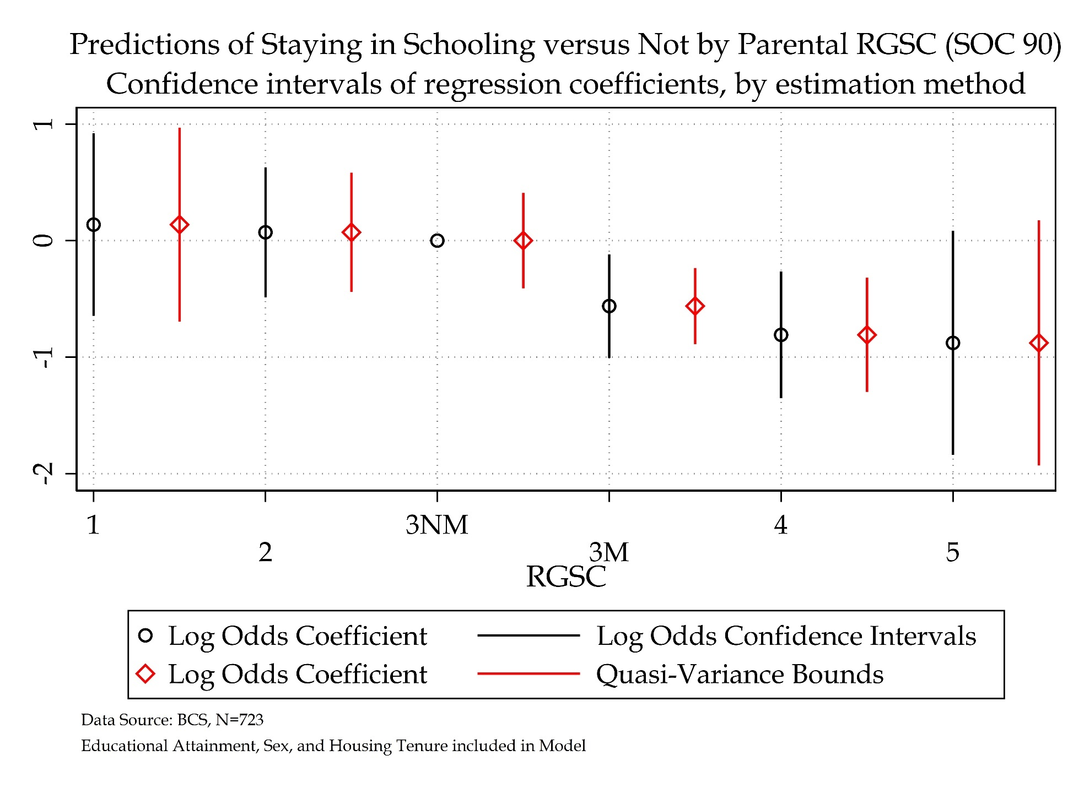

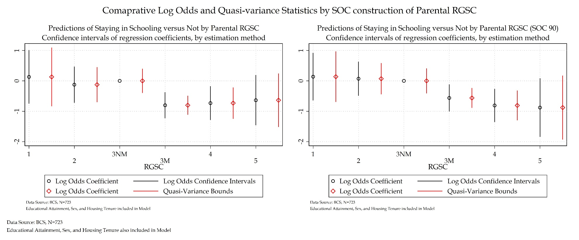

|  |  |  |  |  |  |  |  |  |  |  |  |  |  |  |  |  |
| --- | --- | --- | --- | --- | --- | --- | --- | --- | --- | --- | --- | --- | --- | --- | --- | --- |
|  | RGSC (SOC 2000) | | | Average Marginal Effects | | Quasi-variance | | | RGSC (SOC 90) | | | Average Marginal Effects | | Quasi-variance | | |
| Economic Activity: ‘Don’t Continue Schooling’ Reference Category | **Coef.** | **S.E.** | **Sig.** | **Prob.** | **S.E.** | **S.E.** | **LB** | **UB** | **Coef.** | **S.E.** | **Sig.** | **Prob.** | **S.E.** | **S.E.** | **LB** | **UB** |
| Continue Schooling |  |  |  |  |  |  |  |  |  |  |  |  |  |  |  |  |
| Educational Attainment |  |  |  |  |  |  |  |  |  |  |  |  |  |  |  |  |
| *Less than five O’levels* | Ref. | (.) |  | (.) | (.) | (.) | (.) | (.) | (.) | (.) |  | (.) | (.) | (.) | (.) | (.) |
| *Five or More O’levels* | 1.67 | (0.19) | *** | 0.33 | (0.03) | (.) | (.) | (.) | 1.66 | (0.19) | *** | 0.33 | (0.03) | (.) | (.) | (.) |
| Sex |  |  |  |  |  |  |  |  |  |  |  |  |  |  |  |  |
| *Female* | Ref. | (.) |  | (.) | (.) | (.) | (.) | (.) | (.) | (.) |  | (.) | (.) | (.) | (.) | (.) |
| *Male* | -0.33 | (0.17) |  | -0.06 | (0.03) | (.) | (.) | (.) | -0.32 | (0.17) |  | -0.06 | (0.03) | (.) | (.) | (.) |
| Housing Tenure |  |  |  |  |  |  |  |  |  |  |  |  |  |  |  |  |
| *Own Home* | Ref. | (.) |  | (.) | (.) | (.) | (.) | (.) | (.) | (.) |  | (.) | (.) | (.) | (.) | (.) |
| *Do not Own Home* | -0.33 | (0.21) |  | -0.06 | (0.04) | (.) | (.) | (.) | -0.33 | (0.21) |  | -0.06 | (0.04) | (.) | (.) | (.) |
| RGSC (SOC 2000) |  |  |  |  |  |  |  |  |  |  |  |  |  |  |  |  |
| *1* | 0.13 | (0.45) |  | 0.02 | (0.08) | 0.15 | 0.33 | 1.01 | 0.14 | (0.40) |  | 0.02 | (0.07) | 0.36 | -0.70 | 0.97 |
| *2* | Ref. | (.) |  | (.) | (.) | 0.07 | -0.15 | 0.15 | Ref. | (.) |  | (.) | (.) | 0.18 | -0.41 | 0.41 |
| *3NM* | -0.12 | (0.30) |  | -0.02 | (0.06) | 0.09 | -0.25 | 0.16 | 0.07 | (0.28) |  | 0.01 | (0.05) | 0.22 | -0.44 | 0.58 |
| *3M* | -0.80 | (0.22) | *** | -0.16 | (0.04) | 0.05 | -0.69 | -0.45 | -0.56 | (0.23) | * | -0.11 | (0.04) | 0.14 | -0.89 | -0.24 |
| *4* | -0.73 | (0.28) | ** | -0.14 | (0.06) | 0.09 | -0.83 | -0.41 | -0.81 | (0.28) | ** | -0.16 | (0.06) | 0.21 | -1.30 | -0.32 |
| *5* | -0.64 | (0.42) |  | -0.12 | (0.08) | 0.13 | -1.13 | -0.51 | -0.88 | (0.49) |  | -0.18 | (0.10) | 0.46 | -1.93 | 0.17 |
| Intercept | 0.64 | (0.20) | ** |  |  |  |  |  | 0.52 | (0.20) | ** |  |  |  |  |  |
| Number of observations | 723 | | | | | | | | 723 | | | | | | | |
| McFadden’s $R^{2}$ | 0.14 | | | | | | | | 0.14 | | | | | | | |
| McFadden’s Adjusted Pseudo $R^{2}$ | 0.12 | | | | | | | | 0.11 | | | | | | | |
| Cox-Snell Pseudo $R^{2}$ | 0.17 | | | | | | | | 0.17 | | | | | | | |
| Nagelkerke Pseudo $R^{2}$ | 0.23 | | | | | | | | 0.23 | | | | | | | |
| Tjur’s $R^{2}$ | 0.18 | | | | | | | | 0.18 | | | | | | | |
| AIC | 827.37 | | | | | | | | 828.88 | | | | | | | |
| BIC | 868.62 | | | | | | | | 870.13 | | | | | | | |
| *** p<.001, ** p<.01, * p<.05 Data Source: NCDS [Sweeps 0-4]  Note: Sensitivity Analysis of Social Stratification Measures | | | | | | | | | | | | | | | | |

|  |  |  |  |  |  |  |  |  |  |  |
| --- | --- | --- | --- | --- | --- | --- | --- | --- | --- | --- |
|  | CAMSIS (SOC 2000) | | | Average Marginal Effects | | CAMSIS (SOC 90) | | | Average Marginal Effects | |
| Economic Activity: ‘Don’t Continue Schooling’ Reference Category | **Coef.** | **S.E.** | **Sig.** | **Prob.** | **S.E.** | **Coef.** | **S.E.** | **Sig.** | $Δ$**Prob.** | **S.E.** |
| Continue Schooling |  |  |  |  |  |  |  |  |  |  |
| Educational Attainment |  |  |  |  |  |  |  |  |  |  |
| *Less than five O’levels* | Ref. | (.) |  | (.) | (.) | (.) | (.) |  | (.) | (.) |
| *Five or More O’levels* | 1.67 | (0.19) | *** | 0.32 | (0.03) | 1.63 | (0.19) | *** | 0.33 | (0.03) |
| Sex |  |  |  |  |  |  |  |  |  |  |
| *Female* | Ref. | (.) |  | (.) | (.) | (.) | (.) |  | (.) | (.) |
| *Male* | -0.33 | (0.17) |  | -0.06 | (0.03) | -0.34 | (0.17) |  | -0.06 | (0.03) |
| Housing Tenure |  |  |  |  |  |  |  |  |  |  |
| *Own Home* | Ref. | (.) |  | (.) | (.) | (.) | (.) |  | (.) | (.) |
| *Do not Own Home* | -0.30 | (0.21) |  | -0.06 | (0.04) | -0.31 | (0.20) |  | -0.06 | (0.04) |
| CAMSIS (SOC 2000) | 0.03 | (0.01) | *** | 0.00 | (0.00) | 0.02 | (0.01) | *** | 0.00 | (0.00) |
| Intercept | -1.06 | (0.35) | ** |  |  | -0.96 | (0.33) | ** |  |  |
| Number of observations | 723 | | | | | 723 | | | | |
| McFadden’s $R^{2}$ | 0.14 | | | | | 0.14 | | | | |
| McFadden’s Adjusted Pseudo $R^{2}$ | 0.12 | | | | | 0.12 | | | | |
| Cox-Snell Pseudo $R^{2}$ | 0.17 | | | | | 0.17 | | | | |
| Nagelkerke Pseudo $R^{2}$ | 0.23 | | | | | 0.23 | | | | |
| Tjur’s $R^{2}$ | 0.17 | | | | | 0.17 | | | | |
| AIC | 823.03 | | | | | 823.98 | | | | |
| BIC | 845.94 | | | | | 846.89 | | | | |
| *** p<.001, ** p<.01, * p<.05 Data Source: NCDS [Sweeps 0-4]  Note: Sensitivity Analysis of Social Stratification Measures | | | | | | | | | | |

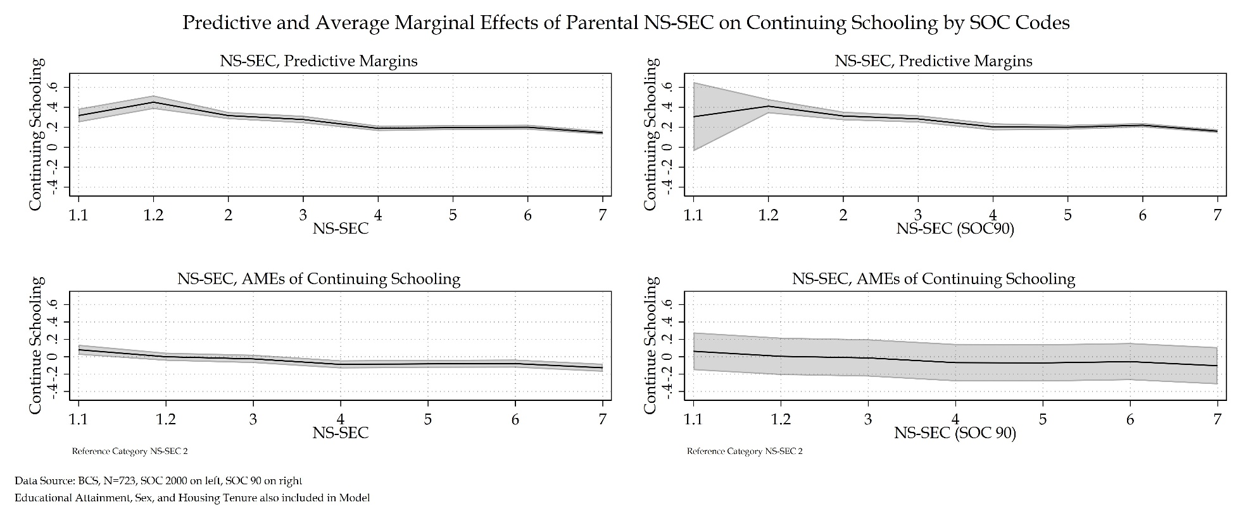

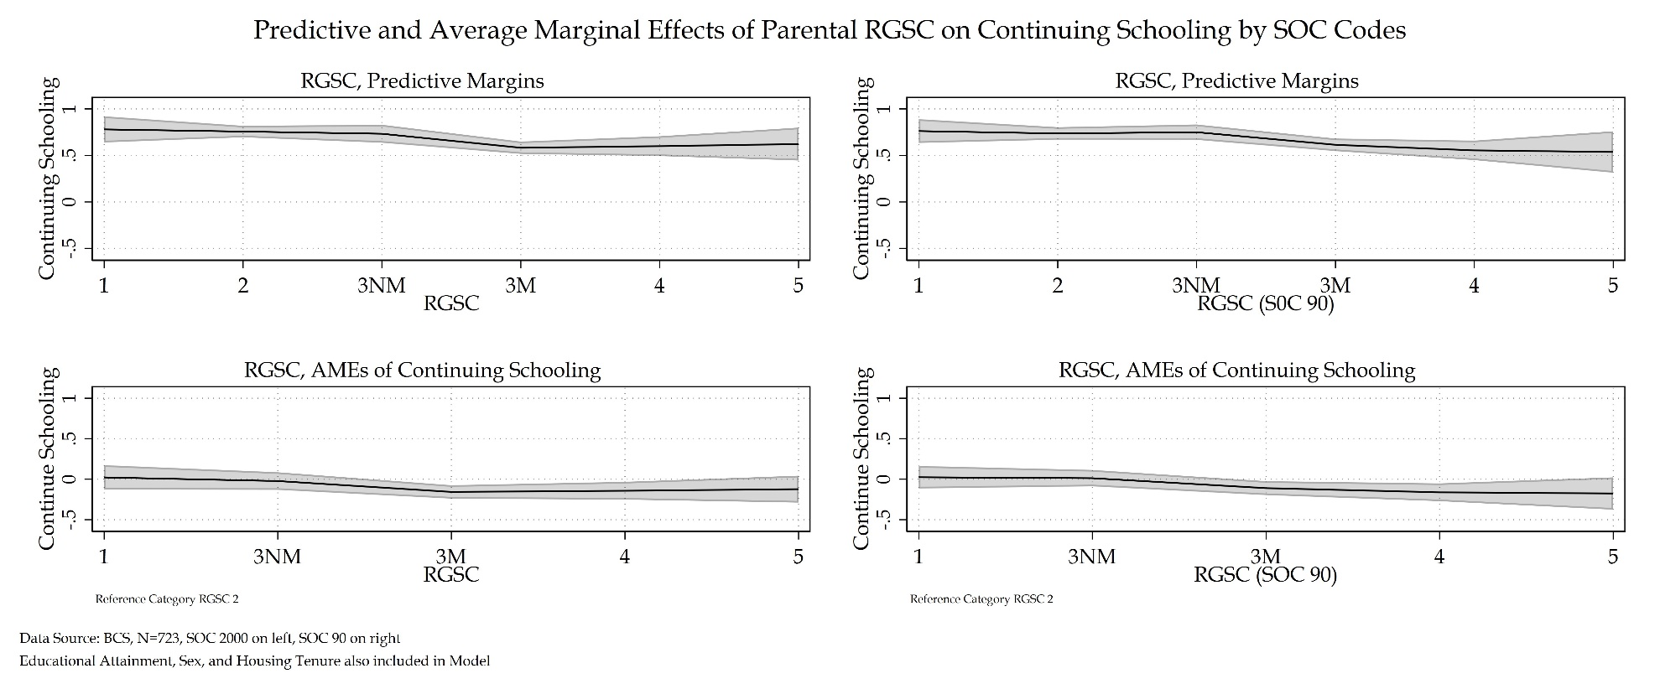

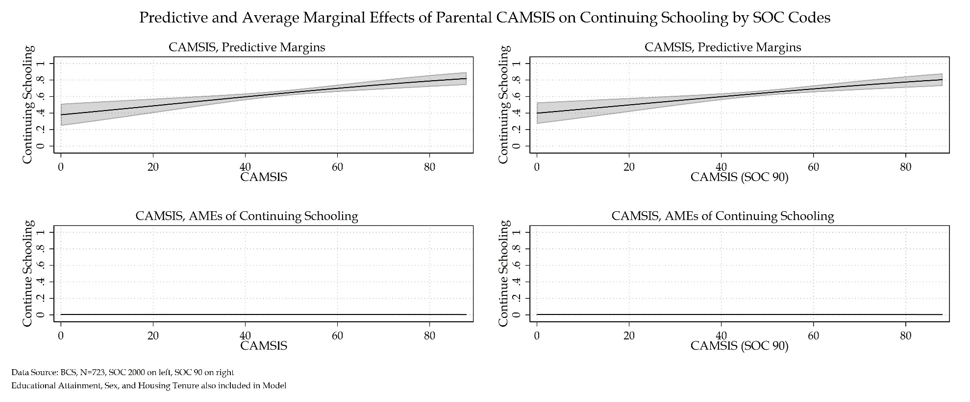

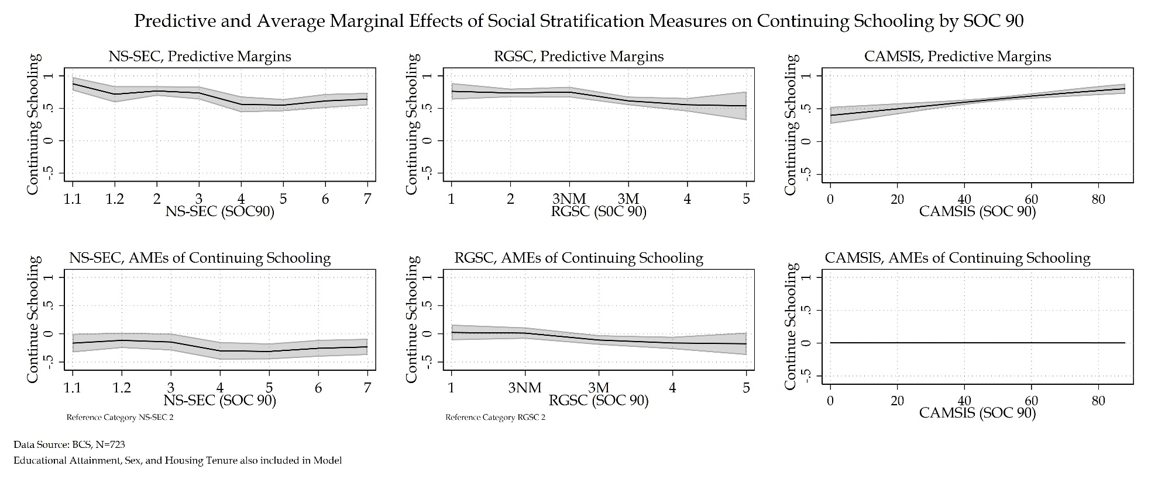

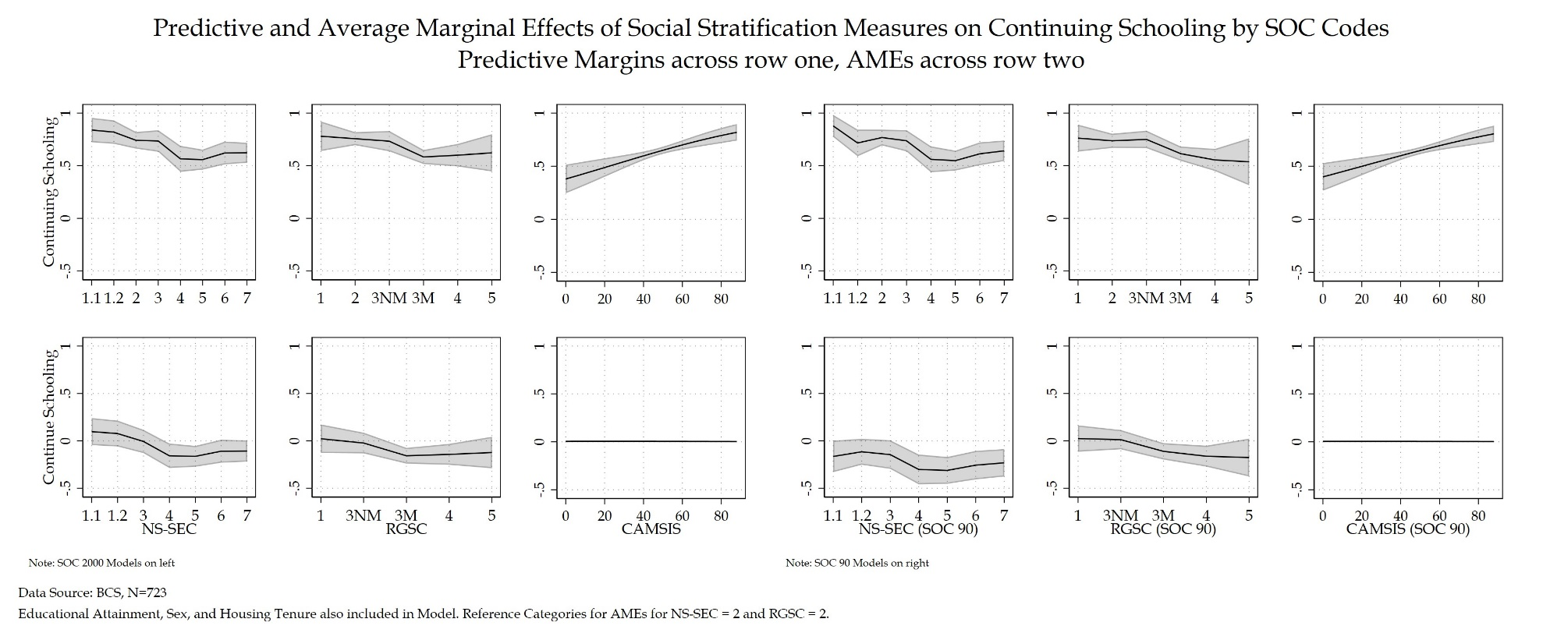

|  |  |  |  |  |  |  |  |  |  |  |
| --- | --- | --- | --- | --- | --- | --- | --- | --- | --- | --- |
|  | NS-SEC (SOC200) CRA | | | Average Marginal Effects | | NS-SEC (SOC 2000) MI | | | Average Marginal Effects | |
| Economic Activity: ‘Don’t Continue Schooling’ Reference Category | Coef. | S.E. | Sig. | Prob. | S.E. | Coef. | S.E. | Sig. | $Δ$ Prob. | S.E. |
| Continue Schooling |  |  |  |  |  |  |  |  |  |  |
| Educational Attainment |  |  |  |  |  |  |  |  |  |  |
| Less than five O’levels | Ref. | (.) |  | (.) | (.) | (.) | (.) |  | (.) | (.) |
| Five or More O’levels | 1.67 | (0.19) | *** | 0.33 | (0.03) | 1.77 | (0.18) | *** | 0.38 | (0.04) |
| Sex |  |  |  |  |  |  |  |  |  |  |
| Female | Ref. | (.) |  | (.) | (.) | (.) | (.) |  | (.) | (.) |
| Male | -0.35 | (0.17) | * | -0.07 | (0.03) | -0.60 | (0.12) | *** | -0.11 | (0.02) |
| Housing Tenure |  |  |  |  |  |  |  |  |  |  |
| Own Home | Ref. | (.) |  | (.) | (.) | (.) | (.) |  | (.) | (.) |
| Do not Own Home | -0.30 | (0.21) |  | -0.06 | (0.04) | -0.54 | (0.14) | *** | -0.10 | (0.03) |
| NS-SEC |  |  |  |  |  |  |  |  |  |  |
| 1.1 | 0.60 | (0.48) |  | 0.10 | (0.07) | 0.43 | (0.36) |  | 0.09 | (0.07) |
| 1.2 | 0.46 | (0.43) |  | 0.08 | (0.07) | 0.54 | (0.35) |  | 0.11 | (0.07) |
| 2 | Ref. | (.) |  | (.) | (.) | (.) | (.) |  | (.) | (.) |
| 3 | -0.03 | (0.34) |  | -0.01 | (0.06) | -0.11 | (0.26) |  | -0.02 | (0.05) |
| 4 | -0.79 | (0.33) | * | -0.16 | (0.07) | -0.76 | (0.25) | ** | -0.15 | (0.05) |
| 5 | -0.82 | (0.29) | ** | -0.16 | (0.06) | -0.75 | (0.23) | ** | -0.15 | (0.05) |
| 6 | -0.56 | (0.31) |  | -0.11 | (0.06) | -0.47 | (0.24) | * | -0.10 | (0.05) |
| 7 | -0.55 | (0.29) |  | -0.11 | (0.06) | -0.82 | (0.22) | *** | -0.17 | (0.05) |
| Intercept | 0.55 | (0.23) | * |  |  | 0.10 | (0.17) | *** |  |  |
| Number of observations | 723 | | | | | 1645 | | | | |
| Average RVI |  | | | | | 0.32 | | | | |
| Largest FMI |  | | | | | 0.50 | | | | |
| *** p<.001, ** p<.01, * p<.05 Data Source: BCS [Sweeps 0-4]  Note: Sensitivity Analysis of Social Stratification Measures | | | | | | | | | | |

Merged:

|  |  |  |  |  |  |  |  |  |  |  |  |  |  |  |  |  |  |  |  |  |  |  |  |  |
| --- | --- | --- | --- | --- | --- | --- | --- | --- | --- | --- | --- | --- | --- | --- | --- | --- | --- | --- | --- | --- | --- | --- | --- | --- |
|  | NS-SEC Model | | | BCS Model | | | Combined Model | | | Cohort Model | | | Education Interaction | | | + Sex Interaction | | | + Tenure Interaction | | | + NS-SEC Interaction | | |
| Economic Activity: ‘Don’t Continue Schooling’ Reference Category | **Coef.** | **S.E.** | **Sig.** | **Coef.** | **S.E.** | **Sig.** | **Coef.** | **S.E.** | **Sig.** | **Coef.** | **S.E.** | **Sig.** | **Coef.** | **S.E.** | **Sig.** | **Coef.** | **S.E.** | **Sig.** | **Coef.** | **S.E.** | **Sig.** | **Coef.** | **S.E.** | **Sig.** |
| Continue Schooling |  |  |  |  |  |  |  |  |  |  |  |  |  |  |  |  |  |  |  |  |  |  |  |  |
| Educational Attainment |  |  |  |  |  |  |  |  |  |  |  |  |  |  |  |  |  |  |  |  |  |  |  |  |
| *Less than five O’levels* | Ref. | (.) |  | (.) | (.) |  | (.) | (.) |  | (.) | (.) |  | (.) | (.) |  | (.) | (.) |  | (.) | (.) |  | (.) | (.) |  |
| *Five or More O’levels* | 3.07 | (0.07) | *** | 1.67 | (0.19) | *** | 2.78 | (0.06) | *** | 2.95 | (0.06) | *** | 3.07 | (0.07) | *** | 3.07 | (0.07) | *** | 3.07 | (0.07) | *** | 3.07 | (0.07) | *** |
| Sex |  |  |  |  |  |  |  |  |  |  |  |  |  |  |  |  |  |  |  |  |  |  |  |  |
| *Female* | Ref. | (.) |  | (.) | (.) |  | (.) | (.) |  | (.) | (.) |  | (.) | (.) |  | (.) | (.) |  | (.) | (.) |  | (.) | (.) |  |
| *Male* | 0.06 | (0.06) |  | -0.35 | (0.17) | * | -0.05 | (0.06) |  | 0.01 | (0.06) |  | 0.01 | (0.06) |  | 0.06 | (0.06) |  | 0.06 | (0.06) |  | 0.06 | (0.06) |  |
| Housing Tenure |  |  |  |  |  |  |  |  |  |  |  |  |  |  |  |  |  |  |  |  |  |  |  |  |
| *Own Home* | Ref. | (.) |  | (.) | (.) |  | (.) | (.) |  | (.) | (.) |  | (.) | (.) |  | (.) | (.) |  | (.) | (.) |  | (.) | (.) |  |
| *Do not Own Home* | -0.40 | (0.07) | *** | -0.30 | (0.21) |  | -0.56 | (0.06) | *** | -0.40 | (0.06) | *** | -0.39 | (0.06) | *** | -0.39 | (0.06) | *** | -0.41 | (0.07) | *** | -0.40 | (0.07) | *** |
| NS-SEC (SOC 2000) |  |  |  |  |  |  |  |  |  |  |  |  |  |  |  |  |  |  |  |  |  |  |  |  |
| *1.1* | 0.00 | (0.18) |  | 0.60 | (0.48) |  | 0.10 | (0.16) |  | 0.08 | (0.17) |  | 0.07 | (0.17) |  | 0.08 | (0.17) |  | 0.08 | (0.17) |  | 0.00 | (0.18) |  |
| *1.2* | 0.57 | (0.16) | *** | 0.46 | (0.43) |  | 0.55 | (0.15) | *** | 0.56 | (0.15) | *** | 0.56 | (0.15) | *** | 0.56 | (0.15) | *** | 0.56 | (0.15) | *** | 0.57 | (0.16) | *** |
| *2* | Ref. | (.) |  | (.) | (.) |  | (.) | (.) |  | (.) | (.) |  | (.) | (.) |  | (.) | (.) |  | (.) | (.) |  | (.) | (.) |  |
| *3* | -0.19 | (0.12) |  | -0.03 | (0.34) |  | -0.20 | (0.11) |  | -0.17 | (0.12) |  | -0.17 | (0.12) |  | -0.17 | (0.12) |  | -0.17 | (0.12) |  | -0.19 | (0.12) |  |
| *4* | -0.69 | (0.12) | *** | -0.79 | (0.33) | * | -0.74 | (0.11) | *** | -0.69 | (0.11) | *** | -0.70 | (0.11) | *** | -0.70 | (0.11) | *** | -0.70 | (0.11) | *** | -0.69 | (0.12) | *** |
| *5* | -0.64 | (0.11) | *** | -0.82 | (0.29) | ** | -0.67 | (0.10) | *** | -0.67 | (0.11) | *** | -0.66 | (0.11) | *** | -0.66 | (0.11) | *** | -0.66 | (0.11) | *** | -0.64 | (0.11) | *** |
| *6* | -0.62 | (0.12) | *** | -0.56 | (0.31) |  | -0.65 | (0.11) | *** | -0.61 | (0.11) | *** | -0.61 | (0.11) | *** | -0.61 | (0.11) | *** | -0.61 | (0.11) | *** | -0.62 | (0.12) | *** |
| *7* | -1.01 | (0.11) | *** | -0.55 | (0.29) |  | -0.97 | (0.10) | *** | -0.95 | (0.11) | *** | -0.95 | (0.11) | *** | -0.95 | (0.11) | *** | -0.95 | (0.11) | *** | -1.01 | (0.11) | *** |
| Cohort |  |  |  |  |  |  |  |  |  |  |  |  |  |  |  |  |  |  |  |  |  |  |  |  |
| *NCDS* | Ref. | (.) |  | (.) | (.) |  | (.) | (.) |  | (.) | (.) |  | (.) | (.) |  | (.) | (.) |  | (.) | (.) |  | (.) | (.) |  |
| *BCS* |  |  |  |  |  |  |  |  |  | 1.82 | (0.10) | *** | 2.19 | (0.11) | *** | 2.35 | (0.14) | *** | 2.31 | (0.15) | *** | 2.23 | (0.25) | *** |
| Educational Attainment # Cohort |  |  |  |  |  |  |  |  |  |  |  |  | -1.48 | (0.20) | *** | -1.46 | (0.20) | *** | -1.44 | (0.20) | *** | -1.40 | (0.21) | *** |
| Sex # Cohort |  |  |  |  |  |  |  |  |  |  |  |  |  |  |  | -0.40 | (0.19) | * | -0.40 | (0.19) | * | -0.41 | (0.19) | * |
| Tenure # Cohort |  |  |  |  |  |  |  |  |  |  |  |  |  |  |  |  |  |  | 0.15 | (0.21) |  | 0.10 | (0.22) |  |
| NS-SEC (SOC 2000) # Cohort |  |  |  |  |  |  |  |  |  |  |  |  |  |  |  |  |  |  |  |  |  |  |  |  |
| *1.1 # BCS* |  |  |  |  |  |  |  |  |  |  |  |  |  |  |  |  |  |  |  |  |  | 0.60 | (0.51) |  |
| *1.2 # BCS* |  |  |  |  |  |  |  |  |  |  |  |  |  |  |  |  |  |  |  |  |  | -0.11 | (0.46) |  |
| *2 # BCS* |  |  |  |  |  |  |  |  |  |  |  |  |  |  |  |  |  |  |  |  |  | Ref. | (.) | (.) |
| *3 # BCS* |  |  |  |  |  |  |  |  |  |  |  |  |  |  |  |  |  |  |  |  |  | 0.16 | (0.36) |  |
| *4 # BCS* |  |  |  |  |  |  |  |  |  |  |  |  |  |  |  |  |  |  |  |  |  | -0.10 | (0.35) |  |
| *5 # BCS* |  |  |  |  |  |  |  |  |  |  |  |  |  |  |  |  |  |  |  |  |  | -0.18 | (0.31) |  |
| *6 # BCS* |  |  |  |  |  |  |  |  |  |  |  |  |  |  |  |  |  |  |  |  |  | 0.06 | (0.34) |  |
| *7 # BCS* |  |  |  |  |  |  |  |  |  |  |  |  |  |  |  |  |  |  |  |  |  | 0.46 | (0.31) |  |
| Intercept | -1.68 | (0.10) | *** | 0.55 | (0.23) | * | -1.22 | (0.09) | *** | -1.59 | (0.09) | *** | -1.67 | (0.09) | *** | -1.69 | (0.10) | *** | -1.69 | (0.10) | *** | -1.68 | (0.10) | *** |
| Number of Observations | 8411 | | | 723 | | | 9134 | | | 9134 | | | 9134 | | | 9134 | | | 9134 | | | 9134 | | |
| McFadden’s $R^{2}$ | 0.38 | | | 0.15 | | | 0.35 | | | 0.38 | | | 0.38 | | | 0.38 | | | 0.38 | | | 0.38 | | |
| McFadden’s Adjusted Pseudo $R^{2}$ | 0.38 | | | 0.12 | | | 0.35 | | | 0.37 | | | 0.38 | | | 0.38 | | | 0.38 | | | 0.37 | | |
| Cox-Snell Pseudo $R^{2}$ | 0.38 | | | 0.18 | | | 0.36 | | | 0.38 | | | 0.38 | | | 0.38 | | | 0.38 | | | 0.38 | | |
| Nagelkerke Pseudo $R^{2}$ | 0.53 | | | 0.24 | | | 0.50 | | | 0.53 | | | 0.53 | | | 0.53 | | | 0.53 | | | 0.53 | | |
| Tjur’s $R^{2}$ | 0.45 | | | 0.18 | | | 0.42 | | | 0.45 | | | 0.45 | | | 0.45 | | | 0.45 | | | 0.45 | | |
| AIC | 6391.02 | | | 825.55 | | | 7560.92 | | | 7255.09 | | | 7210.45 | | | 7207.88 | | | 7209.40 | | | 7216.56 | | |
| BIC | 6468.43 | | | 875.97 | | | 7639.24 | | | 7340.52 | | | 7303.00 | | | 7307.56 | | | 7316.20 | | | 7373.20 | | |
| *** p<.001, ** p<.01, * p<.05 Data Source: NCDS [Sweeps 0-4]  Note: Sensitivity Analysis of Social Stratification Measures | | | | | | | | | | | | | | | | | | | | | | | | |

